

PART

# IV

## Asynchronous Services and Events

*This page intentionally left blank*



CHAPTER

# 12

## Asynchronous Services with SOA Composites and Service Bus

et me write down your number and get back to you” can be much more efficient than “please hold the line.” The former is a typical example of asynchronous communication.

**“L**

This can be much more efficient than actually holding the line, which is the synchronous way of conversing. While holding the line, waiting for a response, you are blocked—unable to engage in useful activities.

In real life, when you tell something to a person, you don’t mind waiting for answer (beyond some form of acknowledgement that your message was heard and understood) if and when:

* You asked a question that you want an answer to.
* You cannot meaningfully continue with your life until you receive the response.
* You do not have to wait too long (a little subjective).
* You will lose the opportunity to receive the answer at all if you do not wait for it.
* You can afford to wait (because of the time or cost of resources involved with waiting).

However, if these considerations do not apply, you want to continue with your life as soon as possible after saying your piece or asking your question.

In the world of services, very similar considerations apply. Replace “you” in these bullets with “the service consumer” and you have a checklist that will help you decide when interactions must be synchronous and when perhaps they could be handled asynchronously.

Synchronously waiting for a response that it is not absolutely required is not just a waste of time: it is also a waste of scarce system resources such as memory and primarily processing threads.

Synchronous interactions also add to the fragility of a system. When instead of a long, complex, all-dependent chain we can work with multiple, smaller, simpler, decoupled chains that would be far preferable. So after having discussed synchronous interactions in most of the preceding chapters, we will focus in this chapter on how we can expose asynchronous interfaces from the SOA Suite. These interfaces will take a request, cease the communication, proceed with the execution of the request and provide a response in a callback. BPEL as we will see provides the easiest way to implement such operations, although using only Service Bus or Mediator we can achieve similar results.

Due to the fact that a BPEL process can be long running, we can speak of instances of a process and we can engage in communication with such an instance. This can be, for example, to learn something about the (status of the) instance, to feed additional information to the instance or to abort the instance. Ensuring that requests end up in the correct instance is one of our challenges—handled in BPEL through a mechanism called correlation.

As a practical show case we will look at the *AircraftServiceOrchestrator*—the intermediate between airlines and providers of fuel, cleaning, catering and repair services on Saibot Airport that helps parties negotiate agreeable terms for services to be rendered under specified conditions.

### Exposing Asynchronous Services

The term asynchronous service is perhaps somewhat misleading. We use it to indicate a category of services that are associated with two interfaces. One is the interface implemented by the service itself with one or more one-way operations that only take an input. The other interface is the callback interface: the interface that the service expects when it calls back to deliver the response message. This interface has to be implemented by the party invoking the service. The address of the implementation has to be delivered along with request message—so the service knows where to call with the response. In human interactions, the callback interface is, for example, the telephone or fax machine and their wired or wireless connection.

Only if you have the ability to be called back in the manner described by the service provider, can you make a successful call to the asynchronous service and get the response you are looking for.

###### NOTE

*A service operation may define an output (that is returned synchronously) and also specify a callback interface. The service operation can be implemented in such a way that it first returns a synchronous response and subsequently makes a call to the callback service and deliver an additional message. In this chapter, we will assume the asynchronous service operations will be one way and deliver a single, asynchronous response message to the callback service.*

The implementation of an asynchronous web service requires some steps in addition to what a synchronous service implementation has to do. These steps concern the interpretation of the request headers to extract the address to send the response to as well as a message identifier used for identification of the conversation. Additionally, the service implementation will have to make a service call itself—to the address dynamically extracted.

This section discusses the implementation of the asynchronous service with Service Bus projects, Mediator, and first of all BPEL. We will also look at invoking asynchronous services from these three environments. Mediator and Service Bus can both expose an asynchronous interface on top of a synchronous and an asynchronous back end or business service. BPEL in addition can present a synchronous interface on top of an asynchronous back end.

The online resources for this chapter describe the implementation of an asynchronous web service using only Java and JAX-WS, as well as the invocation of an asynchronous web service from a Java SE program.

The service we will implement is an asynchronous form of hello world: *ThoughtfulGreeterService*

(Figure 12-1).

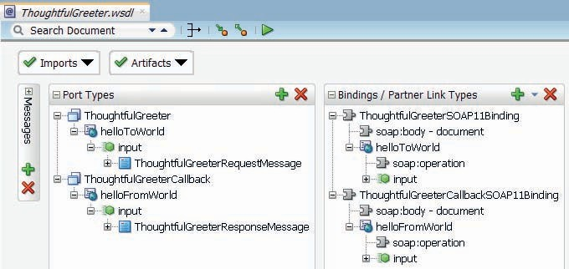

**FIGURE 12-1.** *The WSDL definition for the ThoughtfulGreeterService*

The service definition describes two interfaces: the primary one, implemented by the service itself and the callback one, implemented by the service consumers. The former interface has a single one way operation—*helloToWorld*—that takes a simple request message with a name element as key aspect. It does not return any output.

The callback interface also contains a single operation, this one called *helloFromWorld*. This operation is also one way: it takes as input the response message from the *ThoughtfulGreeterService* and does not return any output. This operation should only be invoked by implementations of the *ThoughtfulGreeterService*’s primary interface.

**Implement the Asynchronous ThoughtfulGreeterService with a BPEL Component**

The *ThoughtfulGreeterService* is just a *hello world* service that takes its time to respond. More precisely: it completes the synchronous interaction with the consumer accepting the request message, it composes the response messages through whatever processing it has to perform and then calls back to the address specified to hand over the response—which is sent as a request to the callback service. This could indeed take some time. However, it could also be near instantaneously. Asynchronous does not necessarily mean slow or delayed. It *does* mean decoupled: receiving the response takes place in a different interaction than the one in which the service was first invoked.

The steps for the BPEL implementation of this service are straightforward (see the result in Figure 12-2):

* Create a new SOA composite application—Empty Template.
* Add BPEL component, based on the ThoughtfulGreeterService.wsdl.
* Check the BPEL process created (Receive and Invoke rather than Reply).
* Choose roles to implement.
* Create SOAP Service Binding at the composite level, based on WSDL.
* Add Assign activity to set the output variable.

Note that between the Receive and Invoke activities, we can include any other activity— including synchronous or asynchronous service calls, iterations (for each) and parallel scopes (flow). There is no risk of a time out—because there is no component waiting for the result—at least not in a blocked, synchronous conversation. Whether the service consumer may be waiting behind the callback interface for the response to arrive—with a fixed deadline and its own time out mechanism—is beyond the scope of this chapter.

##### Test Asynchronous Service from SoapUI

Testing asynchronous web services is somewhat special compared to testing synchronous services because in addition to the request message to be sent to the exposed service endpoint, SoapUI also needs to make a callback service available and it has to set the appropriate WS-Addressing headers in the request headers to direct the asynchronous service to the callback service.

SoapUI has a Mock Service facility. This allows us to publish a web service—based on a port type in a WSDL document and published at a port and endpoint of our choosing. The callback interface is only one way: it receives the response message from the asynchronous service and that is the end of the story. In SoapUI, we can check all messages received by the Mock Service, so we will know if and when the asynchronous service delivered the response.

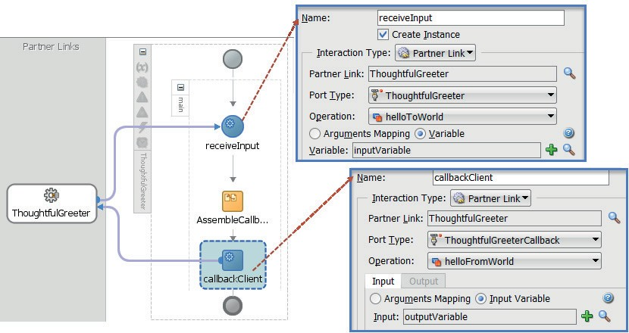

**FIGURE 12-2.** *The BPEL process that implements an asynchronous interface (the final activity*

*is an Invoke instead of a Reply—and it invokes a different portType on the ThoughtfulGreeter partnerLink)*

###### TIP

*The online resource explains and shows in detail how to set up the test project with mock service for the ThoughtfulGreeterService.*

Create a new SoapUI project—based on the WSDL document exposed by the deployed *ThoughtfulGreeter* service (at the address shown as WSDL URL in the EM FMW console after deployment of the SOA Composite, for example: **http://localhost:7101/soa-infra/ services/default/AsynchronousSOAComposite/ThoughtfulGreeter_ep?WSDL**).

The project is created with test cases and requests for both bindings in the WSDL.

Next, we need a MockService in SoapUI—to implement the callback interface (PortType *ThoughtfulGreeterCallback*) for the *ThoughtfulGreeterService*. Right click on the project in SoapUI. Select New SOAP MockService from the context menu. Set the name of the MockService to *ThoughtfulGreeterCallbackService* and click on OK. Add a MockOperation from the context menu for the *helloFromWorld* operation.

Open the MockService Editor, from the context menu on the Mock ServiceOpen the options window for the Mock Service. Set the Path and Port for the Mock Service to appropriate values— such as /*MockThoughfulGreeterCallback* and 8081.

Start the Mock Service. Note that we do not have to specify a response message for this mock service and operation. The operation is one way—only to be invoked in order for the asynchronous service to deliver its response.

Using the icon in the Mock Editor window, open the WSDL page for the Mock Service. It is the easiest way to get hold of the endpoint for the MockService. We need this endpoint, to pass it in the request to the ThoughtfulGreeterService.helloToWorld operation as the ReplyTo address.

##### Configure WS-Addressing in the Test Request for the ThoughfulGreeterService

In order to let the asynchronous service—in this case the BPEL engine—know where to send its response message and what messageId to include in order to allow correlation between request and asynchronous response, several WS-Addressing headers have to be included in the request.

Open the Test Request for the *helloToWorld* operation. Set the endpoint to the endpoint found in the JDeveloper console after deployment. Set a value for the name element in the request message.

Open the tab for Addressing details. Check the checkbox labeled Enable WS-Addressing. Set the ReplyTo property with the endpoint address in the clipboard buffer (copied from the WSDL page for the Mock Service). Check the checkbox labeled Randomly generate MessageId, as shown in Figure 12-3.

This basically means that SoapUI will add several WS-Addressing headers to the request it sends to the *ThoughtfulGreeterService*—including one for the *ReplyTo* address (the callback endpoint) and the message ID to be used in the callback.

Now make the call from SoapUI. Check in SoapUI in the MockService editor. Here you will find a log line for an incoming request. When you inspect the message exchange results, you will

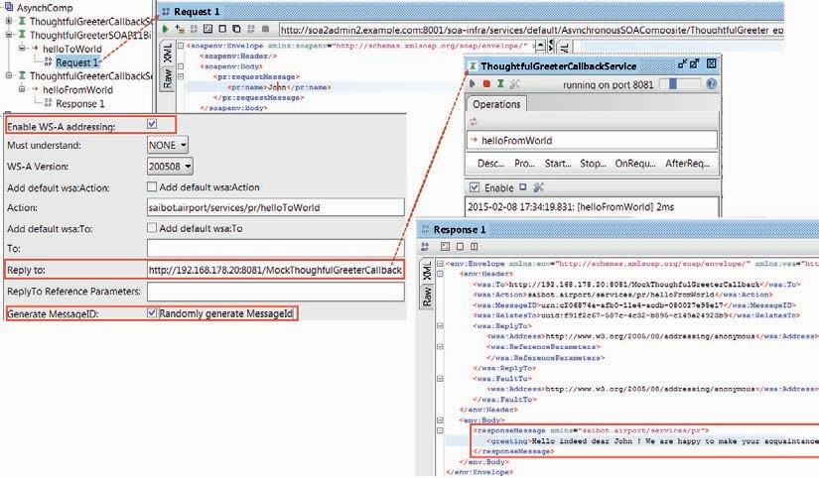

**FIGURE 12-3.** *Configure the SoapUI Test Request (with the WS-Addressing properties to*

*guide the callback message) and the Mock Service receiving the asynchronous response from ThoughtfulGreeterService*

find the response message as well as the *RelatesTo* header property with the same message Id that was sent in the request message.

You can of course also check the flow trace and BPEL audit trail for the SOA composite instance that was created when the SoapUI test request was sent for the asynchronous service.

Note that in the implementation of the service in BPEL did we at no point have to deal with WS-Addressing headers or other low level details concerning the callback location or the correlation ID. The BPEL engine takes care of all that.

#### Implement Asynchronous Service with Mediator

A Mediator can also implement an asynchronous service. It does so not as elegantly as a BPEL component can. The developer has to read and set WS-Addressing settings from the request and to the message sent as response to the callback service. We will briefly discuss this approach.

Add a Mediator component to the SOA composite. Call it *ThoughtfulGreeterMediator*. Choose the *Interface Definition from WSDL* template, check the checkbox *Expose as a SOAP service* and select the ThoughtfulGreeter.wsdl document. Select the *ThoughtFulGreeter* interface as PortType and the *ThoughtfulGreeterCallback* as the Callback Port Type, as shown in Figure 12-4.

Also add a SOAP Reference Binding to the component, based on callback interface in the WSDL document. Note: The endpoint set for this binding at design time is irrelevant. At run time, the endpoint will be set based on the WS-Addressing ReplyTo header received from the service consumer to make the callback to deliver the asynchronous response.

Wire the Mediator to this SOAP binding, as is shown in Figure 12-5.

Open the Mediator editor. It shows a routing rule to a (dummy) SOAP Reference that implements the *ThoughtfulGreeterCallback* interface.

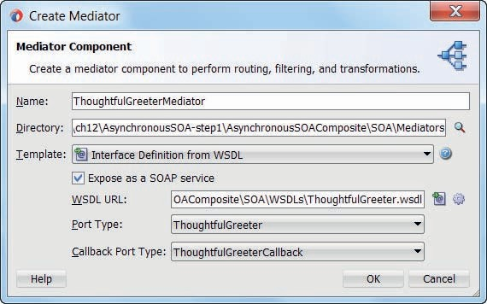

**FIGURE 12-4.** *Configuration of Mediator with asynchronous interface*

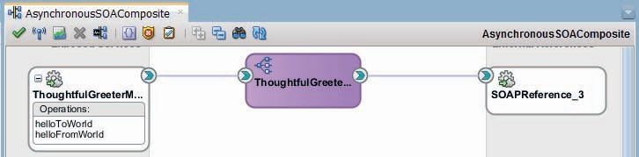

**FIGURE 12-5.** *ThoughtfulGreeterMediator exposing an asynchronous interface and using a*

*SOAP Reference binding to perform the callback.*

Open the Assign Values dialog, see Figure 12-6. Set the *endpointURI* property (in the $out variable) with the value in the *replyToAddress* property in the $in variable (received as header in the request message). Map the *wsa.messageId* property in the $in variable to the *wsa.relatesTo* property in the $out variable. Also set an XPath expression to derive the value for the (greeting element in the) response message.

Deploy the SOA composite. Use the same SoapUI Test Request as before to test the service and verify that the Mediator sends a response message to the callback (mock) service.

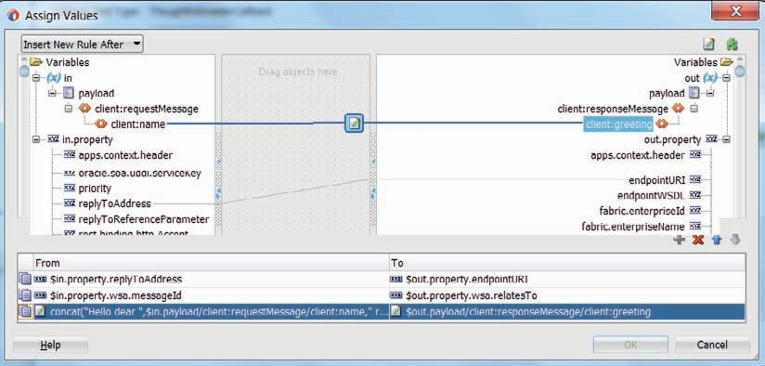

**FIGURE 12-6.** *By setting the endpointURI property on the $out variable, the response is*

*guided to the correct callback service endpoint; the relatesTo property is set with the incoming messageId—to allow correlation by the consumer between the request and the asynchronous response to the callback service*

#### Expose Asynchronous Service Interface with Service Bus

The Service Bus implements an asynchronous interface in a similar way as the mediator does: after an initial one-way incoming conversation, the request is processed in a pipeline and the result of that processing—which may involve calls to one or more business services—is sent to a business service that represents the callback service. The headers in the request message contain the information required to instruct the business service on which endpoint to send the response to.

The steps for implementing the *ThoughtfulGreeterService* with Service Bus are fairly straightforward.

Create a new Service Bus project. Import the WSDL and XSD into the project. Create

a proxy service based on the *ThoughtfulGreeter* port binding and a business service based on *ThoughtfulGreeterCallback*. Note that the endpoint address set for the business service is irrelevant—because as with the mediator, this endpoint will be set at run time from the ReplyTo header property received from the service consumer.

Create a pipeline, also based on *ThoughtfulGreeter*. Wire the proxy service to this pipeline and the pipeline to the business service, as shown in Figure 12-7.

The pipeline gathers the ReplyTo address and MessageId from the request headers, then processes the body to prepare the response and then uses a Publish operation to invoke the

one-way callback interface, after manipulating the header with the appropriate values, as shown in Figure 12-8.

###### NOTE

*This Publish action could instead of calling the outgoing business service also invoke a Service Bus proxy service, which uses its own pipeline to do processing on a* decoupled*,* separate thread*. As long*

*as the WS-Addressing properties are passed along, this pipeline could route to a business service that invokes the Callback interface.*

The first stage—GatherCallbackToandMessageId—contains Assign activities that assign values from the $header variable to local variables:

 $header/wsa05:ReplyTo/wsa05:Address/. => callbackToAddress

and

 $header/wsa05:MessageID/. => MessageId

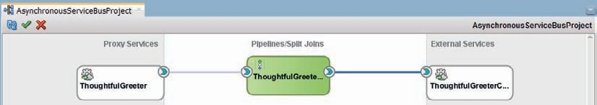

**FIGURE 12-7.** *The ThoughtfulGreeter Service Bus project for asynchronous responses*

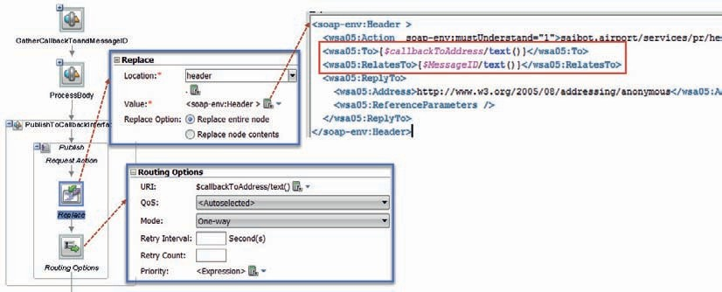

**FIGURE 12-8.** *Pipeline implementing the ThoughtfulGreeter functionality in three steps:*

*retrieve WS-Addressing properties, prepare response and publish to the business service that does the callback*

Note that in a Service Bus pipeline we always have access to both the body and the header element from the request message, in the $body and $header variables respectively.

The response message is prepared in the second stage *ProcessBody* using a replace activity on the $body variable, replacing the node contents with a greeting message that contains the name from the request.

The third stage initiates the callback through the publish action to the business service. The publish action is configured to invoke the business service. It contains a replace activity to replace the entire node in the header variable using the gathered WS-Addressing information.

The Routing Options activity is where the endpoint address is set that the publish action uses to send its message to. The URI property is set based on the $callbackToAddress variable that we set earlier on based on the request header. Note that the endpoint address specified on the business service is completely ignored as it is overwritten by the value set in the Routing

Options activity.

This completes the implementation Service Bus style of the *ThoughtfulGreeterService*. Run it from JDeveloper, then invoke it from SoapUI using the same test project as used for testing the SOA composite—only with the endpoint set for the service exposed on the Service Bus. The result should of course be exactly the same.

###### TIP

*We tend to think of the ReplyTo address as the “return to sender” location—a location that should somehow be related to and located near by the component the asynchronous service. However, we could just as well consider it as the “forwarding address” —a service endpoint that can be completely unrelated to the location from which the service is invoked.*

Additionally, it is of course custom to use the WS-Addressing header properties *RelatesTo* and *ReplyTo* to specify the message ID or correlation identifier and the endpoint to which the asynchronous response should be sent. And for the automatic handling of the asynchronous interactions in BPEL, this is required. However, you have seen how for the Mediator and Service Bus implementations, we have specified ourselves how to retrieve and assign these values. That means that we can read the forwarding address and the correlation identifier in other ways than from the WS-Addressing header properties, if we are so inclined.

### Interacting with Asynchronous Interfaces

Exposing and implementing an asynchronous interface requires something extra compared to synchronous services. Invoking these interfaces and preparing for the callback response is even more of a challenge, as we will see next when we invoke an asynchronous operation from both a BPEL component as well as a Service Bus project.

#### Invoke an Asynchronous Service from a BPEL Component— Synchronous Interface on Top of Asynchronous Back End

BPEL is a language designed for web service orchestration. This includes an ability to handle interactions with asynchronous web services. The manipulation of the WS-Addressing headers as well as the correlation of the asynchronous [call back] response from the asynchronous service back to the invoking BPEL process instance is all handled by the BPEL engine. The developer simply deals with a partnerLink that is invoked as well as received from.

The asynchronous buck stops with the BPEL process: the BPEL process can expose a synchronous interface to its consumers, even when internally it engages in asynchronous interactions. Of course, when the asynchronous response takes a long time to arrive, then the synchronous conversation may time out.

We walk through a simple example of a BPEL process that exposes a synchronous variation of the *ThoughtfulGreeter*: it receives a request message with a name and returns a synchronous response with a greeting. This BPEL component invokes the asynchronous *ThoughtfulGreetingService*—either of the ones implemented earlier in this chapter using BPEL, Mediator and Service Bus, respectively.

The steps are again straightforward:

* + Create a new SOA composite application *LessThoughtfulGreeterService.*
  + Create or import the synchronous WSDL definition for the *LessThoughtfulGreeterService*

(of course, even though this service is synchronous, it cannot really be considered

less thoughtful because for the creation of the response it enlists the so called

*ThoughtfulGreeterService*).

* + Create a Web Service Reference Binding for the ThoughtfulGreeterService.
  + Create a BPEL component called *LessThoughtfulGreeterProcess* based on the

*LessThoughtfulGreeterService.wsdl* document; have this component exposed as a SOAP

Web Service.

* + Wire the BPEL component to the *ThoughtfulGreeterService* reference.

The composite now looks like Figure 12-9.

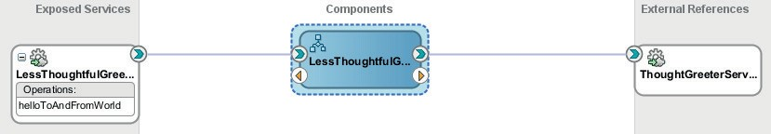

**FIGURE 12-9.** *The SOA composite that exposes a synchronous interface that is backed by*

*an asynchronous back end—with the synchronous-asynchronous decoupling handled by the BPEL component*

Open the editor for the BPEL component. Add an *invoke* activity that calls the partner link for the *ThoughtfulGreeterService*. Configure the activity to call the *helloToWorld* operation on the *ThoughtfulGreeter* portType. Create an input variable for this call. Because this is a one-way operation, there is no output variable to be configured.

The BPEL component will subsequently have to wait for the asynchronous response to come in. To make this happen, we need to add a *receive* activity, just under the *invoke*, and also wire it to the *ThoughtfulGreeterService* partnerlink. However, this time the activity is configured for the *helloFromWorld* operation in the *ThoughtfulGreeterCallback* Port Type, as Figure 12-10 shows.

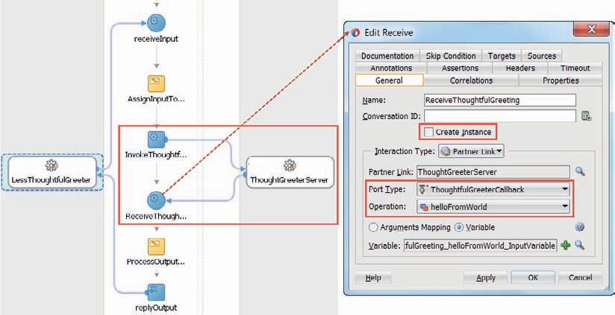

**FIGURE 12-10.** *Configuring the Receive activity that handles the reception of the asynchronous*

*callback*

Make sure that the checkbox *Create Instance* is unchecked in the *receive* configuration: in this case we want to receive the message via the partner link in an existing instance and not create a new instance. Unchecking this checkbox means that the BPEL engine upon reception of the asynchronous callback message will attempt correlation with a running instance—based on the RelatesTo WS-Addressing header property.

###### NOTE

*When the asynchronous service that gets invoked does not support use of the WS-Addressing Relates To property, we can manually define the correlation identifier in the callback message that should be used to associate that message with a running instance. This correlation mechanism is introduced in the next section.*

Finally, add *assign* activities to prepare the input to the *ThoughtfulGreeterService* and to set the *outputVariable* based on the callback message that gets received. Figure 12-9 shows the complete BPEL process.

The SOA composite can now be deployed and its (synchronous) service interface tested. This will demonstrate how BPEL can easily adapt from an asynchronous conversation style to a synchronous one. It can also do the reverse: publish an asynchronous interface while itself interacting with synchronous services.

###### TIP

*There is no reason why there cannot be other activities between the invoke and the receive activity. When the thread executing the BPEL process instance gets to the receive activity, the instance is dehydrated, or compressed and stored, and the thread released.*

*When the callback message arrives, another thread is given the task of reviving the instance and executing the receive activity.*

#### Invoking an Asynchronous Service in Service Bus

The previous section described how elegantly a BPEL component can interact with an asynchronous service. The heavy lifting is done by the engine and as a developer, there is hardly any difference between invoking a synchronous service or an asynchronous one.

Service Bus is stateless and does not have these same facilities for correlating incoming messages. When the callback message comes into to the Service Bus runtime, it is no different from any other (request) message. The callback message needs to be handled by a proxy service, just like any other message. Note that the asynchronous business service can be HTTP/SOAP, but also JMS, EJB, AQ among others.

Service Bus cannot invoke an asynchronous service in the implementation of a synchronous interface. There can be no link between the original synchronous request and the processing of the callback message from the asynchronous business service.

Calling an asynchronous service from Service Bus in the implementation of a one-way service is perfectly possible. The endpoint of the callback proxy service is passed in the ReplyTo header property. This proxy is invoked by the asynchronous service and may continue the next stage in the one-way service implementation.

If the Service Bus should virtualize an asynchronous back end—it can only do so with an asynchronous interface, as shown in Figure 12-11; unlike BPEL it cannot adapt from asynchronous to synchronous. At the end of the processing that starts at the proxy service that handles the callback message, we need to callout to the callback service endpoint stipulated by the external consumer that started the whole conversation. That in turn requires us to transfer the ReplyTo and MessageId properties received in the original call to the asynchronous business service and hope to receive them back in the callback message. Figure 12-12 shows the two-step dance we have to perform in Service Bus.

This means that in order for the Service Bus to completely virtualize the asynchronous business service, it is required that the original ReplyTo value—the address of the *ThoughtfulGreeterCallback* service in Figure 12-12—is somehow passed to the proxy service that is invoked by the business service with the callback message.

There seem to be two main ways to approach this challenge:

1. Have the asynchronous business service pass on the original ReplyTo value—for example, by including it in a (custom) header property that is passed unchanged or by concatenating this value to the message identifier.
2. Have the first proxy service save the ReplyTo address to a (cross cluster) cache— associated with the message identifier as key—and have the second (callback) proxy service retrieve this ReplyTo address from the cache, using the RelatesTo property in the callback message as the key value.

If you have control over the asynchronous service, then the first approach is the easiest. Simply agree on the header property that the invoker may pass in and the asynchronous business service

Client of One-Way Service

One-Way Proxy Stage1

SomeBusinessService (asynchronous)

CallbackProxy (Stage 2 of One-Way)

**Service Bus**

WS-Addressing RelatesTo

WS-Addressing ReplyTo, Messageld

**FIGURE 12-11.** *Calling an asynchronous business service from a Service Bus project; passing the*

*endpoint of the “next stage proxy service” as the callback service in the ReplyTo header property*

ThoughtfulGreeter Client

WS-Addressing ReplyTo Messageld

helloTo ThoughtfulGreeterProxy

World (one-way)

helloTo World

ThoughtfulGreeterService (asynchronous)

ThoughtfulGreeterCallback

helloFrom World

helloFrom ThoughtfulGreeter

World CallbackProxy (one-way)

**Service Bus**

WS-Addressing ReplyTo, RelatesTo

WS-Addressing ReplyTo & originalReplyTo,

Messageld

**FIGURE 12-12.** *Virtualizing an asynchronous business service in Service Bus using two one way*

*proxy services*

will pass through. If the asynchronous service to virtualize cannot be changed in this way, you can either manipulate the message identifier (if the business service sets the RelatesTo property based on the MessageId), or resort to the second approach.

The story for Mediator component is largely the same. This component too is stateless and does not have engine-level infrastructure to handle asynchronous callback correlation. The solution would be similar to what is described for the Service Bus.

### Request Proposal for Airport Service

The COO of Saibot Airport is anxious that operations on the airport run smoothly. Not just when Saibot Airport itself is involved in interactions with airline carriers or other parties performing business activities on or around the airport, but also when various parties have direct interaction without involvement from Saibot. To increase the attractiveness of Saibot for passengers, business partners and especially airline carriers, it is deemed crucial to foster fast, efficient, flexible and consistent business operations.

One area where this desire to have business run smoothly is around aircraft services. Every plane requires a number of services after arrival and before departure. Examples of these are baggage handling, fueling, power and water supply, cleaning (inside and out), small repairs, and catering. Many airlines request these services and a substantial number of companies active on Saibot Airport offer (a subset of) these services.

Saibot has taken the lead in organizing automated, electronic exchange around these services, by specifying a web service interface that any company has to offer if they want to be eligible for performing aircraft services for the airline carriers. When the carriers have scheduled

a flight for which they need help with catering or cleaning, they will send requests for proposal to the web services exposed by all companies that can supply aircraft facilities. The service specified by Saibot is an asynchronous service where a carrier can request a quote for some (combination of) services regarding a flight. After whatever internal processing the aircraft service providers have to go through in order to prepare their response to the RFP, the callback with the price quote is made to the airline carrier that initiated the RFP.

In this section we will briefly introduce the service interface that Saibot’s IT staff has defined.

Next, we will look at an implementation of the *AircraftService* using BPEL to make the asynchronous callback. We then create a second SOA composite to acts as the requestor of the proposals. This composite also contains a BPEL process—that invokes the *AircraftService* provider and waits for the asynchronous callback to arrive.

Finally, we extend this BPEL process to simultaneously call out to multiple

*AircraftServiceProviders* and wait for their proposals in parallel.

#### Introducing the AircraftService

The *AircraftService* defines two portTypes—the “normal” one that is implemented by the aircraft service provider and the callback portType that will be invoked by that provider and that therefore has to be implemented by anyone who invokes the *AircraftService* and wants to receive the asynchronous response.

The *requestProposal* operation is invoked to request a proposal from a supplier of aircraft services. The request contains information about the services to be provided—fuel, cleaning, catering, baggage handling, etc. —for which flight—aircraft type, time slot, flight number, destination, number of passengers—and what the deadline is for the quote. The one-way *submitProposal* operation in the callback interface is invoked with a message that contains an indication from the supplier whether he is able to provide the requested services, what the price is for these services and until what time the offer is valid.

#### Implementing the Asynchronous AircraftService with BPEL

The starting point of this implementation of the *AircraftService* interface that the airport people came up with is obviously the WSDL with its associated XSD documents. Using these, we can create an SOA composite application that exposes a service based on that interface, implemented by a BPEL component that adheres to the same interface.

In just a few steps, we have the foundation of the composite application:

* Create a new SOA application in JDeveloper—called *AircraftServices*—with SOA composite called *AircraftServiceProvider*—based on the *Empty Template*.
* Add a BPEL component called *AircraftServiceRequestProcessor*; this component is based on the AircraftService.wsdl document. The BPEL component is exposed as a SOAP

Service at the composite level

The SOA composite is shown in Figure 12-13. The BPEL component exposes the one-way interface and invokes the callback interface to deliver the proposal.

Open the BPEL editor for the *AircraftServiceRequestProcessor* component. The receive and asynchronous invoke (i.e., the callback) activities are already created and wired to the PartnerLink. All we need to add are an Assign activity—to provide some semi-meaningful content

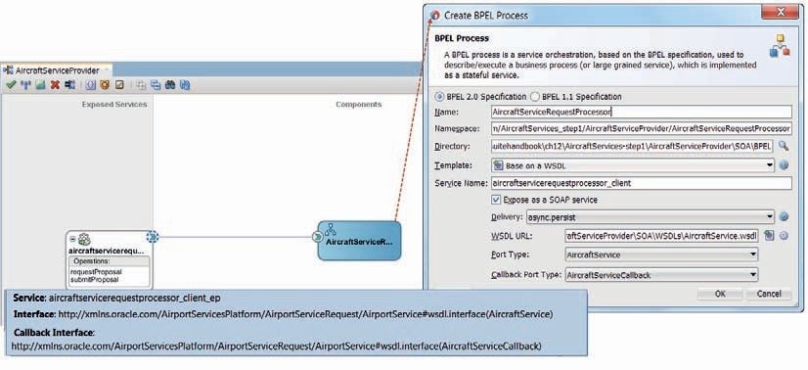

**FIGURE 12-13.** *A BPEL based implementation of the asynchronous AircraftService interface*

for the callback message and a Wait activity—to appear not too eager and to simulate real life at least to a little extent.

This is all that is required to implement the asynchronous interaction. Because the BPEL engine takes responsibility for the asynchronous details such as manipulating the WS-Addressing headers, the developer hardly even notices that the interaction is in fact asynchronous rather than straightforward synchronous request/reply.

You can deploy the composite and test it using EM FMW Control. There will not be a visible response, but by checking the flow trace you will be able to verify if the call back response took place. Using SoapUI with a mock service to implement the callback interface and providing

the proper WS-Addressing header properties, we can find out if the callback message is correctly returned.

#### Implementing the AircraftServiceOrchestrator

An airline carrier—or a party that acts as a broker between carriers and service providers—has to implement an orchestrator: a mechanism to coordinate the search for a party to deliver the required aircraft services. This mechanism has to invoke the *AircraftService* exposed by as many applicable service providers as possible, handle the actual proposals they submit through their asynchronous callbacks, keep an eye on deadlines and collect the results and make or recommend a selection.

We have seen how BPEL is good at invoking asynchronous services and handling the callbacks that deliver the responses. Dealing with multiple parallel activities and maintain the state of the overall activity for some time is definitely something BPEL is well equipped for. Hence we will create an *AircraftServiceOrchestrator* composite to organize the RFP interactions for an airline carrier.

This composite exposes a web service with two operations—*arrangeAircraftService* and

*cancelAircraftService*. The first one initiates and coordinates the proceedings to ask aircraft service

suppliers for their proposals and collect their responses. The second is used to abort the proceedings and is discussed in a later section.

##### Create the AircraftServiceOrchestrator SOA Composite

The steps for creating this composite are very similar to those seen in the previous section:

* Add an SOA project called *AircraftServiceOrchestrator* to the application AircraftServices; have the project be based on the *Empty Template*.
* Add a BPEL component called *AircraftServiceNegotiationProcessor*; this component is based on the AircraftServiceNegotiation.wsdl document. The BPEL component is exposed

as a SOAP Service at the composite level

We want the BPEL component to be able to call out to aircraft service suppliers who expose their implementation of the *AircraftService* that was implemented and deployed in the previous section. Obviously, in real life, there will be many implementations of this service, each with the same interface and their own endpoint. We will deal with that situation later on. For now, we will just create the interaction from the BPEL component with the one *AircraftService* instance we know of—the one we deployed in the previous section.

Drag the SOAP component from the palette to the references swim lane, to create a reference binding for the external *AircraftService*. Set the name of the reference to *AirportServiceProvider*. Select the AircraftService.wsdl document. Select the *AircraftService* and *AircraftServiceCallback,* respectively, for the Port Type and Callback Port Type properties. Press OK.

JDeveloper will show a warning about the abstract nature of the WSDL document: because it only describes the functional interface without providing a port with an actual endpoint where the service is available, we do not yet have enough information to successfully deploy and run our composite. However, to continue its implementation, there is no problem. Acknowledge the warning and continue.

Wire the BPEL process to the *AircraftServiceProvider* Reference Binding. The SOA composite is shown in Figure 12-14.

##### Implement the AircraftServiceNegotiationProcessor Component

The BPEL process accepts a request message—with a service request identifier and details about the required aircraft amenities—and replies immediately with a response that contains that same identifier and also the final time at which the process will summarize all proposals.

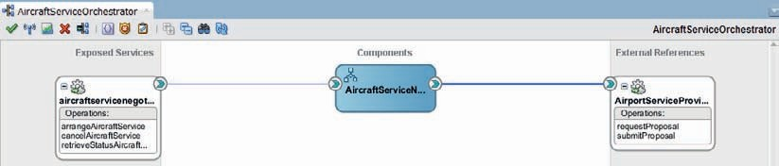

**FIGURE 12-14.** *The AircraftServiceOrchestrator that uses AircraftService Providers to collect*

*proposals to deliver a type of aircraft service*

When this synchronous reply is returned to the invoker, the BPEL process will invoke one *AircraftServiceProvider*, passing the details from the aircraft service request as well as the RFP identifier and the deadline for responding. This call is one way; it initiates an asynchronous conversation that ends with the callback from the service provider. However, when the asynchronous response is not received before the deadline, then the process will cease waiting and complete immediately. At this point, we focus on the asynchronous interaction and the

wait-until-deadline-or-callback and the BPEL process does not actually collect and further process the proposals.

Open the BPEL editor to implement the process as described above. The *receive* and *reply* activities are already created. Define two global variables—*RFPIdentification* of type xsd:string and *Deadline* of type xsd:dateTime. Add an Assign activity—called *SetGlobals*—following the Receive. Set these two variables to:

* + RFPACS<ServiceRequestIdentifier><DDMMYY>
  + 36 hours before the actual service delivery date—which would be done using the expression: xp20:add-dayTimeDuration-to-dateTime($inputVariable.part1/

ns3:ServiceDeliveryDate, ‘-P1DT12H’); for testing purposes you can also just set the current time plus 5 minutes

Next, add an Assign activity to set the *outputVariable* for the synchronous response. This variable contains the service request identifier and the deadline by which the proposals will be gathered.

Finally, add a scope called *ExecuteRFP* underneath the Reply activity. This is where the actual collecting of proposals will be done. The BPEL process now looks as is shown in Figure 12-15.

Next, add an Invoke activity—wired to the one way interface of the *AircraftServiceProvider* partner link; have this activity use a local input variable. Also add a Receive activity for consuming the callback message from the *AircraftServiceProvider* partner link. This is where BPEL

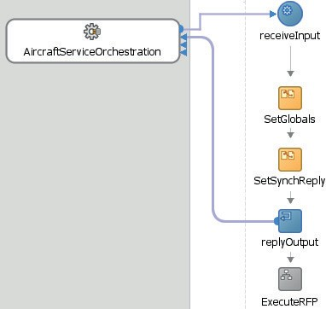

**FIGURE 12-15.** *The synchronous first part of the AircraftServiceNegotiationProcessor*

really shines: receiving a callback message (i.e., an asynchronous response) is about as simple as receiving a synchronous reply. Create another local variable, to hold the callback response.

Add an Assign activity—called *SetInputForRFP*—prior to the Request. In this Assign step, make the necessary mappings between the *inputVariable* and the two globals (*RFPIdentifier* and *Deadline*) to the local input variable for the call to the *AircraftServiceProvider*.

The second part of the BPEL process is shown in Figure 12-16.

At this point, we can almost deploy and run the composite. In a later section we will add the “wait for deadline” functionality that is currently lacking. At that moment, we will add parallel call to a second *AircraftServiceProvider*.

##### Complete, Deploy and Run the AircraftServiceOrchestrator

The composite is not yet ready for deployment. Remember how the reference binding for the *AircraftServiceProvider* was based on the abstract WSDL that we selected from the file system. This WSDL did not provide a concrete port and endpoint which means our composite knows what the service looks like but does not know where to find it. Before we can successfully deploy, we have to specify the exact address of the service.

In later chapters, we will discuss the use of a configuration plan, to provide during deployment the environment specific endpoints for external services. For now, let’s make simple modification to the composite.xml file.

First, open the WSDL document for the *AircraftService* composite that was deployed earlier in this chapter. You can do so from the EM FMW Control. Locate the Port element in the WSDL document. The combination of the *name* attributes of the Service and Port elements in the live WSDL document supplies the value for the wsdl.endpoint in the *port* attribute of the binding.ws element (Figure 12-17). The *location* attribute of the binding.ws element is set based on the *location* attribute in the soap:address element in the *port* element of the live WSDL and indicates the real endpoint address.

When the binding.ws element in the composite.xml file has been completed, we can deploy the composite to the SOA Suite run time. After the deployment, we can invoke the *arrangeAircraftService* operation to commence the proceedings for enlisting an aircraft service provider to help out with fuel, cleaning, catering, and baggage handling for a specific flight.

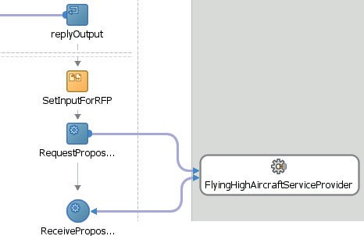

**FIGURE 12-16.** *The asynchronous interaction with a single AircraftServiceProvider*

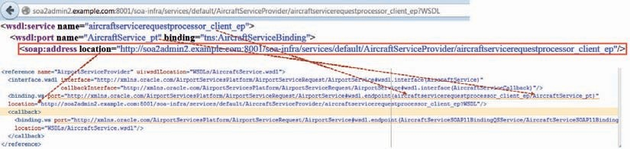

**FIGURE 12-17.** *Derive the concrete binding for the composite.xml reference definition from the*

*live WSDL document for the AircraftServiceProvider*

The trace flow for a request to this operation could look like Figure 12-18.

#### Implementing the Asynchronous AircraftService with ServiceBus

A second implementation of the *AircraftService* can be created using Service Bus. Earlier in this chapter, we have seen how an asynchronous interface is implemented in Service Bus using a callout to a business service after setting the endpoint address based on the WS-Addressing header in the original request. The steps are as follows:

* + Create a new application with a Service Bus project *AircraftServiceProvider.*
  + Add the AircraftService.wsdl and the associated XSD document.
  + Add bindings to the WSDL for both the port types.
  + Create a Proxy Service *AircraftServicePS* for the one way port type and generate an associated pipeline; set the endpoint to */FlyingHighAircraftService/*

*AircraftServiceProvider.*

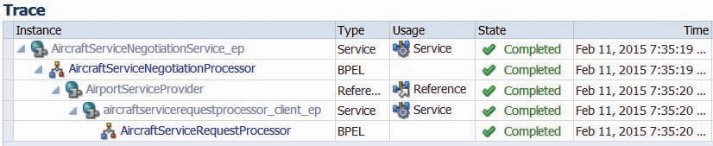

**FIGURE 12-18.** *A call to operation arrangeAircraftService on the AircraftServiceOrchestration*

*service triggered the AircraftNegotiationProcessor and its asynchronous interaction with the AircraftServiceProvider; the callback message from the AircraftServiceProvider is smoothly fed back into the right instance of the AircraftNegotiationProcessor by the BPEL run-time framework*

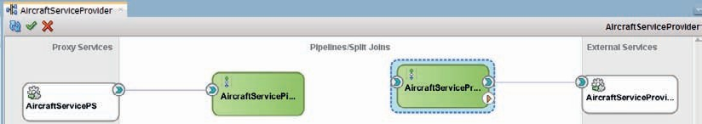

**FIGURE 12-19.** *The Service Bus project that implements the asynchronous AircraftService—with*

*one way request and deferred callback*

* Create a Business Service (*AircraftServiceProviderCallbackBS)* based on the callback port type. Also create a second pipeline (*AircraftServiceProviderCallbackPipeline*), based on

the one way interface also implemented by the proxy service and the other pipeline. Add a *publish* activity in this second pipeline and have it publish to the business service and its *submitProposal* operation.

The Service Bus project is shown in Figure 12-19.

The first pipeline will publish its request to the second pipeline. Through this publish operation, the thread that is handling the reception of the incoming request is immediately released.

This second pipeline contains three stages—as is shown in Figure 12-20:

1. Gather WS-Addressing details in local variables.
2. Prepare the $body with the callback message.
3. Publish to the callback business service; however, before the call to the business service is actually made, we dynamically set the endpoint for this call to have it routed to the callback endpoint found in the WS-Addressing headers in the original request message instead of to the callback pipeline.

Details about the exact implementation can be found online.

We can test this asynchronous service using SoapUI, in the same way we have seen before.

#### Extend the AircraftServiceOrchestrator

We now have two services to invoke—presumably offered by two different companies active at Saibot Airport. Let’s extend the *AircraftServiceOrchestrator* to support this situation. That means that our BPEL process will have a Flow activity. This is a standard BPEL activity that supports parallel activities. In this case, both branches in the Flow will perform an Invoke to the one way interface of the *AircraftService* to request help with our aircraft and then they will both await the asynchronous callback.

Later on, we will build in the deadline observation—to ensure the BPEL process does not wait longer for callback messages from aircraft service providers than the set deadline. We could even further extend this example to dynamically derive a list of services to invoke, instead of working with just these two hard coded ones.

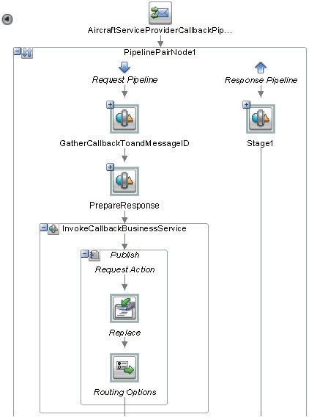

**FIGURE 12-20.** *Implementation of the Callback Pipeline with three stages: extract WS-*

*Addressing headers, compose callback message and publish callback message to dynamically selected endpoint*

**Integrate the Asynchronous Service Bus-Based AircraftService into the Composite** First, we have to determine the endpoint for the *AircraftServicePS* exposed from the Service Bus. Navigate to the Application Servers window and open the Service Bus node for the Integrated WebLogicServer. Under this node, expand the project folder for *AircraftServiceProvider*. Right click in the *AircraftServicePS* node and select Open from the context menu.

The WSDL document is retrieved from the run time and opened in JDeveloper. The location attribute in the address element in the port yields the endpoint. Add ?WSDL to this URL to get the WSDL location.

Open the SOA composite editor for the *AircraftServiceOrchestrator* composite. Add a SOAP Reference binding in the External References swim lane. Set the name to

*FlyingHighAircraftServiceProvider*. Paste the endpoint determined in the previous step into the WSDL URL field. The Port Type is selected automatically. Press OK to create this Reference binding.

Wire the BPEL process to the new reference binding; it is after all our intention to invoke this reference from the BPEL process.

##### Invoke the Second AircraftService Provider from the BPEL Process

Parallel activities are realized in BPEL processes through the Flow activity. A Flow contains two or more Sequence activities that are executed concurrently. This means, for example, that in two branches in the Flow activity an asynchronous call to an external service can be made with both branches waiting for a reply at the same time. Obviously this is more efficient than having to wait for the first response to come in before the second request can be sent out. With a flow, the time it takes for the slowest service to respond determines the processing time of the overall flow, not the times of all calls added together.

Open the *AircraftServiceNegotiationProcessor* BPEL process. Open the scope *ExecuteRFP*. Add a Flow activity to the process, immediately after the *SetInputForRFP assign* activity. Drag the invoke and receive activities—wired to the *AircraftServiceProvider* partner link—to the first branch in the flow. Add an invoke and a receive activity to the second flow branch. Associate these activities with the *FlyingHighAircraftService* partner link. The same input variable can be used for calling this new partner link as is used for the call to the *AircraftServiceProvider* partner link. The second part of the process now has two parallel activity branches—one for each *AircraftService* provider, see Figure 12-21.

At this moment, the BPEL process can only continue processing activities that come after the *flow* activity when the entire flow has completed. That is, when both callback proposals have been received from the two service providers. We need to add a mechanism to monitor our deadline: when we hit the deadline, we have to move on and stop waiting for these callback messages to arrive.

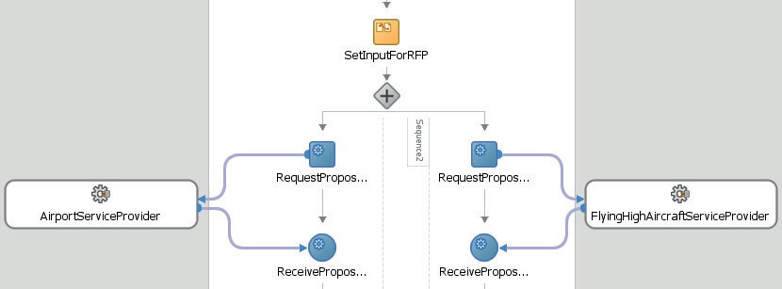

**FIGURE 12-21.** *Flow activity with parallel branches to do the asynchronous interaction with two*

*different service providers simultaneously*

### Introduce Some Asynchronous Interaction to the BPEL Process

A BPEL process can engage in various forms of asynchronous activity. We have seen how the process can wait for the callback message that is effectively the reply from an asynchronous partner [link]. Such a callback message is expected—even though we do not know when—and even if—it will arrive.

Another asynchronous activity we can introduce into the BPEL process is a background timer that runs for a certain period or until a certain deadline. When the timer fires, specified action is taken. The *AircraftServiceOrchestrator* will be made to wait no longer than until the deadline for deciding on a service provider arrives.

And in a similar way, we can have background message listeners that listen for request messages—not callback responses in reaction to previous service invocations from the BPEL process but unexpected new messages.

In this section, we will allow the airline carrier that initially called the *AircraftServiceOrchestrator* composite to invoke a cancel operation on the *AircraftServiceOrchestrator* service to stop the RFP proceedings. This should result in a similar message being sent to all aircraft service providers to inform them of the cancellation of the RFP. This last call, however, is outside the scope of this chapter.

Along similar lines we could have the carrier ask for the status of the proposal and even provide additional information such as an updated number of passengers or a changed slot time.

The ability to call a running instance of an SOA composite is quite special. It relies on a mechanism in BPEL called *correlation*. Through correlation, a request message can be associated with an existing BPEL process instance, rather than initiate a new one as normally would happen.

#### Add Deadline Monitor to AircraftServiceOrchestrator

A *scope* in BPEL is like an encapsulated unit that in addition to a set of activities can have its own local variables, fault handlers, compensation handlers as well as (asynchronous) event handlers. An event handler specifies an asynchronous agent that runs for as long as the scope is running and can do one of two things: wait for a specific moment in time and then act, or receive an incoming message of a specific type and act on it.

Select the *scope* in the *AircraftServiceOrchestrator* BPEL process that contains the flow with the two calls to AircraftServiceProviders. In the icon palette on the left side of the scope, click on alarm clock icon to add an OnAlarm event handler, as shown in Figure 12-22. JDeveloper adds the handler to the scope. Click on the OnAlarm activity to open its editor. Set the radio button to Until—to trigger the alarm at a specific moment—and specify $Deadline as the expression for the time at which the alarm should be triggered. Rename the scope in the event handler to *HandleDeadlineExpiry*. As a first and ultimately crude way of dealing with the deadline expiry, add an *exit* activity to this scope. Note that the OnAlarm handler is only ever activated when not all aircraft service providers send their proposal callback message before the deadline.

In order to see the OnAlarm in action, you want to change the deadline values and manipulation a little bit—or make the *AircraftServiceProvider* a bit slower.

After redeploying *AircraftServiceOrchestrator* composite, we can try out the added logic. Invoke the *arrangeAircraftService* operation with perhaps an early deadline. If the OnAlarm

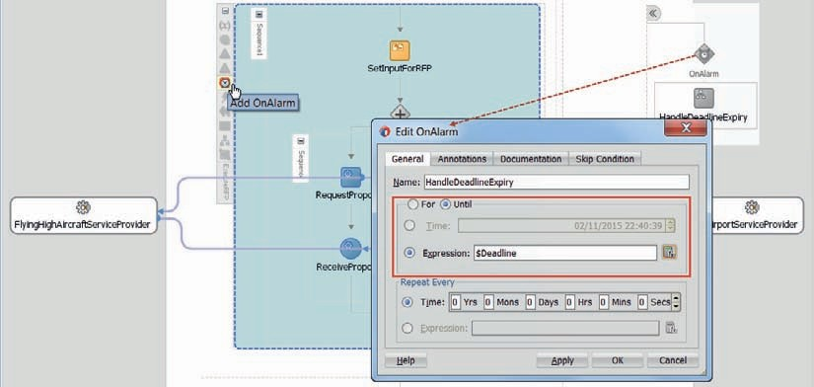

**FIGURE 12-22.** *Configuring an OnAlarm event handler for scope ExecuteRFP, to be triggered*

*when the deadline is reached*

trigger fires, the flow trace and audit flow will indicate this. See Figure 12-23. Note: Since we did nothing to inform the *AircraftServiceProviders* about the deadline expiry, their process instances completed normally—even though their responses could not be handled by the negotiator because of the alarm that terminated normal processing.

#### Use Correlation to add a Cancel Operation to the AircraftServiceOrchestrator

BPEL has a unique capability among all the service engines and languages in the SOA Suite: a BPEL process can receive even after it has started running—and this goes beyond processing synchronous or even asynchronous responses to service invocations. Most computer programs are initiated by an original invocation and return a result once they are complete—they cannot easily or at all be accessed from the outside while they are running. A BPEL process can expose multiple operations—one of which will initiate the instance while others feed messages into a running instance.

We have already seen how BPEL processes can continue to run after they have returned a synchronous or asynchronous response message. To this special behavior we now add the capability of receiving subsequent messages—either by explicitly waiting for them to arrive or by handling them as unsolicited events. In both instances, the key ingredient to this functionality is a BPEL mechanism called correlation—the ability to match an incoming message with one of potentially many running instances.

Receiving messages into a running instance can be done using a Receive activity. Another method is through an onMessage event handler that we can attach to a scope in the BPEL process.

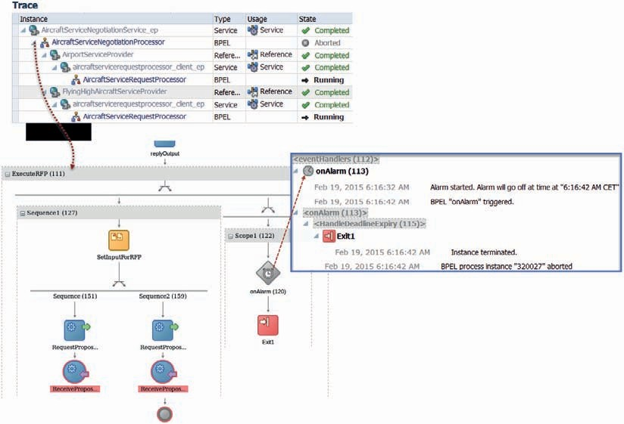

**FIGURE 12-23.** *Message Flow Trace and Audit Trail for AircraftServiceOrchestrator after*

*asynchronous OnAlarm event handler has triggered—and has cut short the execution of the scope*

###### TIP

*A third method for a running BPEL process instance to deal with incoming messages is inside the Pick activity. A BPEL Pick activity is included in a sequence like any other BPEL activity. It, too, deals with events: It instructs the BPEL engine to pause the BPEL process instance until one of potentially many events occurs. The events, as in the case of the event handlers, are either the elapsing of a certain time duration or the reception of a specific message. Unlike the event handlers*

*that sit idle in the background for the entire lifespan of the scope, impacting the BPEL process only when the event they are listening for occurs, the Pick activity stalls the process—or at least the branch in which it lives, because there can be other branches in a common Flow parent—until one of the events for which it is configured takes place. No activity that follows the Pick activity is executed unless one of the Pick events occurs.*

The cancellation can arrive at any time, from the moment the initial request for aircraft services was submitted until the time the RFP is complete and the selection of a service provider is made. It enters our SOA infrastructure as a web service request that should be fed into the BPEL process instance that was created and is still running for that particular aircraft. The BPEL process instance receives the request in the relevant event handler and should then complete the instance entirely.

The cancellation web service request needs to specify exactly which aircraft service request has to be cancelled—just like we would have to do when we cancel such an earlier request by telephone or email. The service request is identified by the identifier that was part of the initial request message. Alternatively, we could also determine an identifier inside the BPEL process and return it in the synchronous reply.

This identifier is used by the SOA Suite run time to associate the incoming cancellation request with the correct running SOA composite application instance. A precondition for this is that the used identifier should be unique across all process instances. The mechanism that makes this match between an inbound request and an existing instance is called correlation.

**Correlation for the AircraftServiceOrchestrator**

Correlation in general deals with the following scenario: A request message arrives at the SOA Suite. It is not intended to start a new composite application instance. Instead, it needs to be routed to an already running instance. It is up to the engine to find the correct instance to hand the message to. In this case, the request to cancel an RFP needs to be handed to the instance that was created for that particular aircraft service request. Refer to Figure 12-24 for an illustration of this.

Of course, the engine needs to be able to extract some sort of identifier from the request message to correlate that message with a running instance. In our example, the *AircraftServiceOrchestrator* was initially invoked with a message that contains a *ServiceRequestIdentifier* which for the purpose of this discussion we assume to unique across all calls to the *AircraftServiceOrchestrator*.

Any subsequent interactions regarding the service request should contain this identifier, and each running instance of the *AircraftServiceOrchestrator*, too, should be identifiable through that identifier. It is the linking pin to correlate new request messages with running instances.

**197**

**FIGURE 12-24.** *Correlation between an incoming message and running composite application*

*instances through a BPEL component*



ServiceRequest Identifier #361

**SOA Suite**

**...**

Cancellation request

**AircraftServiceN...**

**AircraftServiceN...**

**AircraftServiceN...**

**?**

**AircraftServiceN**

**183**

**361**

**23**

Correlation of instances of composite applications is built on the correlation of BPEL process instances; a composite application without a BPEL service component does not support correlation. The message that needs to be correlated to a running composite application instance needs to be sent into the BPEL component—and therefore be sent to a service exposed by the application that is wired to the BPEL component.

In order to make the correlation mechanism work, we have to configure the BPEL process to recognize the *serviceRequestIdentifier* as that correlation key.

An instance of a BPEL process can be identified for correlation using a correlation set. Such a correlation set is a combination of one or more properties, in a way that is very much like a composite primary or unique key database constraint. Properties are defined at the process level, are of a certain type, and are mapped to values in the messages sent from or received by the process. A BPEL process can have multiple correlation sets—just like a database table can have multiple unique keys.

The *AircraftServiceNegotiationProcessor* has a single correlation set that consists of a single property. Let’s call this set the *ServiceRequestIdentifierSet*. We can create a correlation set from the drop-down menu in the bar on top of the BPEL process editor, shown in Figure 12-25.Call the correlation set *ServiceRequestIdentifierSet*. Add a single property called *ServiceRequestIdentifier*, of type String.

Hereby we specify that instances of the *AircraftServiceNegotiationProcessor* BPEL process can be uniquely identified by correlation set *ServiceRequestIdentifierSet* using only the value of this property.

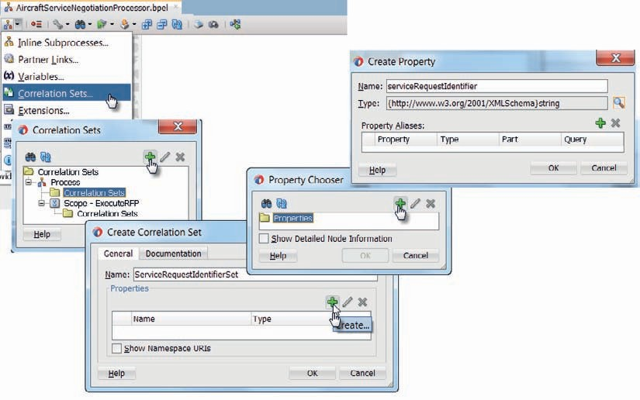

**FIGURE 12-25.** *Creating the correlation set ServiceRequestIdentifierSet and the*

*ServiceRequestIdentifier property for the AircraftServiceNegotiationProcessor*

However, what is the value of that property? When and how is that determined? How does the property relate to the variables in the BPEL process or the messages sent to or from the process?

Correlation always takes place in the context of a message exchange. Either when the BPEL process is receiving a message (onMessage and Receive activities) or when it is sending a message (Invoke and + Reply) does correlation come into play. And only at such times does the engine need to establish the values of the properties in the correlation set that is attached to the message exchange.

The value of a property is associated with the content of the messages sent to or from the process at such exchange moments. For example, the *serviceRequestIdentifier* property gets its value from the outgoing *ArrrangeAicraftServiceResponseMessage* that is returned from the process in the first, synchronous Reply activity. When the cancellation message exchange takes place, the property will get its value from the incoming *CancelAircraftServiceRequestMessage*.

These associations between the property and a particular message exchange are specified using property alias definitions. A BPEL process can contain one or more property aliases that map a property to a specific message part—and to be precise, a specific XPath expression to extract a value from within that message part. This message part is used in the exchange through one of the partnerLinks in the process.

In the case of the *AircraftServiceNegotiationProcessor*, we will have two property aliases, because the *ServiceRequestIdentifier* is associated with two message exchanges (initial aircraft service request and cancellation). These property aliases can be created from the *edit* property window that can be opened using the edit property icon on the correlation set window. This is shown in Figure 12-26. In the Query field, we must specify the XPath expression to retrieve the

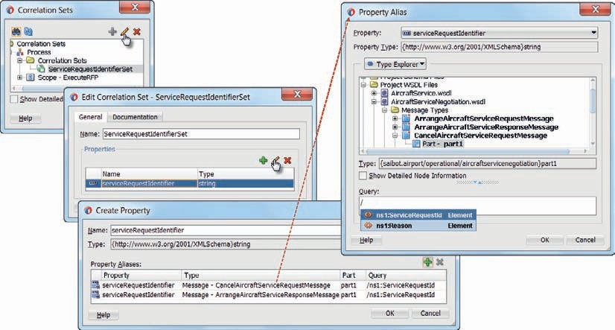

**FIGURE 12-26.** *The correlation definitions for the AircraftServiceNegotiationProcessor:*

*the correlation set, the property, and the two property aliases*

value for the property. Hint: Pressing ctrl-spacebar brings up a list of available XML elements to add to the XPath expression.

The identity of the process instance (the values in the correlation set) is established only once—obviously, because that cannot change later on. Establishing the identity takes place through initialization of the correlation set and capturing the values of the properties in the set at that moment in time. In our case, this happens when the *ArrrangeAicraftServiceResponseMessage* is sent by the synchronous reply operation labeled *arrrangeAicraftService*. The value of the *ServiceRequestId* element in the *ArrrangeAicraftServiceResponseMessage* element in the response message is read and set as the value for the *ServiceRequestIdentifier*—a value that will never change for the instance of the BPEL process.

On each subsequent message exchange, the identification of the process instance, as determined in the correlation set, can be compared to the value as extracted from incoming messages. That allows the engine to link the incoming message to the instance with the same value for the correlation set.

The steps in the correlation processes are as follows:

* 1. The synchronous Reply activity initiates the correlation set, and the value is extracted from the response message and used to set the instance identifier.
  2. The value for the *ServiceRequestIdentifierSet* correlation set is extracted from the incoming Cancellation Request message based on the property alias defined for that message and compared with the identifiers for all running instances to find the matching instance.

The final step in making correlation work like this is to configure the activities that send (Reply) and receive (onMessage handler) the messages that need to be correlated.

First of all, the Reply activity. This activity is special because it needs to instantiate the correlation set. Open the editor by double-clicking the Reply activity. Go to the Correlations tab. Click the green plus icon to add a correlation set that is associated with this message exchange. Select the *ServiceRequestIdentifierSet*. You need to set Initiate to *yes* to indicate that this Reply step is the moment when this correlation set is instantiated and the identifier for this process instance is set. Figure 12-27 illustrates these steps.

Through this definition, we have ensured that when this Reply activity is executed, an instance of this BPEL process is assigned an identity that can be used for correlation purposes.

As an aside, a BPEL process can have multiple identities through multiple correlation sets that have different properties and different values, and can be established at different points in time. The *AircraftServiceNegotiationProcessor*, for example, could have a second correlation set that also identifies the aircraft service request through a combination of the flightNumber and the date and time of the slot.

##### Correlation for the Aircraft Service Request Cancellations

We have laid the foundation for the capability to receive a cancellation request for an aircraft service request. We have configured a correlation set and ensured that the instance identity is determined when the synchronous reply takes place.

Next, we have to add an on [message] event handler to the scope *ExecuteRFP* to handle reception of an *CancelAircraftServiceRequestMessage* when the *cancelAircraftService* operation is called on the *AircraftServiceNegotiation* service. Then we need to configure this onMessage handler to support correlation for this message exchange. Double-click the on event icon to configure the message exchange it will implement. Figure 12-28 illustrates these steps.

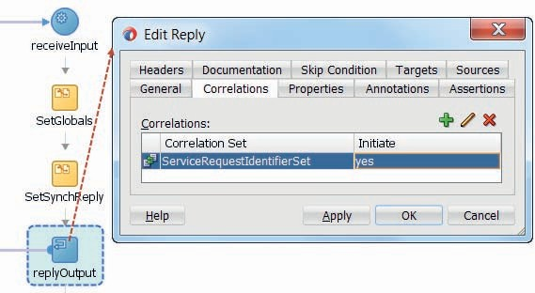

**FIGURE 12-27.** *Configuring the correlation set ServiceRequestIdentifierSet and its initiation for*

*the Reply activity*

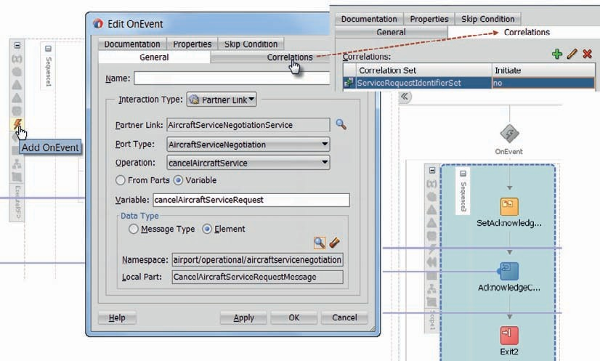

**FIGURE 12-28.** *Configuring the message exchange and correlation for the onMessage branch*

*that will handle the cancellation requests*

The partner link involved in the on (message) event activity is the *AircraftServiceOrchestration*.

The relevant operation in the port type associated with this partner link is the *cancelAircraft* operation. Specify the (input) variable as *cancelAircraftServiceRequest* based on the *CancelAircraftServiceRequest* element on which the request message is based.

Next, click the Correlations tab. The only correlation set that is involved with this on event activity is the *ServiceRequestIdentifierSet*. It should not be initiated, because that already happened through the outgoing message sent from the Reply activity; for cancellations, we will use the value assigned to the property in the correlation set at that time to correlate with the incoming cancellation message’s property value.

To add some degree of decent cancellation handling, add a *reply* activity to the scope inside the onEvent handler. This activity provides the synchronous reply to the cancellation request; it is associated with the *AircraftServiceOrchestration* partner link. Have a local variable generated to hold the response and add an *assign* activity to set the value for this variable with some form of acknowledgement of the cancellation request. Then, as a very crude way that suffices for now, add an *exit* activity to terminate the instance of the *AircraftServiceNegotiationProcessor*.

Deploy the AircraftServiceOrchestrator composite. Invoke the service on its arrangeAircraftService operation. Then, shortly after that call, call the service again, this time on its cancelAircraftService operation, passing in the same value for ServiceRequestId as in the first call. This should result in an AircraftServiceOrchestration process instance being started and being interrupted and aborted by the cancellation request. Figure 12-29 shows the flow trace and the audit trail for this process instance. Note the second call to the AircraftServiceOrchestration_ep service binding; this one does not start a new instance of the composite but is correlated with and fed into the running instance, based on the ServiceRequestId.

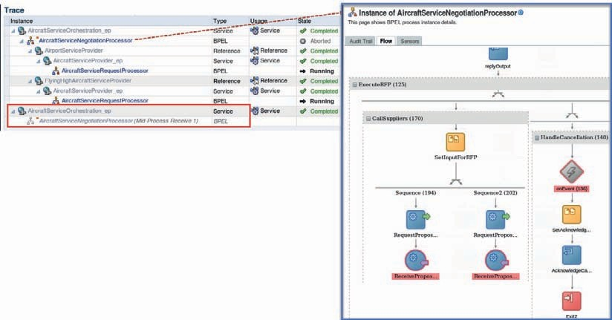

**FIGURE 12-29.** *Flow trace and BPEL audit trail for the AircraftServiceOrchestration composite*

*instance that is cancelled through a correlated service call*

##### Correlation and Asynchronous Service Calls

Correlation is the primary mechanism used by the SOA Suite run time to match up incoming messages with existing instances of composite applications. Yet we did not discuss correlation when we introduced the implementation of our calls to asynchronous services, even though the response from an asynchronous service such as the *AircraftServiceProvider* is returned in the form of a service call to the *AircraftService* callback portType, handled through the partnerlink by the *AircraftServiceNegotiationProcessor*.

The reason for this is that the BPEL engine handles this automatically under the covers using the WS-Addressing standards. In other scenarios we have to implement/configure this ourselves because the components we interact with are not BPEL components. We do not need to make any changes to the BPEL process, the composite definition, or the WSDL file in order to leverage the WS-Addressing method for correlation between BPEL process instances and the asynchronous services they invoke. The BPEL engine run-time framework will add headers to the SOAP message that is sent when an asynchronous Web Service is invoked. These headers—based on the WS-Addressing specification—contain the endpoint location (reply-to address) that specifies the location at which a BPEL client is listening for a callback message and the Conversation ID, which is a unique identifier for the BPEL process instance that sent the request.

When the asynchronous service sends the response by invoking the callback service, it can use the information from the WS-Addressing headers to target the response at the right client. When the asynchronous service is itself a BPEL process, like one of our *AircraftService* providers, the headers are leveraged automatically by the BPEL engine, completely transparently to us as developers.

There are several situations where the built-in, default WS-Addressing correlation mechanism does not suffice when we invoke an asynchronous service. One of those is the case where the asynchronous web service provider does not support WS-Addressing and correlation is required to map the response message to the process instance. Another case is a more complex conversation pattern that involves more than two communication partners and a final response that is not returned by the partner that received the original call that started the conversation.

See the FMW documentation for more information about WS-Addressing, the way it is used in the BPEL engine, and ways to inspect the contents of the SOAP message (and the WS-Addressing headers) using an OWSM logging policy or TCP/IP Listener.

#### Retrieve Current RFP Status from Running AircraftServiceOrchestrator

A BPEL process cannot only receive a correlated message once, for example, to end the process, it can also receive multiple requests and return synchronous responses for each one of them. In this section, we will extend the process to support the ability for the airline carrier to retrieve the

status of the RFP while the orchestrator is still doing the negotiations. We will make use of a BPEL Inline Subprocess that is invoked from each of the parallel branches in the flow to add the aircraft service proposal to a global collection of all proposals. Then we will add a second OnEvent handler to the *ExecuteRFP* scope that receives another correlated message—for the *retrieveStatus* operation that we will add to the portType in the WSDL.

##### Extend the Service Interface Definition

Open the AircraftServiceNegotiation.xsd document. It contains the proposalsListType that is used in the RetrieveStatusAircraftServiceNegotiationResponseMessage. The RetrieveStatusAircraftServiceNegotiationRequestMessage contains a ServiceRequestId element— that should be somewhat familiar by now.

Open the AircraftServiceNegotiation.wsdl document. Add two messages and also one operation in the portType:

 <wsdl:message name="RetrieveStatusAircraftServiceNegotiationRequestMessage">

<wsdl:part name="part1" element="acsn:RetrieveStatusAircraftServiceNegotiationRequestMessage"/>

</wsdl:message>

<wsdl:message name="RetrieveStatusAircraftServiceNegotiationResponseMessage">

<wsdl:part name="part1" element="acsn:RetrieveStatusAircraftServiceNegotiationResponseMessage"/>

</wsdl:message>

<wsdl:operation name="retrieveStatusAircraftServiceNegotiation">

<wsdl:input message="tns:RetrieveStatusAircraftServiceNegotiationRequestMessage"/>

<wsdl:output message="tns:RetrieveStatusAircraftServiceNegotiationResponseMessage"/>

</wsdl:operation>

##### Extend the AircraftNegotiationProcessor Process

Open the BPEL editor for the *AircraftNegotiationProcessor*. Create a new variable, called *collectedProposals*, based on the proposalsListType in the XSD document. In this variable, we will collect all proposals received from our suppliers of aircraft services.

Add a Scope activity to one of the flow branches. In this scope, add an Assign activity. This activity has to append a proposal element to the *collectedProposals* variable. Right click the scope and select the option *Convert to Subprocess*.

Define two variables for the subprocess—as its input parameters; see Figure 12-30 for details.

One is called *proposal*—based on SubmitProposalCallbackMessage that is received from the aircraft service providers—and the other is called *supplier* and is of type string.

Edit the Assign activity to copy all values from the proposal variable to the global *collectedProposals* variable, including the name of the supplier. Figure 12-31 shows this Assign activity.

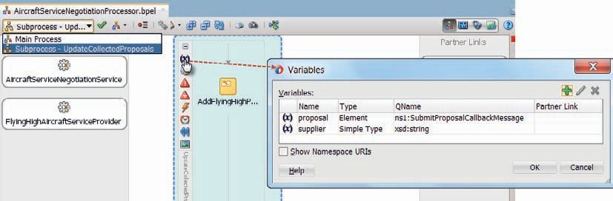

**FIGURE 12-30.** *Define the input parameters for the UpdateCollectedProposals sub process: the*

*received proposal and the name of the supplier who made the proposal*

Add and edit calls to the subprocess from each flow branch. Map local variables to the input parameters to the subprocess, as shown in Figure 12-32.

Add a property alias for property *ServiceRequestIdentifier* to allow correlation of messages sent to the *getStatusRFP* operation. This time, the property is mapped to the *ServiceRequestId* element in the *RetrieveStatusAircraftServiceNegotiationRequestMessage*, as shown in Figure 12-33.

Add an OnEvent handler to scope *ExecuteRFP* for the *retrieveStatus* operation in the *AircraftServiceOrchestrator* service. Configure the correlation set to hook into this event handler, as shown in Figure 12-34.

Add a reply activity for the *retrieveStatus* operation with a generated local variable and add an assign activity to add the contents from the *collectedProposals* variable to this output variable.

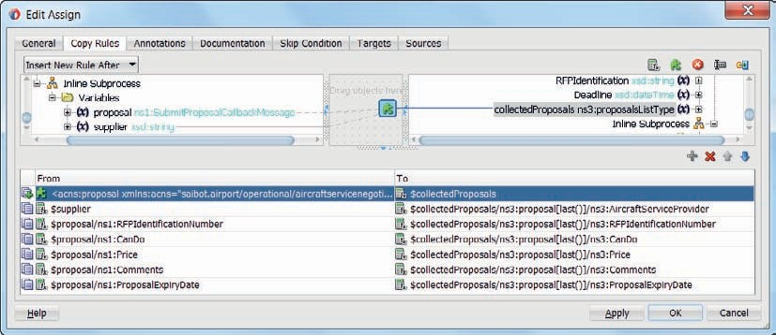

**FIGURE 12-31.** *The Assign activity that copies details about a supplier’s proposal to the*

*collectedProposals collection*

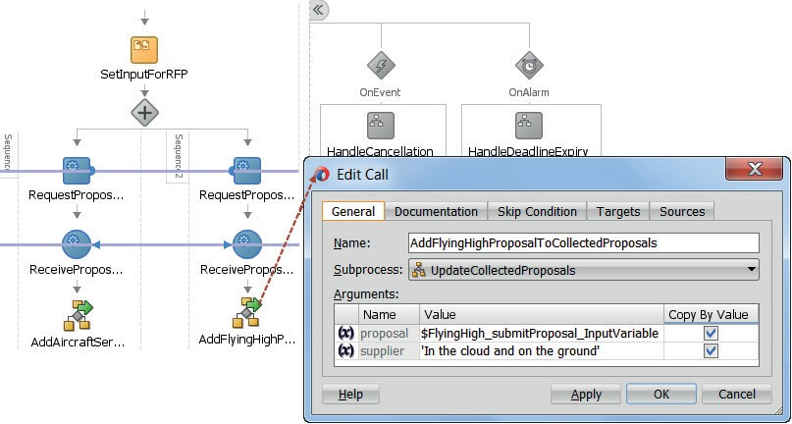

**FIGURE 12-32.** *Configuring the call to the BPEL inline Subprocess to add the received proposal*

*to the collection of proposals*

###### TIP

*To have a little more time to ask for the status of a running instance, you could add a* wait *activity after the flow activity inside scope* ExecuteRFP *to force the instance to run a little longer.*

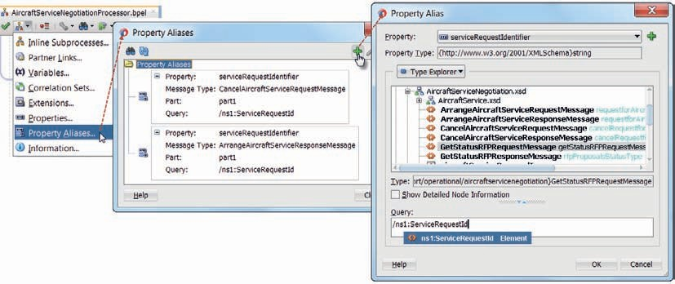

**FIGURE 12-33.** *Adding a property alias for the GetStatusRFPRequestMessage*

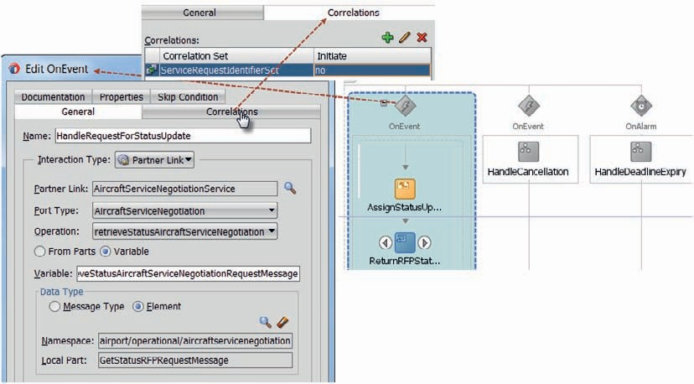

**FIGURE 12-34.** *Configure the OnEvent handler to handle the request message to the*

*retrieveStatusAircraftServiceNegotiation operation with correlation enabled*

Deploy the composite. Invoke the *AircraftServiceOrchestrator* composite as before, calling the arrange operation. Now you can invoke the composite again, this time invoking the *retrieveStatus* operation and passing the same identifier as in the call to the arrange operation. The current status should be returned; its value depends of course on whether the aircraft service providers have already sent their proposal to the orchestrator. Figure 12-35 shows the

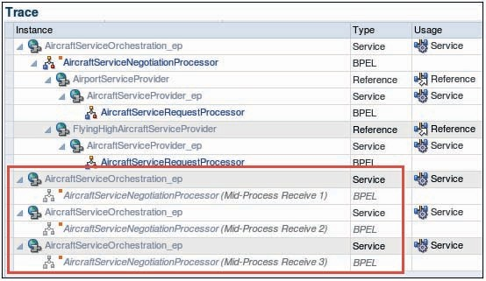

**FIGURE 12-35.** *Message flow trace with three mid-process, asynchronous calls to the retrieve*

*status operation*

message flow trace for the *AircraftServiceOrchestrator*; the three asynchronous, mid-process status retrieval calls are indicated.

Note that you can invoke the *retrieveStatus* operation multiple times. When you invoke the operation before the *arrange* operation is called—that initiates the composite—then the BPEL engine will remember the request and process it as soon as the *arrange* operation has been invoked to instantiate the BPEL process.

The BPEL audit trail for the interactions shown in Figure 12-35 are shown in Figure 12-36.

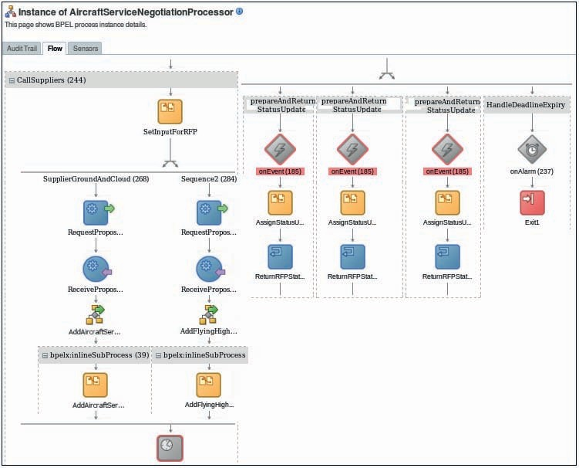

**FIGURE 12-36.** *The BPEL flow trace for the AircraftServiceNegotiationProcessor with two*

*asynchronous interactions with aircraft service providers and three correlated mid-process status retrieval requests*

### Summary

Asynchronous interactions are important in the real world as well as in a service oriented architecture. Tying up resources in synchronous exchanges when the synchronicity is not required is a waste. SOA Suite provides good support for asynchronous message exchanges—both for accessing asynchronous service provides as well as for implementing asynchronous service interfaces.

While Mediator and Service Bus have some support for asynchronous interactions, it is a little lower level and requires manipulating WS-Addressing headers. BPEL is ideally equipped for asynchronous exchanges—both for implementing them as well as for initiating them. The BPEL engine handles all addressing and correlation details; as a result, the developer hardly even notices that an interface is asynchronous rather than synchronous.

In addition to an asynchronous “request followed by callback” pattern, we have in seen this chapter how BPEL can accept subsequent requests into an already running process instance through correlation. Such requests can be explicitly waited for in the main process ‘thread’ or they can arrive as asynchronous events in the process, handled by an event handler. Another type of asynchronous or background event handler is provided by the OnAlarm mechanism that can interrupt the main flow when a deadline has been reached or a certain period of time has passed.



CHAPTER

# 13

## Inbound Adapters— Polling Database, Consuming JMS, and Receiving Emails

OA composites or Service Bus projects do not have to be triggered through a request message from an external consumer. The adapters we have discussed for outbound operations towards databases, file systems, JMS destinations, Advanced Queues, and people

**S**

(UMS through email, SMS and chat) also operate in an inbound direction. In this direction, external events activate the adapter to trigger the proxy service or SOA composite. This includes events such as a new file appears, a database record is updated, a message is published on a JMS queue or topic or an email or chat message arrives.

This chapter demonstrates the use of these inbound adapter actions. These are quite valuable to have our SOA applications quickly respond to events in boundary systems—even though these are not explicitly published as business events. The inbound mode of the adapters mean we do not have to write all kinds of polling logic to keep track of what is going on in various channels and systems around us.

Specifically, this chapter discusses the inbound database adapter mode to spot new or changed database records, the JMS queue listener, and the inbound mode for the UMS adapter, which will monitor incoming emails and chat messages.

### Database Polling for Staged Slot Requests

Data manipulation is ideally done through services only. However, the reality is that in many organizations there are existing applications that directly update database tables—without going the proper service route. It is very well possible that these direct inserts or updates of database records should trigger activity at service and process level—in the SOA Suite. These data manipulations may represent business events that our services need to respond to.

The database adapter was first introduced in Chapter 4. Then we used this adapter to reach out from the Service Bus project or the SOA composite to the database—to invoke PL/SQL stored programs or to query data from tables and views. This adapter also supports an inbound mode— where the initiative lies with the adapter instead of with the service. In this section we will use the inbound mode to inspect a table where an external Portal application and an internal application for Saibot’s account managers can write slot requests—database records that represent a desire from an aircraft carrier to take possession of a certain slot.

In this section, we have to develop a SOA composite that will find these slot request records in the database table and process them—making a call to the *SlotService* for proper registration of the slot allocation in the Future data domain. This composite will poll the table with slot requests. For each record found, a new instance of the SOA composite will be initiated.

#### Prepare Environment

For the SOA composite we are about to develop to poll records from a database table, we need of course to first create that table. The table we will be checking for new records is called *PORTAL_SLOT_ALLOCATIONS*. It is created through the DDL scripts in the on line resources for Chapter 13. The table contains 10 columns that describe a slot allocation request for a particular air carrier.

Additionally, just like the outbound database adapter bindings we discussed in Chapter 5, the inbound adapter binding references (the JNDI name of) a connection specified in the database adapter deployment, that itself uses a JDBC Data Source that connects to the database schema that contains the table. The required configuration steps for the database adapter are described on line.

#### Create SOA Composite

Create a new SOA application *InboundProcessing* with an SOA composite project called *PortalSlotRequestProcessor*. Select the template *Composite with Mediator*. Set the name of the Mediator to *PortalSlotRequestMediator* and choose to define the interface later.

The inbound interface for this mediator will be defined by the inbound database adapter binding in a little while.

##### Configure Inbound Database Adapter

Drag the Database Adapter to the Services swimlane—because in this case the adapter binding will initiate the SOA composite instance and as such act as the service in the SCA meaning of that term. Set the name of the adapter binding to *PortalSlotRequestPoller*. Use the same Saibot database connection as in chapter 4 and set the JNDI Name to eis/DB/SaibotCommonDB— corresponding to the JNDI name of one of the connections defined for the Database Adapter deployment in the run time SOA Suite environment. In step 3 we have a novelty: select *Poll for New or Changed Records in a Table* as the operation type. This operation is only meaningful for inbound database adapter bindings.

On the next page, you have to indicate the table that should be polled: PORTAL_SLOT_ ALLOCATIONS. Then, in step 8, you can specify the behavior for the Database Adapter after processing a record, see Figure 13-1. Depending on how the records to be processed are identified and which privileges the SOA composite application has on the source table, we can choose from a direct update of the database record that was processed (an update or even a delete) or we can indicate that the identifier for each record that has been processed showed be inserted in a different table (in the same or another database as the one being polled) or in a file (locally on the SOA Suite environment).

Whenever possible, it is common to use the logical delete option that will update a particular column for the records that have been processed.

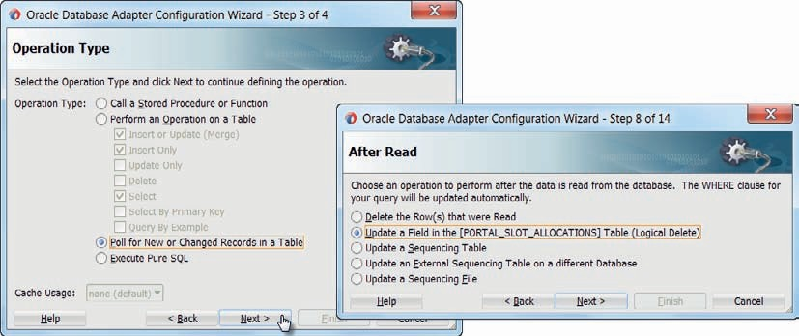

**FIGURE 13-1.** *The inbound mode of the database adapter will poll for new or changed records*

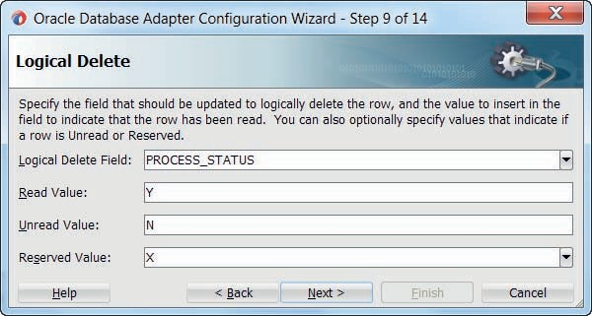

**FIGURE 13-2.** *Configure the details for the Logical Delete on processed database records*

If we pick the option to Logically Delete records after processing, we get to specify the details for this logical delete in step 9 (Figure 13-2). Select column PROCESS_STATUS as the column that will indicate the status of the record. The value Y will indicate the record has been read and processed. The value N for this column identifies records that have not yet been processed. The Reserved Value X is used to mark records that are currently being processed. Records will have this value only briefly.

The next step in the wizard is for the Polling Options (Figure 13-3). In this step we specify the polling frequency; every 20 seconds in this example will do. We set the number of database records that will be passed in a single SOA composite instantiation; we set this property to one, as will usually be the case. The number of database rows picked up in a single transaction is set to two in this case; this means that every 20 seconds, every instance of this database adapter will fetch a maximum of two records from the table and will create one instance of the SOA composite for each record. The number of workers—instances of the database adapter—is determined by two additional properties: *activationInstances* in a clustered environment and *NumberOfThreads* in a multithreaded single node set up.

###### TIP

*If you want to implement your own logical delete mechanism, you can. In that case, select Delete the Row(s) that were Read in step 8 and after the wizard is completed, edit the generated ..-or-mappings*

*.xml file and edit a <delete-query> section that specifies the SQL to execute for each record to be logically deleted.*

Order by can be used to specify the sort order in which unread records should ideally be processed. However, no guarantees are available as to the actual order in which the resulting messages are processed, so it is best to avoid this option altogether.

Check the Distributed Polling check box. This instructs the Database Adapter to use a SELECT .. FOR UPDATE SKIP LOCKED syntax when fetching records from an Oracle database, a syntax that optimizes throughput and reduces negative impact from multiple workers.

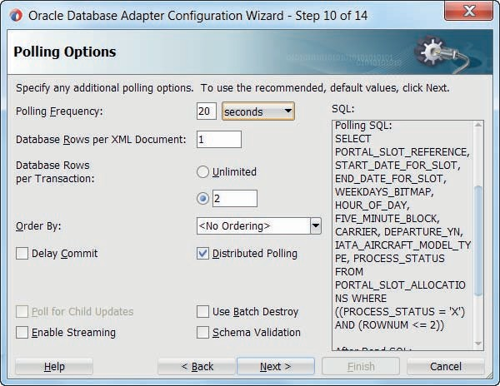

**FIGURE 13-3.** *Configure the polling options to indicate how often the table should be inspected*

*and how many records should be processed per service instance and per transaction or polling event*

Check the documentation for the other, more advanced and/or exotic options. Press Next to go to step 10—Defined Selection Criteria. This step allows us to further refine the SQL statement that should be executed to fetch records to process. Accept the default statement and continue to press Next until the Finish button is enabled. Accept all intermediate defaults and press Finish to complete the configuration of this inbound database adapter binding.

##### Create Reference Binding for Slot Service

We want to invoke the *SlotService* that was created in Chapter 4 (and reused in Chapter 7) for each slot allocation request that the inbound database adapter will hand to the current SOA composite. Therefore, a Reference binding should be added to the composite for the *SlotService*.

Right click in the External References swimlane can select Insert | SOAP from the dropdown menu. Enter the URL for the *SlotService’s* WSDL: http://localhost:7101/flight/SlotService?wsdl. Set the name of the reference to *SlotService*. Press OK. Allow the localization of all files. As a result, the WSDL document and associated resources are copied to the project.

##### Configure the Mediator

In this case, as so often, the mediator component is really the man in the middle. Wire the inbound database adapter binding to the mediator, as shown in Figure 13-4. Wire the mediator the *SlotService* reference binding.

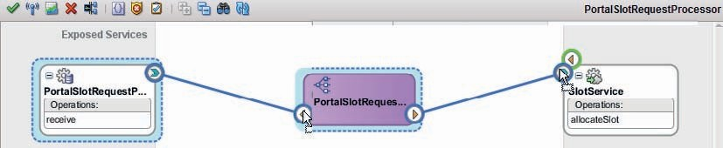

**FIGURE 13-4.** *The PortalSlotRequestProcessor composite with an inbound database adapter*

All we need to do now is map the XML message (structure) that the database adapter will feed into the SOA composite to the message structure expected by the *SlotService*. The former is described by the PortalSlotRequestPoller_table.xsd file that was generated by the Database Adapter wizard. Create a new XSL Map file inboundPortalSlotRequestToallocateSlotRequestMessage.xsl that maps between the *PortalSlotAllocationsCollection* and the *allocateSlotRequestMessage*.

Edit the Mediator: configure the routing rule to use this XSL Map for the transformation of the request message.

#### Deploy and Test

With the SOA composite application complete, we can deploy it. When done, there is not

a service interface that we can invoke for this composite. Its entrance is through the inbound database adapter, which polls the database table.

After deployment, the polling of the database will immediately commence. After the polling interval passes, the *PORTAL_SLOT_ALLOCATIONS* table is inspected for any (new) records with status equal to N. For each record retrieved, a new instance of the SOA composite will be created that gets handed the XML representation of the database record as its request message, with a maximum of two instances per polling interval (in the case of a single adapter instance). The composite transforms the message and passes it on to the *SlotService* for proper processing. The outcome of entire transaction is that a new record is added to table *FUT_SLOTS*.

When we insert three or more records into table *PORTAL_SLOT_ALLOCATIONS* and wait for approximately 20 seconds—we can find the flow trace shown in Figure 13-5 in the EM FMW Control.

Additional unprocessed records will have to wait for the next polling interval to be also retrieved and handled.

#### Inbound Adapters and Exceptions

When processing of inbound messages fails, there is no explicit party to send an error message to. The inbound database adapter is only the man in the middle—picking up records from a table and handing them to the SOA composite. When exceptions occur in or beyond the SOA composite, the SOA composite instance fails. We have to set up fault policies or manual procedures to deal with those failed instances.

Additionally, the inbound adapter can be configured with a rejection handler to deal with rejected messages. A distinction is made between retryable errors—caused for example by

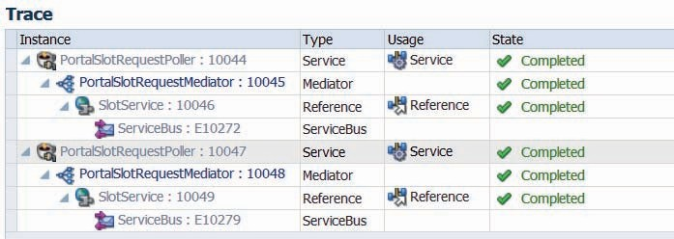

**FIGURE 13-5.** *A single polling action by the inbound database has fetched two database*

*records and created an instance of the SOA composite for each of them; these instances invoked the SlotService (on the Service Bus) that used the outbound database adapter to created records in table FUT_SLOTS*

connection issues—and non-retryable faults, as a result for example of transformation errors or even unhandled business exceptions. A special category of rejection that can be handled is when the inbound adapter does not even get to the stage of handing a message to an SOA composite because of internal issues, for example with the transformation of the native data into the XML format configured with the adapter binding.

A database record that is fetched by the inbound adapter will be logically deleted (have its logical delete status set to *Read*) when the processing leads to a failed SOA composite instance. The recovery has to take place for the SOA composite; at that point, the database record is considered done.

#### Scaling Inbound Adapter Activity

An inbound database adapter could cause a large load to be put on the SOA Suite server: if, for example, an import operation or some batch creates or updates a large number of database records or the inbound database adapter becomes active after a long downtime, you might expect that a large number of SOA composite instances could be created almost instantaneously.

Fortunately, there are tuning parameters available on the adapter binding definition:

* *activationInstances—*the number of concurrent instances of the DB Adapter that is created to process database records in a distributed cluster scenario. In a multithreaded

single node scenario, configure *NumberOfThreads* instead.

* *MaxTransactionSize—*the maximum number of records an DB Adapter instance will process in a single transaction and therefore in a single polling interval.
* *PollingInterval—*the wait time between reads by an DB Adapter instance.
* *MaxRaiseSize—*the number of database records that is to be processed by a single SOA composite instance.

From these parameters, we can calculate the maximum load the SOA Suite engine can be put under as a result from the inbound DB Adapter binding:

The largest number of database records processed per second is calculated as MaxTransactionSize/PollingInterval * activationInstances. For example: with a MaxTransactionSize of 150, 6 activationInstances and a PollingInterval of 5 minutes, no more than 150/300 * 6 = 3 records can be processed per second (although we handle this in bursts per 5 minutes

per instance).

We can compare this to the traffic we expect to see whether our set up will be able to cope in the long run. This does not tell us however how large the effort is to process a single database record so we do not know if in terms of throughput and resources we will actually get those three records processed per second.

To increase scalability and decrease mutual impact from concurrent instance of the DB Adapter, use the Distributed Polling strategy. On an Oracle Database this means that records are fetched using “SELECT FOR UPDATE SKIP LOCKED” which means that polled records are locked, locked records are ignored and no wait time is incurred because of existing locks. This is the by far most efficient way of reserving and fetching batches of records for a DB Adapter instance without any impact on other instances.

Just so you know: inbound adapters can be switched on and off through the embedded Enterprise Scheduler. This allows us for example to respect maintenance windows of external systems. Chapter 14 will provide more details on this.

##### Breaking up BPEL Processes Using Inbound Database Adapter

A BPEL process can be long running. This happens typically when the BPEL process will wait for external actions*—*either messages to arrive from external systems or actions performed by human agents. The BPEL infrastructure however is not ideally suited to very long running process instances. Some considerations include the size of the dehydration store, the deployment of new versions of the SOA composite and an upgrade of the SOA Suite run time environment. Instances that run for days or (much) longer are ideally avoided.

Sometimes the logic of the BPEL process dictates the long running nature. That is just the way the business functionality is defined. At various moments, spread over time, stages of the process have to be performed, each one triggered by a certain external event*—*which can be just the passing of time. And each stage needs access to at least some of the state of the process (instance).

If the stages in the BPEL process are activated by deadlines or by events other than correlated message exchanges, then it may be an option to create separate BPEL processes for each stage and have each of these stage-processes activated through in inbound database adapter that watches for deadlines and status changes. Each stage starts by retrieving the state information and concludes by recording the updated state information for the process instance.

Figure 13-6 visualizes this approach. The original BPEL process*—*indicated by the surrounding rounded rectangle*—*has been split into multiple stage-specific process definitions. Stage 0 initiates the process instances in the regular way, based on a SOAP request. When stage 0 is done, the BPEL component records the state that should carry over to the next stage, using a reusable BPEL subprocess. This subprocess uses a custom format (probably XML based) to record the relevant state in a custom table in a database schema.

SOAP

Service Binding

*Overall Business Process*

BPEL

Stage 0

BPEL

Stage 1

external systems

BPEL Sub

Retrieve State

BPEL Sub

Record State

Process instance State

Process instance deadline & state registry

BPEL

Coordinator

BPEL

Stage 2

BPEL

Stage 3

BPEL Sub

Register Deadline

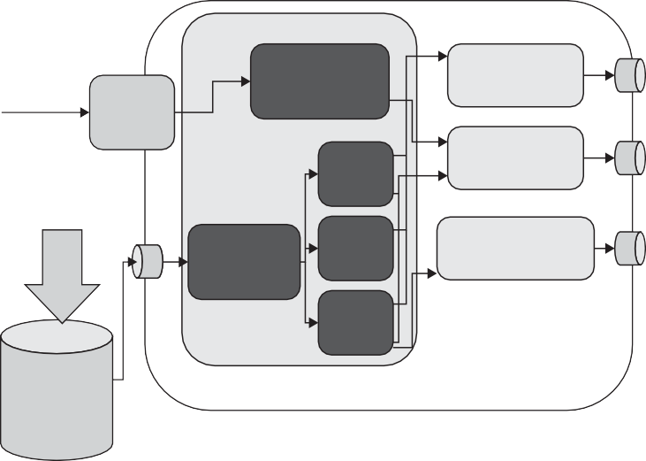

**FIGURE 13-6.** *Breaking up a long-running BPEL process into multiple stages— triggered by an inbound database adapter based on deadline or status changes*

The inbound database adapter monitors a table that holds records for process instances of this specific SOA composite. Each record represents a (running) process instance. The records can trigger the database adapter, either through a status or through a deadline.

When a deadline is passed or the status is set to a specific value, the inbound database adapter triggers a new instance of the SOA composite and invokes the Coordinator BPEL process. The coordinator determines from the current process status read from the database which stage should be executed. It then invokes the BPEL process component for that stage*—*passing the instance identifier of the process.

The BPEL process for the selected state uses this instance identifier to retrieve the process state from the custom process state repository. When the state has been restored, the actions for this stage are executed by the BPEL process. When the stage is complete, the component will record the state the process instance has now reached. It may also write a deadline record or a new status value for the process instance. At that point, the composite instance is done processing. No running instance is left around at the level of the SOA Suite. Only in the custom table we may still have the potential for a next stage to be executed for the business process.

Each stage specific process instance will run for a short duration. The entire business process consists of all stages and may run for days, weeks or even months*—*without introducing all the drawbacks of such long running instances (but introducing a nonstandard process coordinator mechanism that will not produce an end to end message flow trace*—*because to the SOA Suite, each stage is a new conversation). Using composite sensors is at least a way to be able to quickly find all related SOA composite instances for a single business process instance. Note that this approach is similar to what we can do in the BPM Suite with BPMN processes and probably even more so with adaptive cases.

### JMS Queue Reading on Behalf of the Financial Department

The *AircraftMovement* messages that were put on the JMS queue in Chapter 6 make a reappearance here when through the inbound mode of the JMS adapter, they trigger a Financial Department’s Service Bus service. Note: We are using the JCA adapter for JMS in a Service Bus project, only to see how inbound adapters can be used as easily with Service Bus projects as with SOA composites*—*there is no special preference from the products themselves to use inbound JCA adapters with one or the other. The Service Bus project can instead of using the JCA adapter for JMS also leverage the JMS Transport in inbound mode*—*that is a little lighter weight than the JCA-based approach.

We will see how to the pipeline in the Service Bus project, it makes absolutely no difference whether its input originates with an inbound adapter or with a more common incoming SOAP request.

#### Create the Service Bus Project

Create new Service Bus application and project, both called *FinancialAircraftMovementProcessor*. Copy the Schemas folder from the *AircraftMovementService* project that you worked on in Chapter 6 to this new project. This folder contains the schema definition for the messages that the new project will consume from the JMS Queue.

#### Add the Inbound JMS Adapter Binding

Drag the JMS Adapter from the Advanced category in the Component palette to the Proxy Services swimlane.

The adapter configuration wizard appears. Set the name for the inbound service to *ConsumeAircraftMovementMessages*. In step 2, choose Oracle Enterprise Messaging Service and select Oracle WebLogic JMS as the implementation.

On the Adapter Interface step, accept the default of Define from operation and schema (specified later). Press Next. In the Operation page, select the *Consume Message* radio button. Set the operation name to *ConsumeAircraftMovementMessage* (this value is quite arbitrary). Click next to go to the Consume Operation Parameters page, shown in Figure 13-7.

Select the jms/finance/AircraftMovementsQueue as the [JMS] Destination Name. Despite the confusing name*—*Destination*—*we are configuring the JMS queue or topic here from which we want this adapter binding to consume messages. The message body type is *TextMessage*. We will not use a MessageSelector. The JNDI name for the JMS [Adapter] Connection is eis/Finance/ Queue (also see the next section). Click Next to proceed.

The last page of the wizard is for specifying the schema that describes the message that is consumed from the queue. Select the *reportAircraftMovementRequestMessage* element from the AircraftMovementService.xsd. Click Next and then Finish. The Proxy Service is now created as is the JCA file with the adapter configuration.

Right click in the central area of the Service Bus overview editor. Select Insert | Pipeline. Call the new pipeline *ProcessAircraftMovementPipeline*. Click next to go to the second page of the wizard, see Figure 13-8. Select the WSDL radio button. Click on the gears icon to generate the

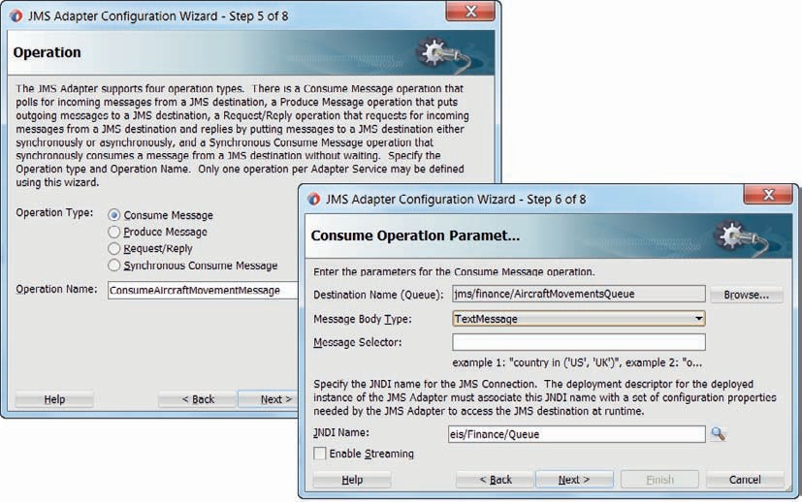

**FIGURE 13-7.** *The crucial steps in the inbound JMS adapter configuration wizard*

WSDL that this pipeline will expose. Accept all defaults*—*including the One Way Interface type. Specify a single input parameter, based on the same *reportAircraftMovementRequestMessage* from the AircraftMovementService.xsd that we used in the JMS adapter configuration.

Also expose the pipeline through a Proxy Service called *ProcessAircraftMovementPS*. Click Finish to create the pipeline.

Wire the proxy service *ConsumeAircraftMovementMessage—*created with the inbound JMS adapter*—*to this pipeline. This means there are now two channels to the pipeline: one through the one-way SOAP Web Service exposed through the *ProcessAircraftMovementPS* and the other from the JMS queue through the inbound adapter and the *ConsumeAircraftMovementMessage* proxy service, as shown in Figure 13-9.

Double click on the pipeline to open its editor. Create a really simple implementation right now, because all we want to show is how the inbound JMS adapter will allow the financial department at Saibot Airport to consume the aircraft movement message that were published by a service in an entirely different department.

Add a pipeline pair. Add a [Message] Report action to the request pipeline. Set the content to

$body*—*so you will be able to see the entire message that is retrieved from the JMS Queue. Define a search key called *FlightnumberForAircraftMovement* and have it return the flight number from the body variable. Save your changes.

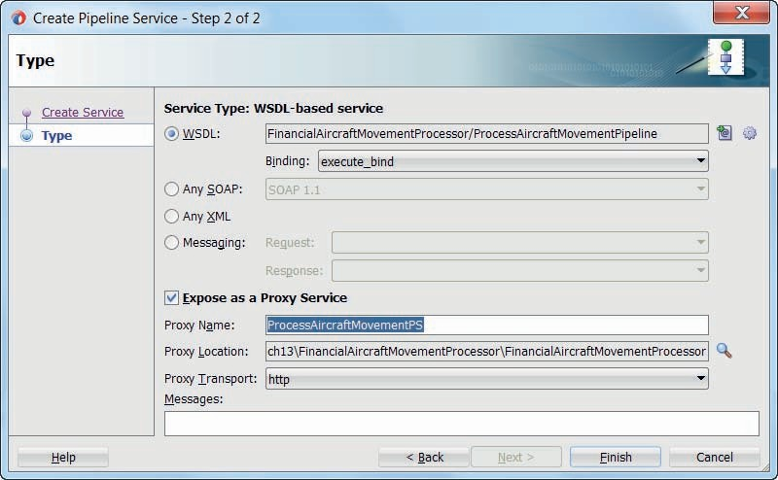

**FIGURE 13-8.** *The configuration for the Pipeline Service ProcessAircraftMovementPipeline*

#### Configure JMS Adapter

Before we can meaningfully deploy the Service Bus project, we have to prepare the JMS Adapter deployment.

In Chapter 6 we already configured the JMS Adapter on the WebLogic Server for the queue we are now discussing. A connection was added through the WebLogic Console to

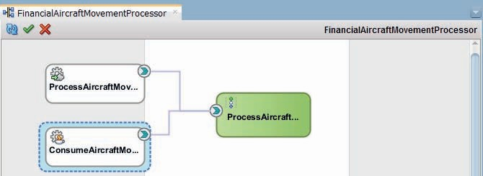

**FIGURE 13-9.** *Two channels into the pipeline, including one from the inbound JMS adapter*

the JMS Adapter’s set of connections with the JNDI name of *eis/Finance/Queue*. This connection refers to the *FinanceConnectionFactory* that facilitates access to resources such as the *AircraftMovementsQueue* that we are now going to listen to with the inbound mode of the JMS Adapter. No more configuration is required if we simply reuse this connection.

#### Deploy and Test

You can test the pipeline directly*—*right click and press run*—*or indirectly through the *ProcessAircraftMovementPS* proxy service. The proxy service *ConsumeAircraftMovementMessage* based on the inbound JMS adapter cannot be directly tested. Instead, we have to deploy the Service Bus project*—*which will register the adapter binding as a subscriber on the *AircraftMovementsQueue*. When we next publish a message on that queue, this should activate the adapter binding and indirectly invoke the pipeline.

By invoking the *AircraftMovementService* that was developed in Chapter 6, we can have the message published on the JMS queue*—*provided that this service picks the correct path in the conditional branch. Alternatively, we can use a tool such as QBrowser, SoapUI (with HermesJMS) or the WebLogic admin console to publish a message on the *AircraftMovementsQueue*.

After you publish a message on the queue, check in the EM FMW Control whether the expected new Message Report is published with details from the message you put on the JMS Queue as proof that the inbound adapter did consume the message and activated the pipeline in the Service Bus project.

### The Airport Information Desk—Receiving Emails

Questions regarding the flight status can be answered over instant messaging (chat) and email, as we have seen in Chapter 6. In this section, we will see how these questions can also be asked over human interaction channels, focusing on email.

The UMS adapter does not only have an outbound mode for initiating interactions with people. It also supports an inbound mode, where it polls email servers, XMPP servers and other messaging engines to allow incoming messages to trigger a new SOA composite instance or a call to the Service Bus. We will use this UMS adapter’s inbound mode to monitor an Inbox for a mail account on a mail server. For each email received in this inbox, there will be an instance of the SOA composite.

#### Create the SaibotHelpdesk SOA Composite

Create a new SOA application called *SaibotHelpdesk*. Create a new project with the same title, using the empty template.

Drag the UMS adapter to the left hand services swimlane, to create an inbound adapter binding. The configuration wizard appears. Set the name to *HelpdeskEmailProcessor*. Accept the default inbound Connection JNDI Name (eis/ums/UMSAdapterInbound). In step 3, the operation type should be *Inbound Receive Notification*. Accept the default operation name *ReceiveNotification*.

Step 4 is for configuring the inbound operation details such as the polling settings, shown in Figure 13-10. Set 30 seconds as the polling interval—or any other value you think appropriate. Given the slow volume in our development environment, we should not need configure multiple threads to handle the incoming emails. Note: Instead of polling mode, we can also choose listener mode. That latter mode allows us to receive email messages in near real time, having the UMS Server perform dedicated work for this composite.

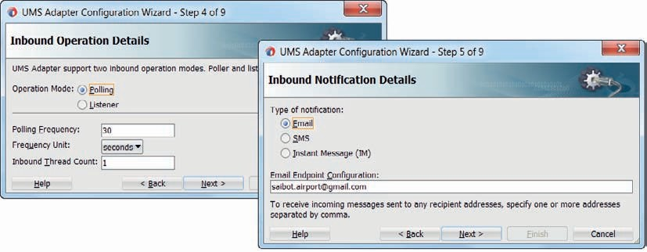

**FIGURE 13-10.** *Configuring the polling operation and the Email Endpoint aka the email account*

*whose Inbox to poll*

In step 5, we specify the email account whose Inbox we want to listen in to. We can provide multiple accounts, in a comma separated list. Provide the email address in the Email Endpoint Configuration property—in Figure 13-10 set to [saibot.airport@gmail.com.](mailto:saibot.airport@gmail.com) The email address(es) provided here have to be configured in the UMS Email Driver, as discussed in the next section.

Step 6 of the wizard is for configuring the message handling. The payload of the email can be passed into the composite application as a string or even a base64 binary object, or it can be natively transformed when the email contents is XML, JSON or some other structured format that can be converted into proper XML. Note that in addition to the email message contents, the SOA composite received a broad selection of JCA header properties that provide details from the subject, to and cc to messageID, reply to, language, encoding, and attachment indication. Mail attachments are also available in the SOA composite for further processing.

In this case, check the box Message is String Type.

In step 7, we can specify Message Filters. These are used to instruct the UMS adapter on which emails to actually process and create an instance of the SOA composite for, and which to ignore. Message filters can make use of white lists (specifically process mails from these senders), black lists (process all but emails from these senders) and text filtering on subject, content, sender, recipient, and reply to. Additionally, in step 8, we can even configure a callout to a custom Java class that performs our own specific inspection of the incoming message to determine whether or not to forward it to the SOA composite.

In this case, do not configure any filtering at all.

Press Next and the Finish, to complete the wizard and create the adapter binding.

Drag a Mediator component to the composite application. Call it *EmailMediator*. Wire the inbound adapter binding to the mediator.

Add a BPEL process component to the application, called *EmailProcessor*. Configure this component with a one way interface, accepting the default simple single string input.

Wire the *EmailMediator* to the *EmailProcessor*. The application will look now as shown in Figure 13-11.

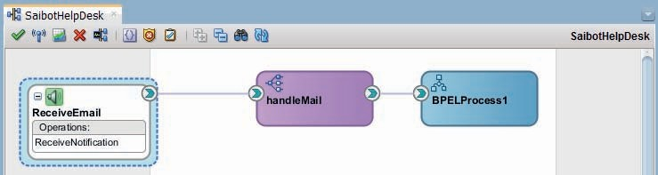

**FIGURE 13-11.** *SaibotHelpdesk composite with the Inbound UMS adapter to intercept*

*incoming emails, handing them off to the Mediator for filtering, transformation and routing, and finally a BPEL process for processing*

Edit the routing rule in the EmailMediator: use the Assign Values option to pass the contents of the email to the BPEL process. This will allow us to see whether we are able to intercept incoming emails, have them trigger new SOA composite instances and passing on the email payload to a BPEL process for processing. A more meaningful usage of the email is discussed later on.

#### Configure Email Driver

In order to configure our SOA Suite run time environment for polling an Inbox for a certain email account on some email server, we have to configure the UMS Email Driver Properties on the managed server. Depending on the mail server that is being used, the IMAP or POP3 protocol are configured, to read messages received on the mail server. The host and port have to be configured as well as the users whose mail accounts are to be polled, the folder that should be polled and the password(s) for the accounts that should be polled.

The online resources describe the details for this configuration.

#### Deploy and Test

Deploy the SOA composite to the SOA Suite run time. As with the composite with the inbound database adapter, there is no direct way to test the composite. It does not have a service interface. It can only be activated through the inbound UMS adapter that is triggered through the reception of an email.

Send an email to the email address that is configured for inbound interactions. After a little while—depending on the polling time configured for the UMS inbound adapter binding—the email will be picked up and handed to a new instance of the SOA composite, as visualized in Figure 13-12.

The SOA composite we have created for processing incoming emails is quite simple— especially since we do not really do any message handling right now. But even so, it might come as a surprise how little effort is required to have the SOA Suite activated through an email. Note that for incoming chat messages we have to go through very similar steps.

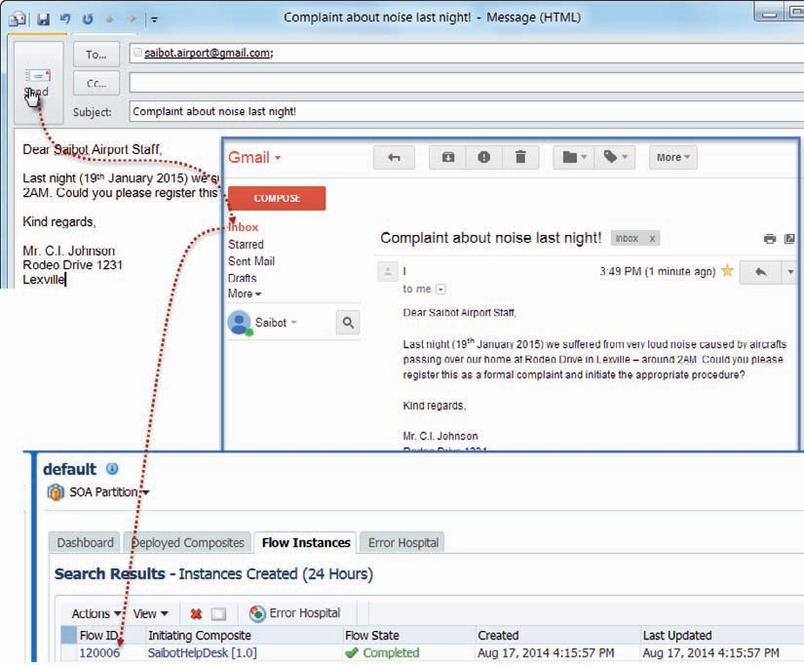

**FIGURE 13-12.** *Sending an email to* [*saibot.airport@gmail.com*](mailto:saibot.airport@gmail.com) *triggers an instance of the*

*SaibotHelpdesk composite through the inbound UMS adapter binding that picks up the email from the Inbox*

### Miscellaneous Inbound Interactions

In addition to the inbound interactions through database adapter, JMS adapter, and UMS adapter (for emails), there are several other inbound actions. We will briefly look at some of these.

The AQ adapter is obviously very similar to the JMS adapter; it subscribes to an Advanced Queue in a database and triggers an SOA composite or Service Bus proxy service whenever a message is consumed from the queue. In this area, there are also the MS (Microsoft), MQ, and MQ Series adapters that have an inbound mode triggered by messages arriving on a queue.

The File and FTP adapters both support file polling. Whenever a new file arrives in a configured directory, it will be retrieved by the File Adapter—from the local [shared] file system— or the FTP Adapter—from a (potentially remote) FTP server – at the end of the polling interval.

The contents from the file are processed as specified, for example, using native format transformation or rather opaque for binary files. Additionally, we can configure File Valves, custom Java classes that perform preprocessing on the retrieved files.

###### TIP

*We can instruct the File Adapter in inbound mode to only start polling once a “trigger file”—a dummy file with a predefined name—is found.*

*In this way we can ensure that a file is only processed when it is complete.*

In addition to the out-of-the-box JCA adapters, you can create your own Custom JCA adapters, to, for example, poll a DropBox folder, an RSS feed or any other resource whose changes you may want to trigger a Service Bus project or an SOA composite instance. A custom adapter leverages the JCA 1-way inbound interaction with activation mechanism for polling activities. The Custom Adapter wizard in JDeveloper can be used to configure the adapter binding for a custom inbound adapter.

Of course, any scheduled process that polls, gathers, aggregates and then triggers a service exposed by Service Bus or an SOA composite can perform an operation very similar to an inbound adapter. In the next chapter, we will look at the Enterprise Scheduling Service (ESS). We can use this service to schedule the execution of services implemented using Service Bus and SOA composites, the activation and deactivation of (inbound) adapters and the execution of external programs—that could perform a polling operation and based on the results, invoke a Service Bus or SOA composite service.

The Event Delivery Network (EDN) is the foundation of an important inbound mechanism for SOA composites. Events published to the EDN can be delivered to running instances or to newly created instances. The EDN provides a functional, more business oriented layer on top of the somewhat more technical JMS messaging infrastructure. We will discuss the EDN in Chapter 15.

### Summary

Inbound adapters are used in cases where the initiative for action in the Service Bus or SOA composite does not lie with some external party who is interested in a response or feels an obligation to call a one way service. Instead, it is the adapter that is configured to periodically inspect external systems for relevant changes—such as new files, new emails or chat messages, changed or new database records, or message on a queue—and upon finding such changes to initiate an SOA composite instance or invoke a Service Bus proxy service. Inbound adapters can play an important role in the implementation of (asynchronous) Straight Through Processing (STP).

This chapter showed the configuration of various inbound adapter bindings. It became obvious that once the adapter has forwarded the payload it retrieved from the external system, the processing of that payload in a pipeline (in Service Bus) or a Mediator or BPEL process (in SOA composites) is no different from processing payload received in normal request messages that were actively sent by external partners.

The configuration of inbound adapters can require some considerable care. To ensure timely action, polling times should not be set to high values. The size of transactions—how large is the chunk processed in a single go—and the number of polling threads concurrently active are very important in tuning the workload and preventing an overload on the server.





CHAPTER

# 14

## Using the Enterprise Scheduler Service

he Fusion Middleware 12.1.3 platform contains the ESS or Enterprise Scheduler Service. This service can be used as an asynchronous, schedule-based job orchestrator. It can execute jobs that are Operating System actions, Java calls (local Java or EJB), PL/SQL calls,

**T**

and web service calls (synchronous, asynchronous and one-way) including calls to SOA composite, Service Bus and ADF BC web services. Schedules used for planning the execution of a job can define a single, future point in time or may describe a periodically repeating pattern for the execution of the job. The finest granularity of schedules is at the level of minutes and hours.

ESS is clearly not intended for very rapid polling or high frequency tasks.

ESS has the concept of Job Sets. A Job Set consists of multiple job step steps where a job set step can be a job or another job set. Execution of job set steps can be configured as sequential or as parallel. Using a serial job set Enterprise Scheduler supports conditional branching between steps based on the execution status of a previous step. Additionally, output from one job set step can be used as the input for the next step.

Jobs and schedules can be defined from client applications that access a Java API, through the Enterprise Manager FMW Control user interface for ESS and through a web service. This web service through which (predefined) jobs can be scheduled can be invoked from BPEL processes in SOA composites, using a special Schedule Job activity. Additionally, a Service Bus business service for invoking the ESS Web Service can be created and a Mediator or Spring component can make that call from an SOA composite.

The ESS is used in at least two more ways from SOA Suite 12*c*, besides invoking services from a scheduled job and being invoked from a service to schedule a job.

One is the bulk recovery of faulted instances. This can be planned using a schedule—to ensure that recovery is performed in the near future, on a convenient moment and spread out over time to prevent sudden a sudden peak load. Behind the covers, the Enterprise Scheduler Service is used to coordinate the execution of the recovery according to the schedule.

The second use case for ESS is the activation and deactivation of (inbound) adapters based on a schedule. Key reasons for scheduling the availability of adapters are the availability of back-end systems—why start processing messages on a queue at any moment when we know that the ERP system that needs to be invoked is down every night—and the load on the system—let’s handle the low-priority inbound flow of documents at a time when the system is not swamped with a peak load of more important processes.

The ESS complements the database scheduler in the area of “middleware jobs.” It collaborates with the database scheduler for the execution of PL/SQL jobs. Note that the scheduled purging of SOA composite instances is done directly through the database scheduler, without ESS involvement. The periodic clean-up of historical job data in contrast is handled by ESS itself.

### Switch Off the Inbound Database Adapter for Processing Portal Slot Requests

The Enterprise Scheduler Service supports a number of administration activities around the SOA Suite. Although we will discuss administration in more detail in Part 6, we will look at one particular use case regarding environment management using the ESS.

In the previous chapter, we introduced the inbound database adapter. We have created the

*PortalSlotRequestProcessor* SOA composite that uses a database poller looking for new records in

table *PORTAL_SLOT_ALLOCATIONS*. The polling frequency was set to once every 20 seconds. And that goes on and on for as long as the SOA composite remains deployed and active.

Imagine the situation where every day during a certain period, there is a substantial load on the SOA Suite, and we would prefer to reduce the resource usage from noncrucial processes.

Further suppose that the slot allocation requests arriving from the portal are considered not urgent, for example, because the business service level agreed with our account managers is that these requests have to be processed within 24 hours—rather than once every 20 seconds. We do not want to create a big batch, and whenever we can, we strive to implement straight through processing. But between 1 and 2 AM on every day, we would like to pause the inbound database adapter.

In this section, we will use the Enterprise Scheduler Service to achieve this. We will create the schedules that trigger at 1 AM every day, used for deactivating the adapter, and 2 AM, used for activating the adapter. In fact, in order to make testing more fun, we will use schedules that trigger at 10 past the hour and 30 past the hour. These schedules are then associated in the Enterprise Manager Fusion Middleware Control with the inbound database adapter binding *PortalSlotRequestPoller*.

#### Create Schedules

An ESS Schedule is used to describe either one or a series of moments in time. A schedule can be associated with one or many job definitions to come to describe when those jobs should be executed. A recurring schedule has a frequency that describes how the moments in time are distributed over time. A recurring schedule can have a start time and an end time to specify the period during which the recurrence should take place.

To create the schedules that will govern the inbound database adapter, open the EM FMW Control and select the node Scheduling Services | ESSAPP. From the drop-down list at the top of the page, select Job Requests | Define Schedules, as is shown in Figure 14-1.

Click on the icon to create a new schedule. Specify the name of the schedule as At10minPastTheHour. Set the display name to “10 minutes past each hour.” The schedule has to be created in the package [/oracle/apps/ess/custom/]soa. This is a requirement for schedules used for adapter activation.

Select the frequency as Hourly/Minute, Every 1 Hour(s) 0 Minute(s) and the start date as any date not too far in the future (or even in the past) with a time set to 10 minutes past any hour. An example is shown in Figure 14-2.

Note that using the button Customize Times, we can have a long list of moments in time generated and subsequently manually modify them if we have a need for some exceptions to the pattern.

Click on OK to save this schedule.

Create a second schedule called *At30minPastTheHour*. The definition is very similar to the previous one, except for the start time that should 30 minutes past some hour. Click OK to save this schedule definition.

Note that more sophisticated recurrence schedules can be created through the Java API exposed by ESS as well as through the IDE support in JDeveloper. These options that allow specific week days or months to be included or excluded can currently not be set through the EM FMW Control.

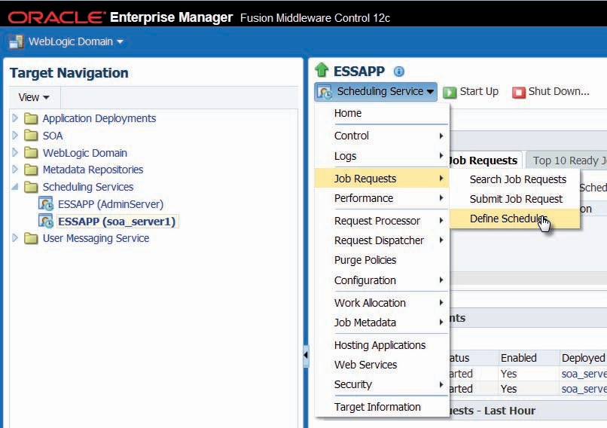

**Figure 14-1.** *Open the page to Define the ESS Schedules*

#### Apply Schedules for Activation and Deactivation of Inbound Database Adapter

Select node SOA | soa-infra | default | PortalSlotRequestProcessor—the composite we created in the previous chapter. Under Services and References, click on the *PortalSlotRequestPoller*, the inbound database adapter binding, as shown in Figure 14-3.

The *PortalSlotRequestProcessor* appears. Click on the icon for adapter schedules. In the Adapter Schedules popup that appears (Figure 14-4), we can select the schedule that is to be used for deactivating and for activating the adapter binding. Use the *At10minPastTheHour* schedule for deactivation and *At30minPastTheHour* for activation. Press Apply Schedules to confirm the new configuration.

From this moment on, the inbound database adapter binding that polls table *PORTAL_ SLOT_ALLOCATIONS* is active only for 40 minutes during every hour, starting at 30 minutes past the hour.

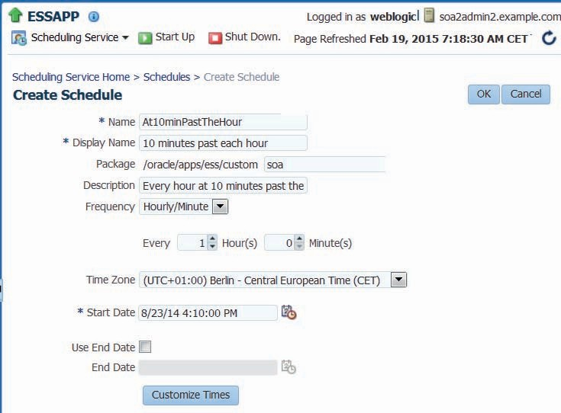

**Figure 14-2.** *Configure the Schedule At10minPastTheHour*

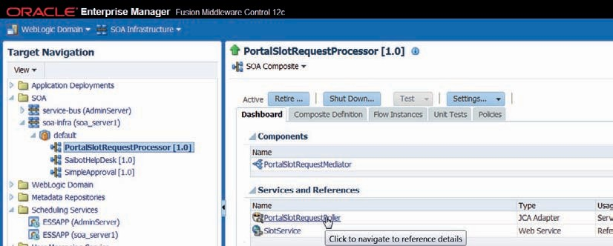

**Figure 14-3.** *Drill down to the configuration of the inbound database adapter binding*

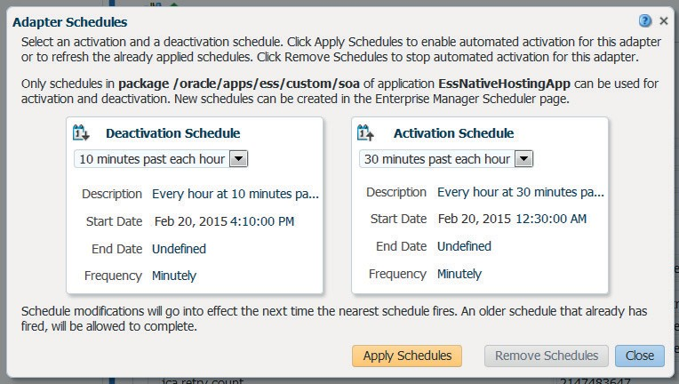

**Figure 14-4.** *Associating ESS Schedules with the database adapter binding to schedule*

*deactivation and activation*

#### Test Switching Off and on of Database Adapter Binding

When the schedules for activation and deactivation have been applied, they are immediately in effect. You can test this in the Dashboard page for the inbound database adapter binding, as is shown in Figure 14-5.

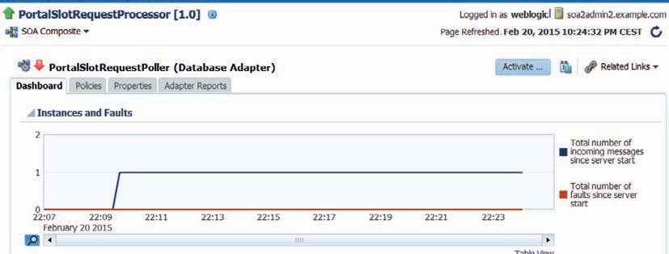

**Figure 14-5.** *Dashboard showing the status of the PortalSlotRequestPoller Database Adapter binding*

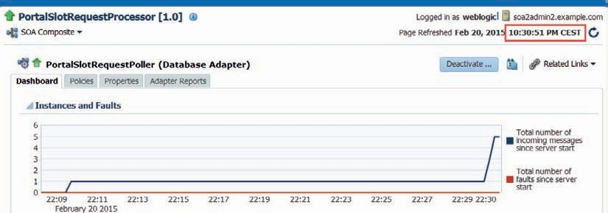

**Figure 14-6.** *At 30 minutes past the hour, the adapter binding is activated again and it processes*

*four records—inserted at 22:11 and 22:12—in two polling cycles*

Here we see how a single record was processed by the adapter binding, insert at 10:09 PM. Four more records were inserted into table PORTAL_SLOT_ALLOCATIONS at 10:11 and 10:12. However, because the adapter binding is currently not active, so these records have not yet been processed.

At 30 minutes past the hour—10:30 in this case—the adapter becomes active again and starts processing the records it will then find in the table. Because the adapter was configured to pass just a single record to an SOA composite and not process more than two records in a single transaction, it will take two polling cycles to process the four records that were inserted between 10:10 and 10:30. Figure 14-6 illustrates this.

When you check in the ESS UI in EM FMW Control, you will find two new Job Definitions, generic Jobs for executing SOA Suite management tasks. In the Job Requests overview, instances of these jobs appear, every hour one of each. And the details of these job requests specify which adapter binding in which composite is the target of the SOA administrative action performed by the job.

You can submit requests for these Job Definitions yourself, providing different values for the application properties, to activate or deactivate selected inbound adapters.

### Schedule Daily Flight Data Transfer

At Saibot, the Future database [schema] holds data about current and future slot allocations. From the data in this schema, Saibot derives every day the flights that are to take place in the next 24 hours. Details about these flights are loaded into the Present database [schema] that is the source for the flight information system presented to travelers in the terminals, on the website and in the mobile app. A third database [schema] used by Saibot is called Past. It holds data from flights and aircraft movement as they took place a week or more ago. Every day, data is moved from Present to Past—in order to keep Present, the live operational database—as lean as possible.

The two daily data movements described above are good candidates for scheduled orchestration by ESS. We will focus on the first one. A PL/SQL package is provided in the online sources that is called with a date parameter and will create the flight records in Present based on the slot allocation details in Future.

Initially, we will create a simple SOA composite application that uses the database adapter to call out to this package. Then we will create an ESS Job Definition for calling the SOA composite and create a job request that associates that job definition to a daily schedule. Subsequently, we will take the SOA composite out of the equation and create a PL/SQL Job Definition to carry out the daily data creation job directly from ESS to PL/SQL.

#### Create SOA Composite PresentFromFuture

Create SOA composite application and project called *PresentFromFuture*. Create a Mediator called *PreparePresentFromFutureMediator*, initially without interface.

Add an outbound database adapter called *CallFlightDataManager* to invoke procedure derive_ present_from_future in package flight_data_manager.

Right click in the exposed services swim lane and select Insert | SOAP. Call the service *PreparePresentFromFutureService* and have it implement the single port type in PresentFromFuture.wsdl.

Wire the service to the Mediator and the Mediator to the outbound database adapter binding.

Figure 14-7 shows the state of the composite.

Use the Assign Values settings in the Mediator to pass values from the request message to the database adapter binding and subsequently to the PL/SQL procedure.

Deploy the SOA composite. Make a test call and see if it completes successfully—and does in the database what you expect it to do. Note: We do not intend to make such direct calls in the future—that is what ESS will do for us.

#### Create and Schedule daily execution of PresentFromFuture with ESS

We will now create the Job Definition to invoke the *PresentFromFuture* composite and schedule it for execution once per day.

##### Create the Job Definition CreateCurrentFlightData

Open the EM FMW Control and go to the ESS page. From the drop-down menu, select Job Metadata | Job Definitions. Click on the create button.

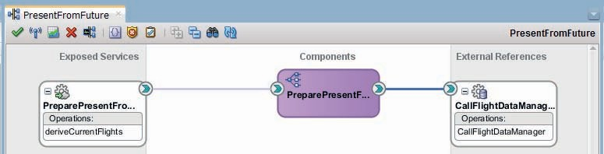

**Figure 14-7.** *SOA composite PresentFromFuture—a simple web service to PL/SQL package flow*

Edit the new job definition. Name is *CreateCurrentFlightData*, display name is “Derive current flights” and package is [oracle/apps/ess/custom/]saibot/flight. Job Type is *SynchWebserviceJobType*. Click on Select Web Service. A popup appears. Enter the URL for the WSDL for the service exposed by the *PresentFromFuture* composite. Set the Web Service Type to SOA. Press the Go button.

The WSDL is retrieved and processed. A list of (one) services is shown—click on *PreparePresentFromFutureService*. The drop-down element labeled *Port Type* is now populated. Select the *PreparePresentFromFutureService_pt* option. This will extend the dialog to include a drop-down list with operations. Select operation *deriveCurrentFlights*. A sample request message to this operation is shown. Set the value of the *PeriodDuration* element to ${ESS_REQ:NUMBER_ OF_HOURS}. This is a placeholder that tells ESS to replace it with the actual value of the application property *NUMBER_OF_HOURS* set for the specific job request. See Figure 14-8 for the complete Job Definition.

Finally, add an Application Defined Property to the job definition. This property is called NUMBER_OF_HOURS and is of type Integer. The initial value is 24 and the property is not read only.

##### Create the Once per Day Schedule

Use Job Requests | Define Schedules in the drop-down menu on the Scheduling Service page in EM FMW Control. Click on the create icon. The page for creating a new schedule appears, see Figure 14-9. Set the name to OncePerDayAt1AM and the display name to something similar.

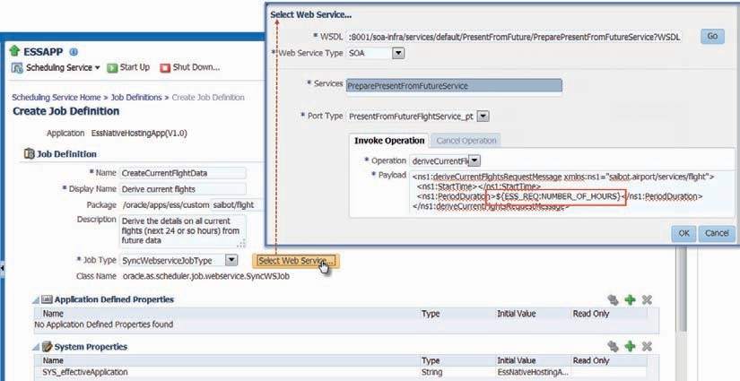

**Figure 14-8.** *Configure the Job Definition CreateCurrentFlightData that involves invoking a*

*synchronous web service exposed by SOA composite PresentFromFuture*

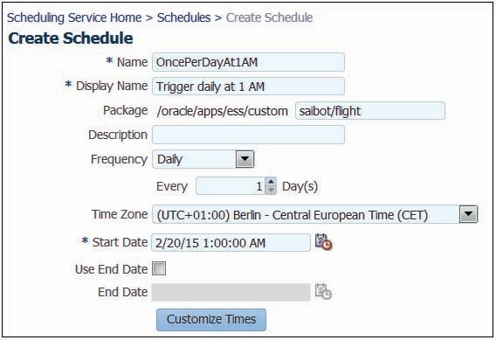

**Figure 14-9.** *Configuring the OncePerDayAt1AM schedule*

Set package to [/oracle/apps/ess/custom/]saibot/flight. Set the frequency to daily and the start date to any date in the past or near future. Set the time component of the start date to 01:00:00 AM to ensure that this schedule fires every day at that time. Press OK to complete the schedule definition.

By just creating this schedule, we have not yet accomplished anything, except providing this schedule definition for anyone who wants to submit a job request—which consists of the combination of a schedule and a job definition optionally along with specific values for application and system properties.

##### Create Job Request to Execute CreateCurrentFlightData Once per Day

Open the drop-down menu on the Scheduling Service page in EM FMW Control. Click on Job Requests | Submit Job Request.

The form for creating the Job Request submission appears, see Figure 14-10. Select the Job Definition *CreateCurrentFlightData*. Select the *OncePerDayAt1AM* Schedule. Provide some submission notes and perhaps provide a special value for the application property NUMBER_OF_ HOURS, to override the default of 24 for every execution of the job as a result of this submission. Press OK to complete the form and submit the Job Request.

After submitting this request, a request ID is assigned and reported back. The request with this id will be the parent request for specific job requests for the CreateCurrentFlightData job that are going to be generated by ESS. The first one is immediately created, scheduled for execution at 1 AM tomorrow, see Figure 14-11.

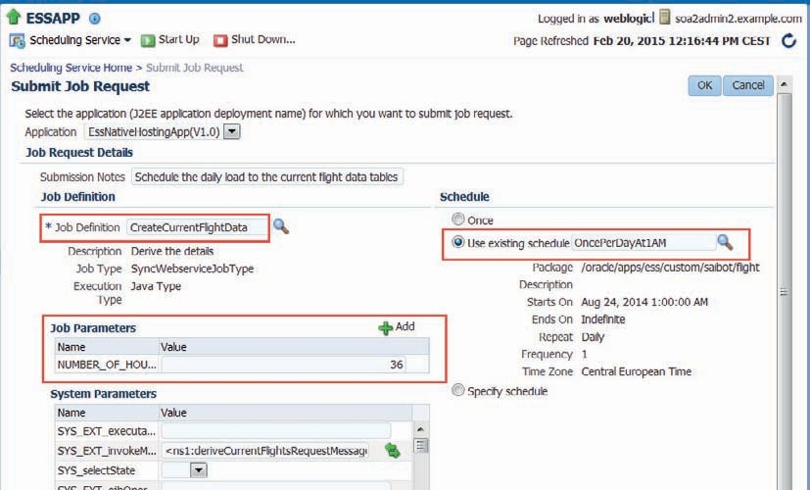

**Figure 14-10.** *Configuring the Job Request for CreateCurrentFlightData according to the*

*OncePerDayAt1AM schedule*

##### Testing Our Job Request

In terms of testing, there is really not a lot we can do—except wait for the first 1 AM to arrive and see whether an instance of the *PresentFromFuture* SOA composite is created. Of course, we can speed up things a little, by tampering just a little with the schedule—for example, by changing the frequency from daily to hourly. Note that you have to reassign the (same but now modified) schedule to the job request in order for the change in frequency to have an

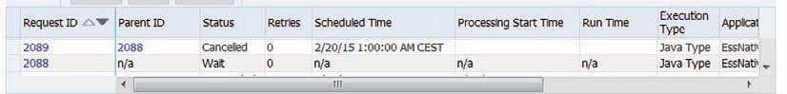

**Figure 14-11.** *The Job Requests records created by ESS as a result of submitting the Job Request*

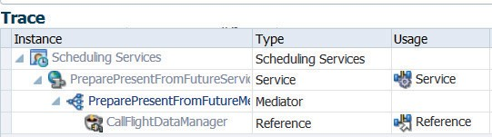

**Figure 14-12.** *Flow trace of the scheduled execution of the (call to the) SOA composite*

*PresentFromFuture*

effect. Alternative, you can submit a single execution request for the Job Definition. That will not test the schedule, but it will ensure the execution of the job and therefore the SOA composite.

At the scheduled time, ESS will trigger the execution of the job, leading to an invocation of the SOA composite that will call the PL/SQL package to perform the data creation in the tables with current flight information, see Figure 14-12. And at the next scheduled moment, that will happen again.

#### Turn Present Flight Data Creation into an ESS PL/SQL Job

In the previous section, we have created an SOA composite to invoke a PL/SQL procedure to perform data creation. Subsequently, we have scheduled a call to the service exposed by the SOA composite. And sure enough, it all works smoothly enough. However, the value of having the SOA composite between the Enterprise Scheduler Service and the PL/SQL procedure is extremely small. It produces some additional logging, which is basically it. It could do enrichment, fault handling, and post processing, but these are currently not required. So we are putting load on the SOA Suite that is not valuable at all. Additionally, the work done in the PL/ SQL package might take considerable time and could even lead to a transaction time out for the SOA composite.

In short, it might be a much better idea to simply schedule the current flight data creation as a PL/SQL Job Type without involving the SOA Suite at all. In a few simple steps, that is exactly what we will be doing in this section.

##### Prepare the Saibot Database Schema for ESS PL/SQL Jobs

In order to successfully create and execute the PL/SQL wrapper around the PL/SQL package flight_data_manager that ESS can invoke, we have to grant some privileges on database objects in the ESS database schema to the Saibot schema: Execute on ESS_RUNTIME, ESS_JOB and ESS_ SCHJOB_PROC. Additionally, create private synonyms in the Saibot schema for some objects in the ESS schema: ESS_RUNTIME and ESS_JOB.

##### Create the PL/SQL Wrapper Procedure

A PL/SQL procedure that is to be invoked from ESS as a PL/SQL Job has to implement a specific signature: a single input variable of type varchar2 that provides the ESS request identifier. Input

values can be read by the PL/SQL procedure from the ESS request context using that identifier, through package ess_runtime. That same package ess_runtime can be used to pass results from the PL/SQL procedure back to the ESS engine.

Note that the PL/SQL procedure handles its own transaction management—the ESS engine does not coordinate a transaction. The next code fragment is a stripped down version of the one you will find in the sources for this chapter: all exception handling that should part of it is taken out for readability purposes.

 create or replace

procedure ess_job_derive_pres_from_fut ( request_handle in varchar2

) is

l_number_of_hours number(5,0); l_number_of_flights number(5,0); l_request_id number := null;

begin

l_request_id := ess_runtime.get_request_id(request_handle); l_number_of_hours := ess_runtime.get_reqprop_int(l_request_id, 'NUMBER_OF_

HOURS');

flight_data_manager.derive_present_from_future ( p_start_time => trunc(sysdate)

, p_hours => l_number_of_hours

, p_number_of_flights => l_number_of_flights

);

-- Update an existing request property with a new value. ess_runtime.update_reqprop_int(l_request_id, 'NUMBER_OF_FLIGHTS_PROCESSED',

l_number_of_flights);

commit;

end ess_job_derive_pres_from_fut;

##### Create ESS Job Definition of PL/SQL Job Type

Open the EM FMW Control and go to the ESS page. From the drop-down menu, select Job Metadata | Job Definitions. Click on the create button.

Edit the new job definition, as is shown in Figure 14-13. The name is *CreateCurrentFlightDataPLSQL* and package is [oracle/apps/ess/custom/]saibot/flight. Choose your own display name and description. Set the Job Type to PlsqlJobType. Set the procedure name to saibot.ess_job_derive_pres_from_fut. Create to Application Defined Properties, called NUMBER_ OF_HOURS and NUMBER_OF_FLIGHTS_PROCESSED. Both are not read only and both are of type Integer.

Press the OK button to create the Job Definition.

##### Schedule the PL/SQL Job for Daily Execution

The PL/SQL job that we have just created will take over from the SOA job *CreateCurrentFlightData* that we created earlier on and that we submitted a job request for. This job request can be withdrawn, using the Action | Cancel option on the request details page.

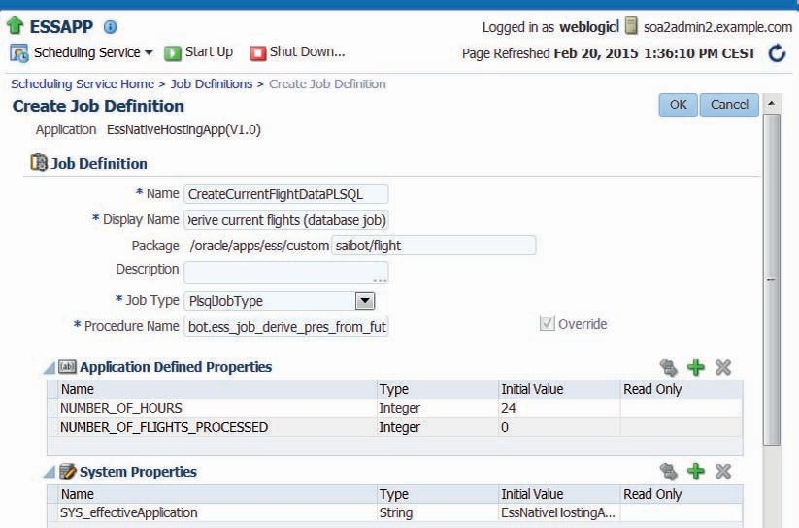

**Figure 14-13.** *Creating the CreateCurrentFlightDataPLSQL Job Definition of type PL/SQL Job*

*Type to invoke PL/SQL wrapper procedure ess_job_derive_pres_from_fut*

Submit a new Job Request for the PL/SQL job *CreateCurrentFlightDataPLSQL* in the same way as before: Click on Job Requests | Submit Job Request in the drop-down menu. The form for creating the Job Request submission appears. Select the Job Definition *CreateCurrentFlightDataPLSQL*. Select the *OncePerDayAt1AM* Schedule. Provide some submission notes and perhaps provide a special value for the application property NUMBER_OF_ HOURS, to override the default of 24 for every execution of the job as a result of this submission. Press OK to complete the form and submit the Job Request, as shown in Figure 14-14.

Once again, we can do little to test, except wait for the schedule to trigger the first execution of the job. Alternatively, you can submit a second job request that executes only once—just to try out the job definition itself.

Once the job request has completed, the job request parameter NUMBER_OF_FLIGHTS_ PROCESSED will contain the number returned from the PL/SQL procedure and stored in the job request by the wrapper procedure. We will find no trace of the request and its execution in the SOA composite flow trace—because the SOA Suite is not involved. The ESS pages in EM FMW Control provide the details about each child Job Request spawned by the request we submitted in Figure 14-15.

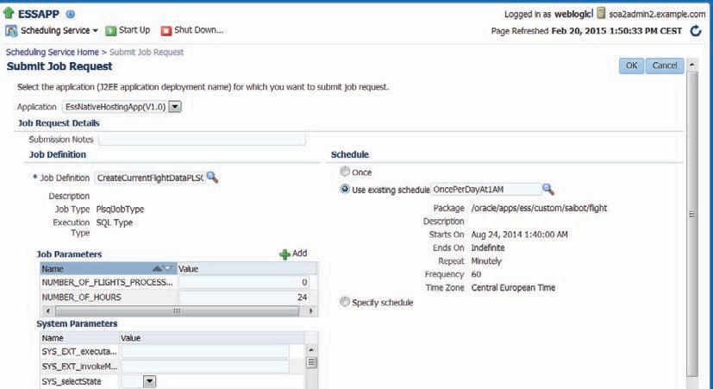

**Figure 14-14.** *Submitting a job request for job definition CreateCurrentFlightDataPLSQL*

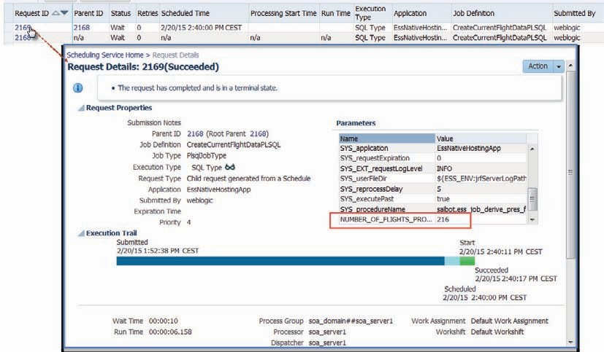

**Figure 14-15.** *Details on the request for PL/SQL Job Definition CreateCurrentFlightDataPLSQL*

### Delayed Invocation of ESS Job from SOA Composite

In the introduction to this chapter, we have discussed how the ESS Scheduler Web Service can be invoked from SOA composites or Service Bus pipelines. In this section, we will see an example of this. The SOA composite *PortalSlotRequestProcessor* that we created in Chapter 13 to process slot allocation requests submitted from a portal application will be extended.

When among the slot allocation requests there are requests for slots in next 48 hours, the composite will instruct ESS to run the *CreateCurrentFlightDataPLSQL* job that was defined in the previous section.

This ensures that new flights derived from these requests that are to take place in the very near future are also loaded into the current flight tables. This happens asynchronously, outside the SOA Suite and will have very little impact on the execution of the *PortalSlotRequestProcessor*.

#### Add BPEL Process to Composite

Add a BPEL component—called *IfDoRunPresFromFutJob*—to the composite. It should be based on the One Way BPEL Process template, not be exposed as a SOAP Service and it can use the predefined input.

Edit the XSD file IfDoRunPresFromFutJob.xsd that is generated by JDeveloper. Change the name of the input element to *slotStartDate* and change its type to *dateTime*.

Open the BPEL process for editing. Add an If activity with an expression that tests if the

*slotStartDate* is within 48 hours from now.

 $inputVariable.payload/client:slotStartDate <= xp20:add-dayTimeDuration-to- dateTime(xp20:current-dateTime(),'PT48H')

Add a *Schedule Job* activity to the *if* branch, see Figure 14-16. Drag an Empty activity to the

*else* branch.

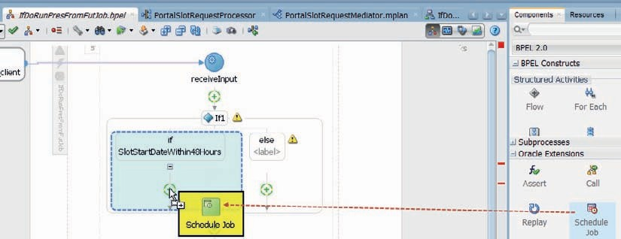

**Figure 14-16.** *Add a Schedule Job activity to the BPEL process*

The next step to take is editing the *Schedule Job* activity. Note that for doing so, there needs to be a special connection available in JDeveloper: an MDS Database connection that connects to the *essUserMetadata* partition in the MDS.

With that connection set up, double click the Schedule Job activity. Set the name of the activity as *ScheduleJobPresentFromFuture*. Select the job *CreateCurrentFlightDataPLSQL*; this will populate the Application field. Do not select a Schedule: this means that we want the ESS to execute this job immediately. See Figure 14-17 for the complete dialog. Click OK to complete the definition of the activity.

When you close the dialog, a warning appears about the fact that the WSDL for the ESS Service is an abstract one. Click Yes to acknowledge this message—we will fix this problem a little bit later on.

#### Forward Response from DB Adapter to BPEL Process

Return to the composite editor and double click on the Mediator. In the routing rule, click on the gears icon behind the field for Synchronous Reply, to set the destination to route a request to once the reply is received from the outbound database adapter. Select the (existing) service exposed by the BPEL process as this destination.

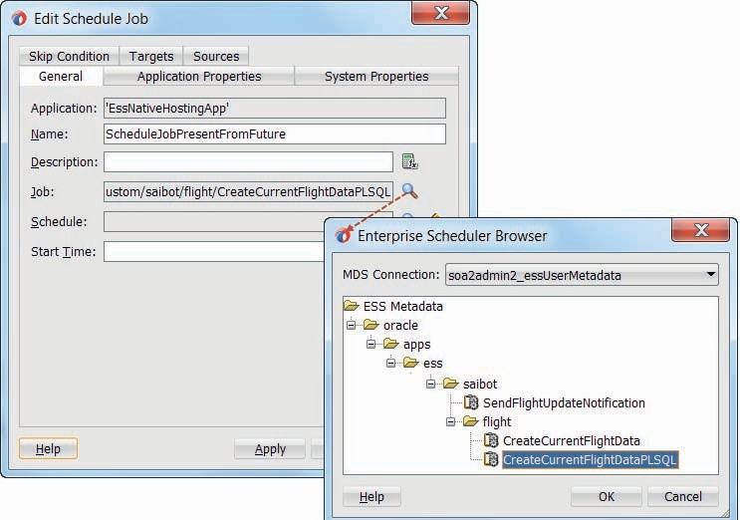

**Figure 14-17.** *Editing the Schedule Job activity to have ESS immediately run the*

*CreateCurrentFlightDataPLSQL job*

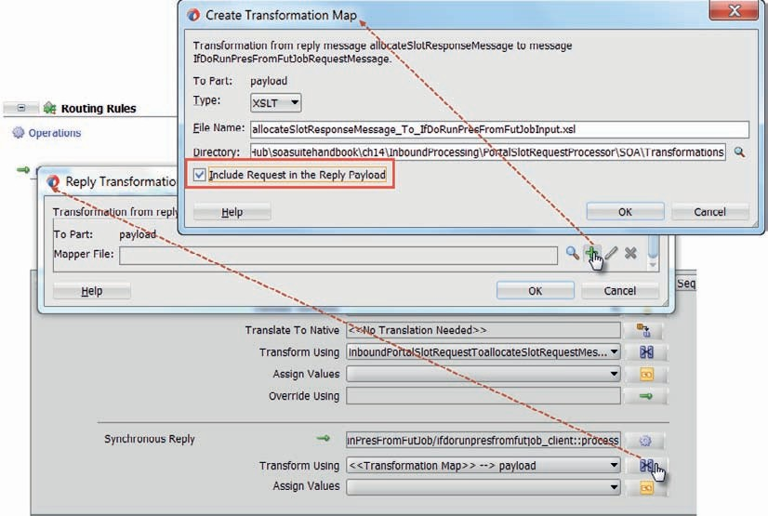

**Figure 14-18.** *Create the mapping for the input to the BPEL process using the original request*

*from the inbound database adapter as input parameter*

Click on the transformation icon to specify the file to use for transformation. In the popup, click on the plus icon to create a new mapping file. In the second popup, set the name of the new mapper file to allocateSlotResponseMessage_To_IfDoRunPresFromFutJobInput.xsl. Check checkbox *Include Request in the Reply Payload*. This instructs the Mediator to make the original request that entered the routing rule to be available as a parameter when the transformation of the response takes place—so we can take input from the request and pass it onward to the BPEL process, see Figure 14-18.

In the XSL Mapper, map the *startDateForSlot* element from the original request to the

*slotStartDate* element in the request to the BPEL process.

#### Environment Preparation

There some things we have to do on top of the functional implementation to make this all work. Some have to do with security—a topic discussed in more detail in Chapter 24.

##### Attach Policy to ESS Web Service

Jobs in ESS cannot be run as an anonymous user. So if ESS does not know who makes the request for scheduling a job, it will not perform the request. To ensure a user’s identify is

established when our BPEL process schedules a job, we have to attach a WSM security policy to the ESS Web Service and pass a WS Security Header with valid username and password in our request.

The steps are: in EM FMW Control, click on the node for the Scheduling Service | ESSAPP on the relevant managed server. From the drop-down menu on the right side of the page, selection option Web Services. You will be taken to the Web Service overview page. Click on the link for the *SchedulerServiceImplPort*. This brings you to another overview page for the *SchedulerServiceImplPort*. Open the tab labeled WSM Policies. Click on the icon labeled Attach/ Detach. Now you find yourself on the page where policies can be attached to this Web Service (port binding). Find the security policy oracle/wss_username_token_service_policy in the list of available policies. Click on the Attach button to attach this policy to the ESS Web Service. Click on OK to confirm this new policy attachment.

At this point, the ESS Scheduler Service can only be invoked by parties that provide a valid username and password. As a result, the web service’s operations are executed in the context of a real user—just like job-related operations performed through the EM FMW Control’s UI for ESS are or actions from a client application through the Java API.

##### Set Concrete WSDL URL for ESS Web Service Binding

To resolve the warning about the abstract WSDL for the *EssService*, we need to get hold of the WSDL for the live ESS Web Service. On the page in the EM FMW Control where you just added the security policy, there is also a link to the WSDL document—it is called *SchedulerServiceImplPort*. Click on that link to review the WSDL document and more importantly, to get hold of its URL.

Return to the composite editor. Right click the *ESS Service* Reference Binding and select Edit from the menu. Set the WSDL URL in the field in the Update Reference dialog.

##### Attach Policy to ESS Reference Binding

Because the ESS Scheduler Web Service is protected by a WSM Security Policy, it requires callers to pass the appropriate WS Security Header. We can simply attach a WSM policy (of our own) to achieve that effect. We can even do so through EM FMW Control, in the run-time environment, rather than right here at design time. But this time we will go for the design time, developer route.

Right click the *EssService* reference binding. Select Configure SOA WS Policies | For Request from the menu. The dialog for configuring SOA WS Policies appears. Click on the plus icon for the Security category. From the list of security policies, select oracle/wss_username_token_client_ policy. Then press OK. The policy is attached to the reference binding. Press OK again.

What we have configured at this point will cause the OWSM framework to intercept the call from our SOA composite to the *EssService* and inject WS Security policies into it. Or at least, that is what it would like to do. But the policy framework needs access to credentials to put in the WS Security header. The normal approach with this is for the policy framework to inspect the configured credential store for the username and password to use.

There is a short cut however, that we will use here. Instead of using a credential store, our security policy can also simply use a username and password that are configured as properties on the reference binding to which the policy is attached. Click on the reference binding once more. Locate the section Composite Properties | Binding Properties in the properties palette, as shown in Figure 14-19.

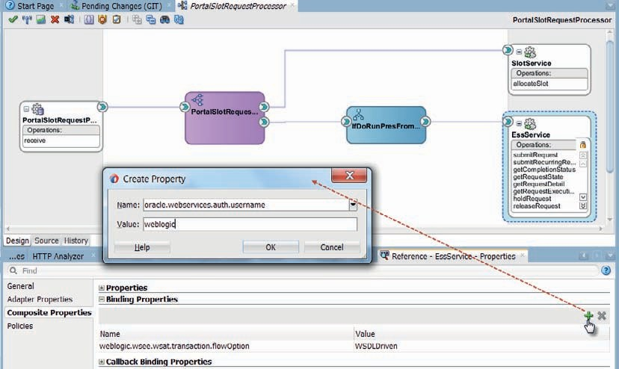

**Figure 14-19.** *Set property oracle.webservices.auth.username on the Reference Binding for the*

*EssService*

Click on the green plus icon to add a new property. Its name is oracle.webservices.auth

.username and the value is for example weblogic. Then add a second property, called oracle

.webservices.auth.password and set its value. You will notice that these two properties are not displayed in the property palette. However annoying that is, it is not a problem: the properties are added to the composite.xml file all the same.

#### Deploy and Test

Deploy and make sure to override the existing PortalSlotRequestProcessor that was deployed in Chapter 13.

Next, insert a record into table PORTAL_SLOT_ALLOCATIONS and make sure that the START_DATE_FOR_SLOT column has a value within the next 48 hours—as that should trigger the BPEL process into scheduling a job. After committing the transaction and waiting some time for the inbound database adapter to do its polling (ensure that it is not currently deactivated!), you should find a new SOA composite instance with the flow trace similar to Figure 14-20.

When you check the Job Requests in the ESS management pages, you will see that a one off request for the *CreateCurrentFlightDataPLSQL* was created and has been executed. When you inspect the ESS request log for this request, you will find the SOA Flow Id for the SOA composite instance that triggered this job request—which sure enough corresponds with the instance of the *PortalSlotRequestProcessor* that was created by the inbound database adapter.

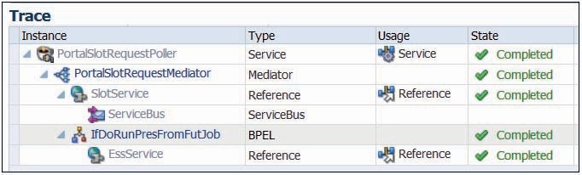

**Figure 14-20.** *The message flow trace resulting from the new Portal Slot Allocation request*

*record that was processed by the inbound database adapter and resulted in a job request being submitted to ESS*

### Summary

The Enterprise Scheduler Service provides a means to schedule the execution of SOA composites—as well as several other job types—according to a specific schedule. This opens up options for having work done in the background, periodically and at appropriate moments—such as the implementation of custom inbound adapters, to poll, for example, Dropbox, Twitter, or an RSS Feed.

A powerful option is the ability to associate inbound adapters with an ESS schedule for deactivation and activation. This means we can bring the adapter binding up and down in accordance with the availability of external systems and or the capacity of our own environment. Activating or deactivating an adapter binding can be done from the ESS console or from an SOA composite as well.

From within an SOA composite or a Service Bus pipeline, we can invoke the ESS Scheduler web service, to submit job requests. This means that our service implementations can easily request various types of postprocessing to be performed asynchronously, outside the (transaction) boundaries of the service execution—at a selected moment in time. We could for example schedule the Performance Review Process service to be invoked 30 days after the first working day of a new employee in the baggage handling department. And also run Operating System processes that an SOA composite does not directly have access to.





CHAPTER

# 15

## The Event Delivery Network

OA is about decoupling and reuse, leading to business agility. In the previous chapters, we have seen many examples of decoupling, both within and between our SOA composite applications, as well as between these composites and external services and systems.

**S**

The use of XML and web service standards is good for decoupled interoperability across heterogeneous technology stacks—for example, file systems, databases, Java applications, packaged applications, and SOA Suite. The integration between service components based on the WSDL contracts and the SCA infrastructure allows us to use the best tool for the job—Business Rules for business logic, Mediator for routing and transformation, BPEL for stateful processes, and technology adapters to leverage functionality in other platforms.

The asynchronous capabilities that queues such JMS and AQ, as well as the events introduced in this chapter, provide us with also allow for temporal decoupling where consumer and provider can communicate without having to be available at the same time.

In terms of decoupling, we have at least one other challenge left: How do we make sure that services are called at the right time? Some services provide clear value to their invoker, such as the requests for the latest flight information. Such services will be called whenever their functionality is desired by an application. The application is functionally decoupled from the service—the canonical model and reusable web service contract as well as end point virtualization by the Service Bus take care of that. However, the application still needs to explicitly invoke the service, needs to know some endpoint location, and work according to the service contract.

The story is even more interesting for one-way services, which may need to perform some action when a flight is cancelled or no service provider bids on a contract offered by a certain air carrier. Who is responsible for calling these services? No one will call them to get something out of them—because they do not return a response. Other services and applications may possess the information that the one-way services need to get. But whose responsibility is it to get it to them? How should these information owners know which one-way services are interested in their data? And should the onus be on them to explicitly call these services? Surely we do not want to modify and redeploy applications whenever a new consumer of their information comes along—or an existing one loses interest. That would not be decoupling at all!

This chapter introduces the Event Delivery Network (EDN) in SOA Suite—a facility that provides advanced decoupling by mediating events between producers and consumers that are unaware of each other. Composite applications can subscribe to one or more of the centrally defined business event types and are notified by the EDN whenever an instance is published of one of those types. More specifically, both Mediator and BPEL components can produce and consume events. Events can also be correlated into running composite instances through BPEL components. The EDN can be listened to or published onto from local and remote Java clients as well as from Oracle Event Processor (see the next chapter) and BPM processes (see Chapter 19). Note: Service Bus does not natively interact with the EDN; however, the underlying implementation of EDN is JMS and of course Service Bus can interact with a JMS Topic.

### Event-Driven Architecture for Super Decoupling

Event-Driven Architecture (with the obvious acronym of EDA) made a lot of heads turn. Seen as the successor to SOA by some and as a welcome complement to SOA by others, EDA is clearly on to something. Extremely Decoupled Architecture would be a perfect secondary meaning of the acronym—because extreme decoupling is one of the things that EDA adds to “traditional”

SOA. In the world of EDA, events are the messages, replacing direct service calls. Events are not targeted to a specific service provider. Events are published with some logical name on some central, generic infrastructure that the event producers use in a fire-and-forget mode. After publishing their event, these producers have no more responsibility for it. They have done their job by handing the event to the central event-coordinating facility and no longer have strings attached to the event. In fact, they may later on even consume their own event just like any other consumer—because their origin is unknown to event consumers. Events typically have a header and a payload. The header contains metadata such as the event type and a timestamp. The body or payload contains the details that describe the facts of the event instance that business logic in the consumer will process.

Anyone interested in occurrences of a specific type of event can subscribe to it, registering their interest in that event type with a central facility that coordinates events. This coordinating facility receives all events that get published, relieving the event publisher of the responsibility for the event. After receiving an event, it will traverse all subscriptions for the particular event type, taking into account any filters that may have been defined on such subscriptions to see whether the specific event occurrence should actually be forwarded to the subscription’s consumer, and propagate the event to all qualifying consumers. The event coordinator may support mechanisms to retry delivery of an event upon initial failure or deferred delivery for currently unavailable consumers.

###### NOTE

*None of the producers of events are aware of subscriptions for events. They should continue to publish their events even if no subscriptions exist at all. They should neither know nor care.*

The terms SOA 2.0 and Event-Driven SOA have made some inroads into the SOA community.

They both indicate a service-oriented architecture where event mechanisms are used to further decouple applications and services from each other. Instead of coupling applications and services that are sources of business events to the (often one-way) services that have a need for the information, events are used to convey the data through a generic facilitating medium: an event coordinator. In the SOA Suite, the role of event coordinator is implemented by the Event Delivery Network.

**Introducing the Event Delivery Network**

Oracle SOA Suite comes with the Event Delivery Network (EDN), an infrastructure that provides a declarative way of defining, publishing, and registering for consumption of business events. The EDN enables implementation of the EDA patterns in the SOA Suite.

The Event Delivery Network is a man-in-the-middle, a central coordinator that interacts with three types of entities: publishers of events, consumers of events, and the events themselves. The publishers—composite SOA applications or external parties such as Java applications or PL/SQL code running in the database—create an event and publish it by telling the man-in-the-middle about it.

However, before events can be published, their meta-definition needs to be in place, consisting of a (fully qualified) name and an XSD definition of their payload. The payload of an event is the data associated with it, provided by the publisher and available to the consumer. The meta- definitions of the business events are defined in EDL—the Event Definition Language. EDLs are

deployed inside composites or stored in MDS. These event-definition files typically import one or more XSD documents that provide the element definitions on which the event payload is based.

EDL is just another XML language—based itself on an XSD (edl.xsd in the JAR file bpm-ide- common.jar) that is registered with JDeveloper. Note that there are no explicit references to EDL files, not from composite.xml or from any of the components’ definitions files. All EDL files in a project help provide events that the components can subscribe to or publish, and all EDL files deployed to an SOA Suite instance are available to all composites in that SOA Suite. One EDL file can contain multiple definitions of event types.

The Event Delivery Network works across and beyond the SOA Suite, coordinating events from and to all composites running in the SCA container. The event definitions should therefore ideally be generic, based on canonical data model definitions.

Once event definitions have been registered with the EDN, subscriptions can be created on those events. SOA composite applications register their interest in events of a specific type with the EDN through Mediator or BPEL components that consume such events. BPMN components— which will be introduced in Chapter 19—can also subscribe to EDN events that are consumed as BPMN signal events. Many different composite applications can subscribe to the same event.

Each of these applications will receive notification of the events from the Event Delivery Network.

Upon deployment of an application with event-consuming components, the subscriptions are automatically detected by the EDN and used to distribute the published instances of those events. These subscriptions are durable—they continue to exist when the composite is deactivated for some reason. Upon reactivation, the events published during the composite’s downtime are delivered.

Undeploy ends subscription of an SOA composite, as does Retire.

Publishers of events do not have to be registered beforehand; anyone can publish an event of a type that is defined through EDL. Events of a specific type can be published by many different publishers, both inside the SCA container and outside of it. Primary publishers of events to the Event Delivery Network are Mediator, BPMN, and BPEL service components as well as OEP applications and Java Clients. Additionally, ADF Business Components can be configured to publish events to the EDN when data manipulations on entity objects occur. The EM FMW Control has a facility for publishing events for test purposes—we will be using that feature later in this chapter.

### The FlightStatusUpdate Event

One of the key business events at Saibot Airport is the *FlightStatusUpdate* event. Every time something happens around a flight, when it is within 20 minutes of landing, touches down or arrives at the gate, when the cleaning crew completes the job or the baggage hits the belt, an event is published. Many different parties at the airport make use of these events to coordinate their own activities. All companies, for example, who have a contract to provide some sort of aircraft service to a particular flight. And everyone involved in informing humans who have expressed an interest in the flight.

In this section, we will define the *FlightStatusUpdate* event in an EDL file, the definition format for EDN. We will then create a new SOA composite that registers on this event using a Mediator and that makes calls to the *FlightUpdateNotificationService* for every person and channel**—**email, Twitter, chat—for which an active interest in the flight is registered. We will first use the test facility in EM FMW Control to publish the event on the EDN and then we will look at publishing the event from a Service Bus service.

#### Define the Business Event FlightStatusUpdate

The *FlightStatusUpdate* event is defined in an EDL file—as an airport-wide event type with a canonical payload—not specific to any application or service and based on elements defined in the canonical data model. Note that the EDL file has to be created and deployed as part of an SOA composite application, even though it does not really belong to any one application— it is applicable throughout the SOA Suite container and is more or less “community property.” In Chapter 21, we will see how MDS can be used to centrally store, share, and manage EDL definitions.

Create SOA Application *FlightStatusRelay* with an SOA composite project with that same name using the Empty Composite template.

Right click on the folder SOA | Events and select New | Event. Enter *FlightEvents* as name for the EDL file. Set the namespace to saibot.airport/events/flight. Click the green plus icon to add the first event definition. Select the element *FlightStatusUpdate* from the XSD FlightEvents.xsd, in the Type Chooser pop-up window. Enter *FlightStatusUpdateEvent* as the name for the event, as shown in Figure 15-1. Click OK to complete the event creation.

At this stage, the business event has been defined. There are no consumers yet, the run time EDN does not know of it and there is no one publishing the event.

#### Consume FlightStatusUpdate from EDN

In order to consume a specific event such as the *FlightStatusUpdateEvent* from the Event Delivery Network, an SOA composite needs to have a subscription for that event with EDN. A subscription can be created in two ways: through a Mediator or a BPEL component (or a BPMN component as we will see in Chapter 19). A Mediator routing rule can have an event as its source, rather than a request message passed in over a wire from a service binding or another SCA component. A BPEL component can have a Receive or (mid process) OnMessage activity listen to an event instead of a partner link.

Add a Mediator component called *FlightStatusUpdateEventHandler* to the application—without interface at this time. Right click on the created Mediator and select Add Subscribed Events. Click on the green plus icon in the dialog that appears and browse for the *FlightStatusUpdateEvent*, as

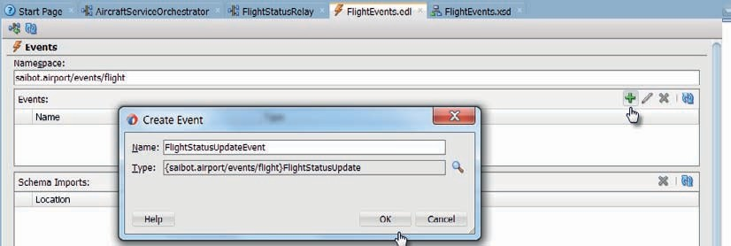

**FIGURE 15-1.** *Defining the FlightStatusUpdateEvent in the FlightEvents.edl file*

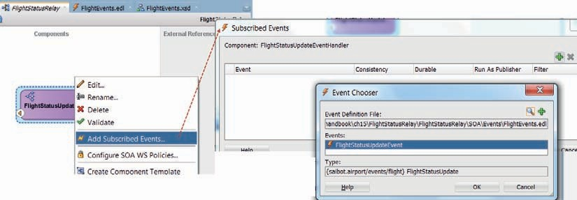

**FIGURE 15-2.** *Configuring the Mediator to consume the FlightStatusUpdate event*

shown in Figure 15-2. Then click OK and OK to confirm the Mediator’s subscription on the event— with default settings for Consistency (one and only one), Durable (yes), Run as Publisher (yes), and Filter (none).

With this event subscription, a new instance of this *FlightStatusRelay* composite will be created whenever the *FlightStatusUpdateEvent* is published on the EDN. The payload of the event is transferred to this new instance and will be the input to the Mediator. At that point, there is no distinction in the subsequent processing of the event payload with a regular request message that arrives.

Because the default settings that we accepted configure the subscription as *Durable*—the events are guaranteed to be delivered to the composite. Even when it is temporarily off line, the events are stored and will be forwarded to the composite once it comes back on line. The other default setting we have accepted is to run the event processing in the security context of the publisher of the event.

Next, create a reference binding in the SOA composite for the *FlightUpdateNotificationService*, last seen in Chapter 10. Wire the Mediator to this reference, as shown in Figure 15-3. Next, open the Mediator for editing. Use the Assign Values dialog to copy

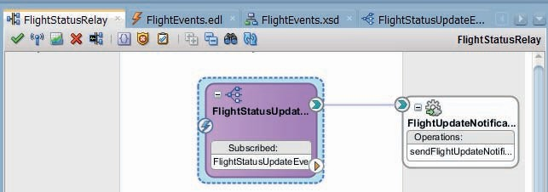

**FIGURE 15-3.** *The FlightStatusRelay composite that is initiated by the FlightStatusUpdateEvent*

*and invokes the FlightUpdateNotificationService*

the *Carrier*, *FlightNumber* and *FlightStatus* from the event to the input for the *FlightUpdateNotificationService*. Also define values for the communication meta data, especially the *to* address and the *channel* (email, im, twitter).

Deploy the SOA composite. This will make the run time EDN environment aware of the

*FlightStatusUpdateEvent* and its one and only consumer at present. Time to let the events come in.

##### Publish Test Event from EM FMW Control

Open the EM FMW Control. Click on the node SOA | soa-infra. From the drop-down menu, shown in Figure 15-4, select *Business Events*.

You will find a list of all know event definitions, containing a single event: *FlightStatusUpdateEvent*. You can inspect the definition of the event and browse the subscriptions for this event, as well as their status. In the EM FMW Control, you can view the service components that have subscribed to business events. Service component subscriptions are created in Oracle JDeveloper during design time and cannot be modified in Oracle Enterprise Manager Fusion Middleware Control.

You can also publish the event, by clicking the Test button. You have to provide an XML message that forms the payload of the event. In this case, that means an XML fragment based on the *FlightStatusUpdate* element, see Figure 15-5.

Press Publish to transfer the event to the Event Delivery Network. A popup will appear that informs you that the event was successfully published.

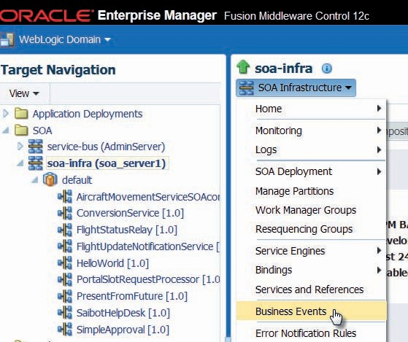

**FIGURE 15-4.** *Open the Business Events console in EM FMW Control*

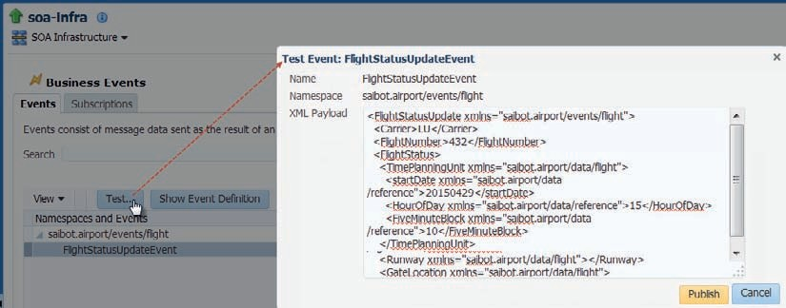

**FIGURE 15-5.** *Publish the FlightStatusUpdateEvent to EDN from EM FMW Control*

EDN absorbs the event, checks the subscribers and delivers the event to each of the subscribers.

In this case, the *FlightStatusRelay* composite is instantiated because of its subscription and the event’s payload is transferred to the *FlightStatusUpdateEventHandler* Mediator component, see Figure 15-6 for the message flow trace that started with the event.

##### Under the Covers: JMS

When you open the WLS Administration Console and you check the *EDNTopic* in the *SOAJMSModule*, you will find one durable subscriber in the Monitoring tab. This represents the event subscription in the Mediator component in the *FlightStatusRelay* composite.

Open the EM FMW Control and click on the node SOA | soa-infra. Navigate to the tab Deployed Composites. Click on the *FlightStatusRelay* composite. Then click on the button Shutdown, to temporarily deactivate the composite.

Publish the FlightStatusUpdateEvent again.

The subscription for the composite is still there. But the composite is not up and running. What happens now is that the event is held in the JMS Topic, until such time as the composite is ready to

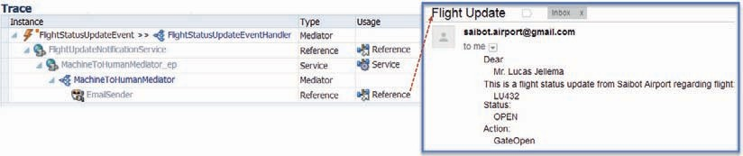

**FIGURE 15-6.** *The FlightStatusUpdateEvent triggered the FlightStatusRelay composite that*

*invoked the FlightUpdateNotificationService that sent the email to the interested traveler*

consume again. In the WLS Admin Console, in the Monitoring tab for the *EDNTopic*, you will now find this message-in-transit when you click the button *Show Messages* for the durable subscription.

When you next start up again the composite, this message will disappear from the topic because it can be delivered to the composite. You will find a new composite instance, initiated right after the composite becomes active again.

### Air Carrier Suspended Event

Due to international tensions and resulting sanctions as well as financial turmoil and escalating business disputes, there is a real possibility of air carriers being suspended. When that happens— a business event to that effect should be published.

In this section, a BPEL process will subscribe to this event. When the event is consumed, the BPEL process will retrieve all flight numbers of current flights by that air carrier and will publish their cancellation through the publication of instances of the *FlightStatusUpdateEvent*.

Subsequently, the *AircraftServiceOrchestrator* BPEL process that was introduced in Chapter 12, will be extended to also consume that event. When it does, it will immediately cease the RFP process it has started for the air carrier. The event is consumed through correlation into a running instance for the air carrier—it does not start a new instance.

#### Consume EDN Event into New BPEL Process

Find all open flights and publish the *FlightStatusUpdateEvent* for all now cancelled flights by the suspended carrier.

##### Preparation

First we define the SOA application, the project and the *AirCarrierSuspended* event definition. We also create a simple BPEL process that returns a (static, dummy) list of flights for a given carrier.

**Create the SOA Application and Project** Create new SOA Application called *CarrierWatcher* with an SOA composite (project) called *CarrierWatcher*, based on the empty template. Copy the file CarrierWatcher.xsd to the Schemas folder.

**Define the AirCarrierSuspendedEvent EDN Event** Right click Events folder. Select New | Event Definition from the context menu. Set the name [of the edl file] to *AircarrierEvents* and the namespace to saibot.airport/events/aircarrier.

Click green plus icon to create a new event. Define the event name as *AirCarrierSuspendedEvent*.

Select element *carrierSuspension* from CarrierWatcher.xsd as the event payload. Click OK and OK to complete the definition of the event and the .edl file.

**Create BPEL Component to Gather All Current Flights** Create a synchronous BPEL process component called *CurrentFlightsRetriever* that is not exposed as a SOAP service. The input is based on the *CurrentFlightsRequest* element in CarrierWatcher.xsd and the output on *CurrentFlightsResponse* in that same file. This component accepts criteria for current flights—in this case only the air carrier— and returns a list of all current flights in a 48 hour time window.

In a real-world airport and a real end to end application, this component would call out to various business services that in turn query the *present* database where flight details are stored. However, in the scope of this chapter where we focus on events, we create a very simple dummy implementation that returns a few flights for the air carrier whose IATA code is passed in.

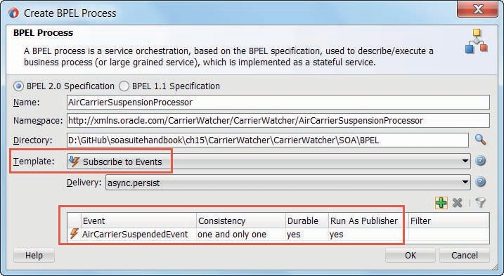

**FIGURE 15-7.** *Creating a BPEL process component that is initiated by the consumption of the*

*AirCarrierSuspendedEvent from the Event Delivery Network*

Open the BPEL process. Add an Assign activity. Open the editor. Drag the icon for a literal [XML fragment] to the *outputVariable/payload* element. Use the contents from the CurrentFlights. xml document in the Samples directory to populate the fragment.

##### Create BPEL to Consume AirCarrierSuspendedEvent

Add a new BPEL component to the composite. Set the name to *AirCarrierSuspensionProcessor*. Select the Template *Subscribe to Events*. Click on the green plus icon to create an event subscription. Subscribe the BPEL component to the *AirCarrierSuspendedEvent*, as shown in Figure 15-7. Accept the default settings. Click OK to complete the creation of the BPEL component.

Wire the BPEL component to the *CurrentFlightsRetriever*. Next, open the component for editing. Add an Invoke activity to the *CurrentFlightsRetriever* component. Have the input and output variable generated. Add an Assign activity to map the air carrier code from the event that triggers the BPEL component to the input variable that flows to the *CurrentFlightsRetriever*.

Add a For-Each activity. Configure the activity to loop over all Flight elements in the *CurrentFlights* list returned from the invoke activity. Check—in an If activity—for each flight if its status is unequal to cancelled and closed—because those flights do not require further action. Add an Invoke activity to the If branch. Configure this activity to not invoke a partner link but instead to publish the *FlightStatusUpdateEvent*. Have the input variable created that is used

to set the payload for the event. Add an Assign activity—just above the Invoke activity that publishes the event—to set the value of this input variable from the current flight element in the For Each loop. Figure 15-8 shows what the BPEL process should look like.

The entire composite looks as shown in Figure 15-9. There are no service or reference bindings. Instead: the input and output into and from this composite consists of the EDN events consumed and published by the first BPEL component.

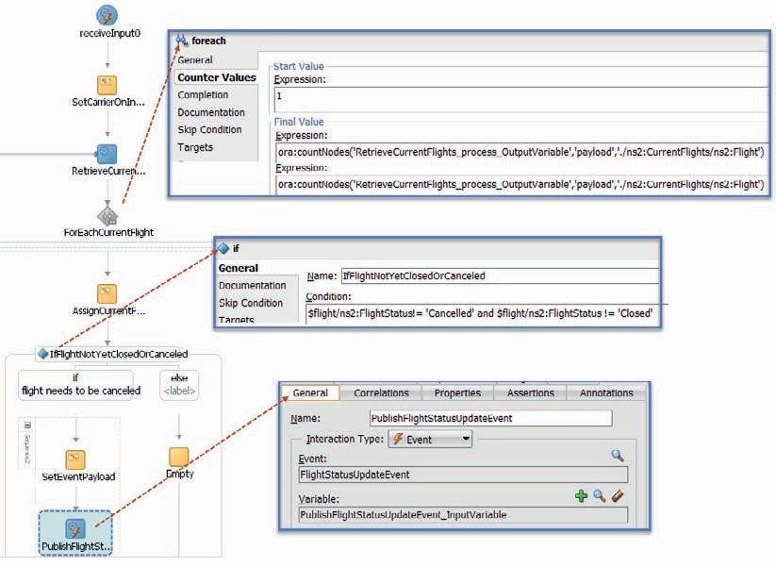

**FIGURE 15-8.** *The BPEL process that retrieves the current flights for the suspended carrier and*

*published the FlightStatusUpdateEvent for each relevant flight*

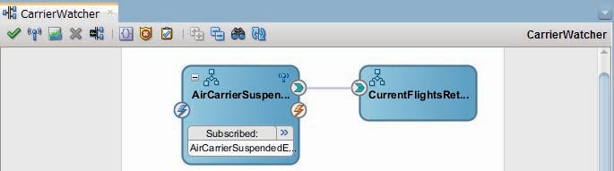

**FIGURE 15-9.** *The CarrierWatcher composite that subscribes to the AirCarrierSuspendedEvent*

*and published the FlightStatusUpdateEvent for the air carrier’s current flights*

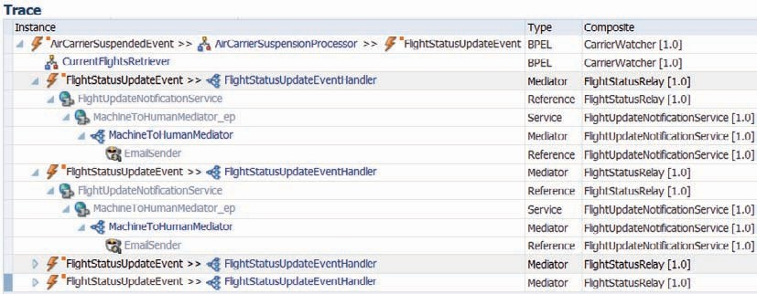

**FIGURE 15-10.** *Message flow trace, kicked off by the AirCarrierSuspendedEvent and resulting*

*in four FlightStatusUpdateEvent instances published to EDN and processed by the FlightStatusRelay composite*

##### Deploy and Test

Deploy the *CarrierWatcher* SOA composite. Then publish an *AirCarrierSuspendedEvent* instance from the EM FMW Control. The *CarrierWatcher* composite should be triggered and the BPEL component should consume the event, retrieve a list of flights to cancel and publish the *FlightStatusUpdateEvent* for each of these flights. Verify this activity in the message flow trace for the *CarrierWatcher* composite, as shown in Figure 15-10.

##### Define a Composite Sensor on the Event Subscription

Composite sensors—first seen in Chapter 5—can be defined on service and reference bindings to publish relevant and typically identifying details on an instance of a SOA composite—much like message reports in Service Bus pipelines. Such sensors can also be defined on event subscriptions, to track (relevant information for) composite instances that have consumed an event.

Return to JDeveloper and open the composite editor for the *CarrierWatcher* composite. Click on the sensor icon in the icon bar, as shown in Figure 15-11. In the popup, select the consumed *AirCarrierSuspendedEvent*. Click on the plus icon to create the composite sensor. Set the name of the sensor to *AirCarrierSuspensionSensor*. Specify an XPath expression that retrieves the carrier code (of the suspended carrier) as the value for the sensor.

###### NOTE

*The expression can be created as a* Variable *or an* Expression *using the same XPath. However, the first option results in a iataAirlineType as output and the second approach produces a String. The latter is far easier to search for.*

Redeploy the composite. Publish another instance of the *AirCarrierSuspendedEvent*. Check whether an instance of the composite is created. Then find out if the composite sensor value is available in the EM FMW Control, as is shown in Figure 15-12.

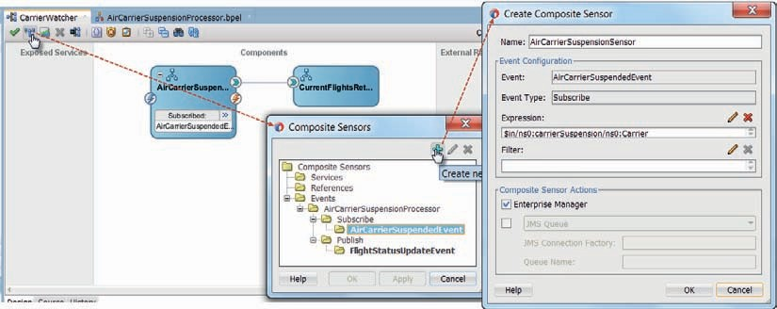

**FIGURE 15-11.** *Creating a composite sensor that exposes the carrier code on all instances of the*

*CarrierWatcher composite triggered by the AirCarrierSuspendedEvent*

#### Consume into Running BPEL Process AircraftServiceNegotiationProcessor

The *AircraftServiceOrchestrator* composite engages one or usually more than one provider of aircraft services to solicit proposals for an airline carrier. The services that the composite invokes are asynchronous—a response can take several hours to multiple days to come in. The whole RFP can and should be terminated as soon as the air carrier that requested it has been suspended. That means that the BPEL component *AircraftServiceNegotiationProcessor* should consume the *AirCarrierSuspendedEvent* into a running instance for the suspended carrier (if there is one) and terminate that instance.

We have seen in the previous section how a BPEL process can be instantiated through the reception of an event. We will now go one step further and use an event instead of an mid process incoming request message, to correlate into the instance.

##### Define Correlation Set for BPEL Process

Open the AircraftServiceOrchestrator composite. Open BPEL component AircraftServiceNegotiationProcessor for editing.

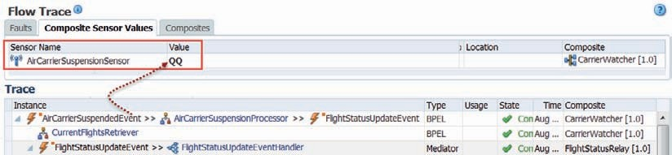

**FIGURE 15-12.** *The composite sensor value derived from the AirCarrierSuspendedEvent*

Add a correlation set, called *AirCarrierCorrelation*. Add property *AirCarrierIataCode* of type String to the set. Define a property alias for this property, based on the *RequestingCarrierIATACode* element in the incoming *ArrangeAircraftServiceRequestMessage*.

Edit the Receive activity that starts the BPEL process. On the Correlations tab, add the new *AirCarrierCorrelation* correlation set. Set initiate to true—the reception of the request message by this activity is the trigger for specifying the identifying value for the *AirCarrierIataCode* for this BPEL process.

##### Add Asynchronous Event Handler for AirCarrierSuspendedEvent

Click on the *onEvent* icon for scope *ExecuteRFP*. Edit the *onEvent* handler that is added to the scope. Set the name to *ConsumeAirCarrierSuspendedEvent*. Select the *AirCarrierSuspendedEvent* from the AircarriersEvents.edl file in the *CarrierWatcher* project. Allow the edl file and the associated XSD files to be copied to the current project.

Set the name of the variable to *carrierSuspension*, based on the element of that name in the CarrierWatcher.xsd document. Figure 15-13 shows the configuration of the *onEvent* handler.

Add an Exit activity to the *onEvent* scope. This is our first, rather crude way of handling the *AirCarrierSuspendedEvent*. Ideally of course we would inform all aircraft service providers that are participating in the RFP and whose asynchronous responses we are still awaiting. Those are refinements we ought to add in the real world. In this example, they do not add to our understanding of correlating EDN events into running BPEL process instances, so we ignore them.

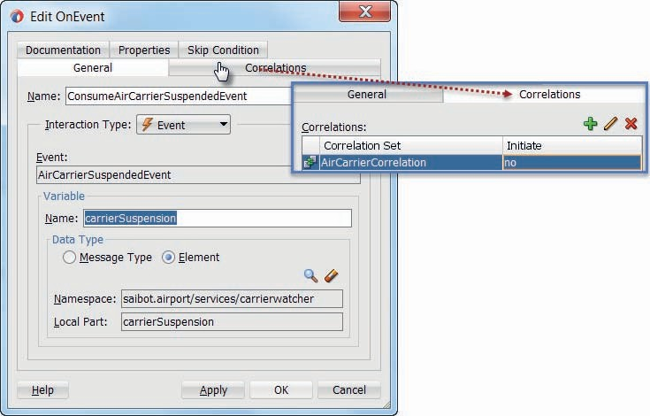

**FIGURE 15-13.** *Configuring the onEvent handler to consume the AirCarrierSuspendedEvent into an instance with the corresponding air carrier value for the correlation set AirCarrierCorrelation*

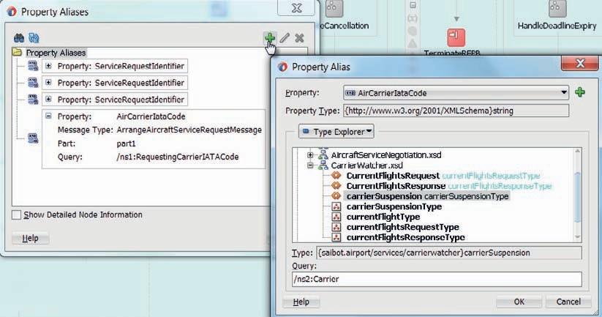

**FIGURE 15-14.** *Adding a property alias for property AirCarrierIataCode based on the Carrier*

*element in the payload of the AirCarrierSuspendedEvent*

Finally, add a property alias to the correlation set that maps the Carrier element in the payload of the *AirCarrierSuspendedEvent* to the property *AirCarrierIataCode*, as shown in Figure 15-14.

##### Deploy and Test

Deploy the SOA composite *AircraftServiceOrchestrator*. Invoke operation *arrangeAircraftService*

with a value of XX for element *RequestingCarrierIATACode* in the request message.

When you inspect in the EM FMW Control, you will find a running

*AircraftServiceOrchestrator* instance, initiated by your request.

Use the Business Events console in the EM FMW Control to publish an instance of the *AirCarrierSuspendedEvent*. Set the *Carrier* element in the payload for this event to XX. The running *AircraftServiceOrchestrator* instance should consume this event in the new *onEvent* handler that we have just added. This in turn should result in the immediate termination of the instance.

###### NOTE

*Correlation in BPEL assumes uniqueness of the correlation set among all running instances. That means in this case that only one instance of the* AircraftServiceOrchestrator *can be running at any one time for a specific air carrier. In reality it will frequently occur that an event should be consumed into more than one running instance***—***and we need a somewhat more involved approach than this described above. The book’s website contains a reference to an article introducing a way to*

*“fan out EDN events” so as to have one event impact multiple instances.*

### More about the Event Delivery Network

This section contains a number of useful details about the Event Delivery Network and how it can be used. Of course, it is only a limited collection. Check out the on line resources for more details.

#### Transactions, Security, and Scalability

With the “Consistency” setting on an event subscription, do we indicate whether the delivery of the event is part of the transaction in response to the event (one and only one) or whether the delivery is in separate transaction (guaranteed). The former (and default) setting means that the event delivery is rolled back when errors occur in the consumer (and the event can be delivered again), whereas the latter causes the event to be lost for this subscription when the consuming transaction is rolled back. The third value—immediate—specifies that events are delivered to the subscriber in the same global transaction and same thread as the publisher, effectively (and usually very undesirably) coupling the publisher to the consumer. Stay away from that option, unless you have a very good reason for using it.

The setting “Run as publisher” is set to yes to have the consumer executed with the same security context (identity) as the composite that published the event. According to the documentation, alternatively an Enterprise Role can be set to execute the consuming composite with. However, the IDE does not appropriately support this.

The SOA Suite does not keep track of EDN events, in the form of an archive or audit trail or something along those lines. When an event is consumed by a composite, the composite flow trace will reflect the event occurrence. Events associated with durable subscriptions by currently unavailable consumers are retained at JMS level.

If your SOA composite application includes a business event subscription, and you deploy different revisions of the composite, all event subscriptions from all revisions of the composite are active and receive messages.

An Oracle WebLogic Server JMS topic (default) and an AQ JMS topic are automatically configured for EDN use after installation. The default JMS type can be switched from Oracle WebLogic Server JMS (default) to AQ JMS in Oracle Enterprise Manager Fusion Middleware Control. You can map business events to JMS topic destinations on the Business Events page in Oracle Enterprise Manager Fusion Middleware Control—to reduce the risk of bottlenecks when all events flow through a single JMS Topic.

###### TIP

*A human task component—to be introduced in Chapter 17—can be configured to publish events to the Event Delivery Network for every task and workflow event. This includes task assigned, claimed, rejected, escalated, and completed.*

###### NOTE

*Events are not subject to authorization mechanisms: Any composite can register for any event type on the EDN and every instance of events is delivered to every consumer—when allowed by the optional filter expression on the subscription. No authorization can be specified or enforced.*

#### Missing Event Detection

An event indicates that something happens—or so you would think. However, it is quite possible to have a meaningful event when something does not happen. When the expected does not occur, that can be quite an event indeed. If the sun or the tide forgot to rise, we would have major events indeed.

On a slightly smaller scale, we, too, have the situation where the fact that something we expected did not actually happen in itself is a meaningful event. The invoice was sent but the payment never materialized; the suitcase went into the baggage-handling system but never came out; the complaint was filed but a response was never sent. Such an event is often called a nonevent. The absence of an event is an event in its own right.

A common challenge in event processing is the detection of nonevents: events that should take place (before a certain moment in time) but do not happen. SOA Suite does not have support for this detection out of the box. We have to implement some logic to find the nonevents and turn them into real EDN business events. Here is one way of approaching this challenge.

When an aircraft touches down and starts taxiing towards the gate, an event is published to the Event Delivery Network (say, the *AircraftLandedEvent*) with the flight number as payload. A composite application is subscribed to this event and a new instance is initiated upon consumption. This composite contains a BPEL component that consumes event. It enters a Pick activity with two branches: One is a Wait activity that will wait for 30 minutes. The other branch is an *onMessage* that will wait for an *AircraftAtGateEvent*. The *onMessage* will correlate this latter event on the flight number.

When an aircraft arrives at the gate, this *AircraftAtGateEvent* should be published. When it is, the BPEL component will consume it, conclude the Pick activity, and terminate the instance altogether. However, if after 30 minutes this event is still not received, the wait branch of the Pick activity is activated and it will publish the “nonevent” *AircraftDidNotArriveAtGateEvent*. The BPEL component turns the absence of the business event—after the specified period—into another business event, which subsequently can be responded to by all consumers.

### Event Exchange with EDN from Other Channels

Publishing and consuming EDN events can easily be done from a Mediator and a BPEL process. Oracle Event Processor has an adapter to interact with EDN, ADF Business Components can be configured to publish to EDN and anyone capable of communicating over JMS can interact with EDN. This makes it possible to, for example, publish events to EDN from Service Bus, despite the fact that Service Bus does not understand the EDL file nor has a native EDN integration.

In this section, we will first look at the interaction from a simple Java Client with the Event Delivery Network. Next, we will focus specifically on Service Bus as consumer and producer of events.

#### Publish FlightStatusUpdateEvent from Java Client to EDN

Java clients can make use of the EDN Java API that Oracle ships with the SOA Suite. By using this API, most details surrounding the communication and event definition are taken care of. Alternatively, we could communicate at plain JMS level—which leaves us with far more responsibility regarding EDN intricacies.

Create a Service Bus application called *EDNandAlternativeChannels*. Create a new Java project called *EDNJavaClient*. Add the following libraries and jar files to the project:

* Libraries: SOA Runtime, WebLogic 12.1 Remote-Client, JRF Runtime
* Jar-files: Tracking-core.jar and Jca-binding-api.jar (note: these jar files can be found in the directory FMW_HOME\Oracle_Home\soa\soa\modules\oracle.soa.adapter_11.1.1 and

FMW_HOME\ Oracle_Home\soa\soa\modules\oracle.soa.fabric_11.1.1, respectively

Create a Java class called *FlightStatusUpdateEventPublisher*. Add the following code that will publish the *FlightStatusUpdateEvent* to the Event Delivery Network. Note the address and login details of the SOA Suite managed server that are provided; you need to adapt them for your environment. Note that the import statements have been left out for the sake of brevity. You will of course find the correct imports in the on line sources:

 package saibot.airport.events.client;

public class FlightStatusUpdateEventPublisher { public static void main(String[] args) {

Properties props = new Properties(); props.put(Context.PROVIDER_URL, "t3://soa2admin2:8001/soa-infra"); props.put(Context.INITIAL_CONTEXT_FACTORY, "weblogic.jndi.

WLInitialContextFactory"); props.put(Context.SECURITY_PRINCIPAL, "weblogic"); props.put(Context.SECURITY_CREDENTIALS, "weblogic1"); String FlightStatusUpdateEventBody =

"<FlightStatusUpdate xmlns=\"saibot.airport/events/flight\">\n" + "

<Carrier>ZQ</Carrier>\n" +

" <FlightNumber>1134</FlightNumber>\n" + " <FlightStatus>\n" +

" <Action xmlns=\"saibot.airport/data/flight\">GateOpen</Action>\n" + " </FlightStatus>\n" + "</FlightStatusUpdate>";

try {

Element eventBody = XMLUtil.parseDocumentFromXMLString(FlightStatusUpdateEv entBody.toString()).getDocumentElement();

BusinessEventConnectionFactorySupport.setJndiProperties(props); EdnConnection ec = (EdnConnection) BusinessEventConnectionFactorySupport.

findRelevantBusinessEventConnectionFactory(true). createBusinessEventConnection();

String namespace = "saibot.airport/events/flight"; String eventName = "FlightStatusUpdateEvent";

BusinessEventBuilder builder = BusinessEventBuilder.newInstance(); builder.setEventName(new QName(namespace, eventName)); builder.setBody(eventBody);

ec.publishEvent(builder.createEvent(), 4); ec.close();

} catch (Exception e) {

e.printStackTrace();

}

}

}

When you run this Java class, its main method is executed. It builds up an EdnConnection to the SOA Suite run time server—without having to know a lot about the configuration of EDN in terms of JMS Topics and connection factories. Through the EdnConnection, it is easy to publish an event. Setting the right namespace and event name are of course crucial to instruct EDN on the nature of the event.

Run the class and verify whether a new instance of SOA composite *FlightStatusRelay* is created.

#### Consume FlighStatusUpdateEvent from EDN to a Java Client

With the JDeveloper project that we created in the previous section to publish an EDN event, we are already well underway to also consume an event from EDN. We can fairly easily create an event subscription and register one of our own objects as a listener. We can specify the event type to listen for and also use an event filter. The EDN API takes care of creating the appropriate durable JMS Topic subscription and transferring the event to our listener. With the subscription, we can specify a time out that indicates if and for how long our code should block waiting for the event we subscribe to.

Create a Java Class *FlightStatusUpdateEventSubscriber*. The following code also establishes an EDN Connection. It then creates a subscription on the *FlightStatusUpdateEvent*—registering itself as listener. The Class implements the interface *BusinessEventHandler* that is defined in the EDN API. The method *onEvent* has to be implemented in the Class, to satisfy the interface. This method is called whenever the event is published on EDN.

 public class FlightStatusUpdateEventSubscriber implements BusinessEventHandler { public static void main(String[] args) {

Properties props = new Properties(); props.put(Context.PROVIDER_URL, "t3://soa2admin2:8001/soa-infra"); props.put(Context.INITIAL_CONTEXT_FACTORY, "weblogic.jndi.

WLInitialContextFactory"); props.put(Context.SECURITY_PRINCIPAL, "weblogic"); props.put(Context.SECURITY_CREDENTIALS, "weblogic1");

BusinessEventConnectionFactorySupport.setJndiProperties(props); EdnConnection ec = (EdnConnection) BusinessEventConnectionFactorySupport.

findRelevantBusinessEventConnectionFactory(true). createBusinessEventConnection();

String namespace = "saibot.airport/events/flight"; String eventName = "FlightStatusUpdateEvent";

ec.setEventHandler(new FlightStatusUpdateEventSubscriber()); ec.setTimeout(12000);

ec.subscribe(new QName(namespace, eventName), "mySubscriptionForFlightStatusUpdateEvent");

}

public void onEvent(BusinessEvent be) throws FabricInvocationException { System.out.println("Hey, I received an event of type " + be.getEventName()+";

payload = " + be.getBodyAsText());

}

}

Run this class. Now either publish the *FlightStatusUpdateEvent* from the EM FMW Control or using the Java class *FlightStatusUpdateEventPublisher* created in the previous section. Check if the *onEvent* method does indeed receive the event.

#### Interact with EDN from Service Bus

As was stated before, Service Bus does not have out of the box integration with the Event Delivery Network. Having said that, because EDN can be accessed through a Java API to publish events and uses JMS to deliver events, it turns out not incredibly difficult to interact with EDN from Service Bus. Using a Java Callout to a Java class very similar to the one created in the previous section, we can publish EDN events from a Service Bus Pipeline. Subsequently we will subscribe a Service Bus proxy service to a specific EDN event using an inbound JMS transport.

##### Use Java Callout to Publish to EDN

Create Java project *EDNServiceBusCalloutLibrary*. Add the same libraries and JAR-files as in the *EDNJavaClient* project. Also add the XML Beans jar-file we previously used to construct a Java Callout in Chapter 7 (com.bea.core.xml.xmlbeans_x.y-z.p.jar). Finally, create a new deployment profile for the project called *EDNServiceBusCalloutLibraryJAR* of Profile Type JAR file.

Create Java class *EDNEventPublisher* with static method *publishEDNEvent* that takes an *XmlObject* with the payload of the EDN event and strings for the namespace and [local] event name of the EDN event. (The final input parameter is the name of the root element—to work around the SB characteristic of using xml-fragment as root element.)

Implement this method much like the main method in Java class *FlightStatusUpdateEventPublisher* discussed before, only make the code generic: not tied to the *FlightStatusUpdateEvent*.

 public static void publishEDNEvent(XmlObject eventPayload, String ednEventNamespace, String ednEventName,

String rootElementName) { String xml = eventPayload.toString().replaceAll("xml-fragment",

rootElementName);

Properties props; // define properties as before try {

Element eventBody = XMLUtil.parseDocumentFromXMLString(eventBodyXML. toString()).getDocumentElement();

BusinessEventConnectionFactorySupport.setJndiProperties(props); EdnConnection ec =

(EdnConnection) BusinessEventConnectionFactorySupport.findRelevantBusi nessEventConnectionFactory(true).createBusinessEventConnection();

BusinessEventBuilder builder = BusinessEventBuilder.newInstance(); builder.setEventName(new QName(ednEventNamespace, ednEventName)); builder.setBody(eventBody);

ec.publishEvent(builder.createEvent(), 4); ec.close();

} catch (Exception e) {

// implement exception handling ...

}

}

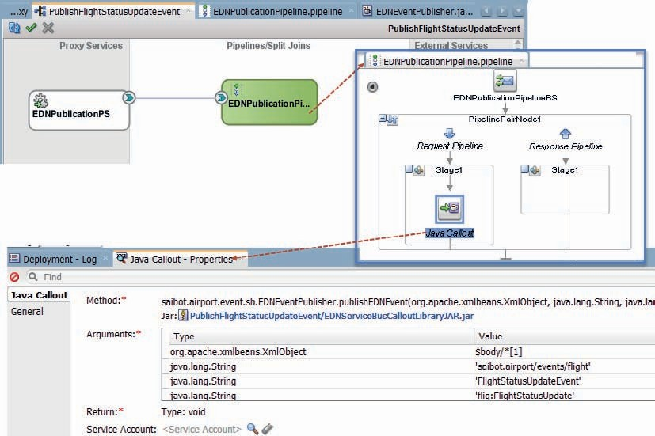

**FIGURE 15-15.** *Configuring the Service Bus project to publish events to EDN*

Deploy the project according to the *EDNServiceBusCalloutLibraryJAR* deployment profile, producing a JAR file.

Create a new Service Bus project called *PublishFlightStatusUpdateEvent*. Create a ProxyService *EDNPublicationPS* with service type Any XML. Generate a pipeline called *EDNPublicationPipeline* for this proxy service. Add a pipeline pair in the pipeline. Add a Java Callout in the request branch. Configure the callout to call method *publishEDNEvent* in *EDNEventPublisher* Class in JAR file EDNServiceBusCalloutLibraryJAR.jar. The first argument is set with the first element in the $body variable, the other three are set to saibot.airport/events/flight, FlightStatusUpdateEvent, and flig:FlightStatusUpdate, respectively, see Figure 15-15.

Run the Pipeline or the Proxy Service. Set the input to an XML document that is the payload for the *FlightStatusUpdateEvent*. The event should be published and, for example, consumed by a new instance of the *FlightStatusRelay* composite.

##### Consume EDN Events in Service Bus Using Inbound JMS Transport

Consuming EDN events can be done in Service Bus projects using a simple inbound JMS Transport. A Service Bus proxy service is subscribed as durable listener on the *EDNTopic* and

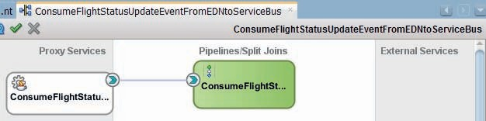

**FIGURE 15-16.** *The Service Bus project that consumes EDN events using an inbound JMS*

*Transport*

using a message filter we ensure that (only) all instances of a specific EDN event type are delivered into the proxy service.

Create Service Bus project *ConsumeFlightStatusUpdateEventFromEDNtoServiceBus*. Right click in the Proxy Services swim lane and select Insert Transports | JMS Transport. Set the name of the proxy service to *ConsumeFlightStatusUpdateEventFromEDN*. Expose the service as a pipeline, called *ConsumeFlightStatusUpdateEventFromEDNPipeline*. In step two of the Proxy Service wizard, set the service type to Any XML. In the third step, set the Endpoint URI to jms://<host_of_ SOA_managed_server>:<port_of_SOA_managed_server>/jms.fabric.xaEDNConnectionFactory/ jms.fabric.EDNTopic (e.g., jms://localhost:7101/jms.fabric.xaEDNConnectionFactory/jms.fabric. EDNTopic).

Complete the wizard. The project will now look like Figure 15-16.

With the current configuration, this Service Bus project will consume all events that published on EDN, regardless of type. We need to set a message selector on the Transport Details page for the proxy service. We can find the required expression by inspecting the durable subscription for the Mediator *FlightStatusUpdateEventHandler* in the *FlightStatusRelay* composite:

 (JMS_WL_DDForwarded IS NULL OR (NOT JMS_WL_DDForwarded)) AND EDN$namespace = 'saibot.airport/events/flight' AND EDN$localName = 'FlightStatusUpdateEvent'

Also set the Destination Type to Topic and check the box for Durable Subscription, as shown in Figure 15-17.

At this point, the event is consumed but nothing is done with it. In order to at least prove that EDN events of type *FlightStatusUpdateEvent* do indeed trigger the *ConsumeFlightStatusUpdateEventFromEDN* proxy service, we can add a Report activity in a Pipeline Pair in the *ConsumeFlightStatusUpdateEventFromEDNPipeline* that publishes a report with the entire event payload (which is loaded in the $body variable inside in the pipeline).

Deploy the project. Then publish the *FlightStatusUpdateEvent* using either the EM FMW Control or the Java Client or Service Bus project *PublishFlightStatusUpdateEvent* that were created in the previous sections.

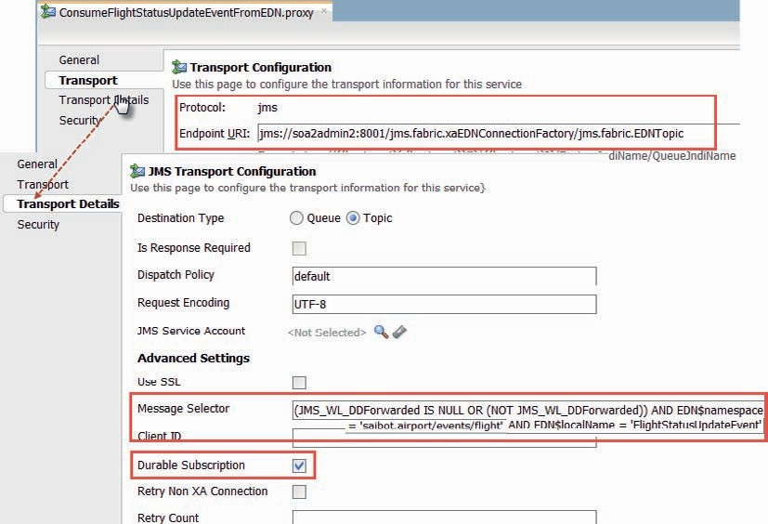

**FIGURE 15-17.** *Configuration of the inbound JMS Transport for consuming EDN events of type*

*FlightStatusUpdateEvent*

### Summary

Events add an important element to a service-oriented environment: they provide a means of interacting in a truly decoupled way. Consumers and publishers do not know about each other— yet they are hugely important to one another. The Event Delivery Network enables the exchange of events, from SOA composites through Mediator and BPEL components as well as other parties, including Service Bus and remote Java clients. This chapter demonstrated some of the key aspects of using EDN for publishing and subscribing and consuming events.

However, this only scratches the surface. Using events as integral part of the SOA opens up a lot of questions, challenges, and opportunities that require careful investigation. Note that events and the EDN will make appearance in some upcoming chapters, including the next one—on continuous event processing—and Chapter 19 on BPM.





CHAPTER

# 16

## Fast Data Processing with Oracle Event Processor

nderneath the tier of business events discussed in the previous chapter exists a world of fine-grained signals, measurements, and facts. This is the world of fast data where streams of time stamped data statements flow continuously through the IT systems. Live

**U**

data is produced by the IoT (Internet of Things)—all kinds of connected sensors, cameras, wearables, and other devices, as well as by social media such as Twitter and Facebook, and by sensors on mobile apps, web applications, administrative software systems, and business process engines.

By processing these streams, we may be able to learn important business information.

Aggregation, filtering, missing event detection, and pattern matching are some of the operations we can apply to promote findings from this avalanche of signals to the business level. Event processing typically produces business events that provide insight and trigger action. The interpretation of streams of data facts typically has to be done in (near) real-time, which adds to the challenge and necessitates the use of specialized technology.

A typical companion to event processing is business activity monitoring (BAM). Through BAM—both the act of monitoring and the product (to be discussed in Chapter 20), operational insight is provided through live dashboards and near real-time reports. It is common for results produced by event processing to be reported through a BAM dashboard.

The Oracle Event Processor (OEP) is a component integrated in SOA Suite that provides the capability to process fast data and produce business events from continuous streams of fine-grained data events. OEP can consume fast data from various channels—including JMS, EDN, HTTP/REST, RMI—and supports creation of custom adapters for collection fast data from, for example, Twitter, messaging systems such as Tibco Rendezvous, Sockets, APIs from financial data feeds, etc. Similar adapters are used to publish the outcomes produced by OEP. The integration between OEP and SOA composites and Service Bus hinges on

JMS and EDN.

OEP is not only for processing huge volumes of events. It will also be the tool of choice for detection of predefined patterns that span cross process instances and service calls. OEP can be made to remember business events for quite some time and rapidly correlate additional (or missing) events to produce a relevant insight or alert.

Stream Explorer (SX) is a tool on top of OEP, targeted at the Line of Business User (the nontechnical IT consumer). This tool provides a visual, declarative, browser-based wrapper around Oracle Event Processor, and Oracle BAM. With Stream Explorer it is every easy to create explorations and dashboard on live (streams of) data—reporting in real time on patterns, correlations, aggregations, and deviations.

In this chapter, we will use OEP to process a simulated feed with car park events that report cars entering and leaving one of the car parks at Saibot Airport. These events are processed to produce messages on JMS whenever a car park is close to filling up. Using the event stream, OEP will detect towing candidates: cars that have been abandoned or that at least have stayed in the car park for longer than 48 hours. OEP will also produce *car stay* events—derived from the base *car entry* and *car leaving* events—that are then aggregated to produce *average car stay duration* reports.

Finally, OEP is used by the security department at Saibot Airport—to detect a string of suspicious credit card transactions in the airport’s shopping area, following a specific pattern identified in earlier theft cases. Such findings are reported as business events on EDN to be taken care of by one or more SOA composite applications.

### Sorting Out the Real-Time Data Avalanche

The term ongoing events can refer to many different things—from fairly high-level business events such as signing a long-term agreement with some vendor or the arrival of a large order from a wholesaler, to tiny crumbs of information such as the current temperature in a fridge, a click on a navigation link in the patient self-service web application, the heartbeat of some device, or the fact that some security badge was scanned to gain entry into a storage room. The higher-level events typically have a much lower frequency—counted in occurrences per hour or day—than the lowest-level data grains, arriving in up to thousands per second. The information contents of these two ends of the events spectrum tend to range from rich for the high-level, low-frequency events, to quite sparse for highly frequent packets.

An important aspect of the processing of these events is that much of it must be done in real time. Ongoing business leads to continuous streams of events that may require instantaneous actions. We cannot afford to just dump all the data into data warehouses that we will analyze later on, even though for some of the (derived) data that is, of course, exactly what we will do. The urgency of some of the reactions the events may prompt us to come up with is one reason. The sheer volume of the data is another: Thousands of low-level events occurring every second represent tons of data that a data warehouse cannot comfortably handle—and should not handle, as the vast majority of those events represent entirely useless information, especially when considered by themselves.

Therefore, we need a way to process the zillions of events that the business operation keeps on producing. A processor that turns these events into information—usually by producing a higher-level type of event that has some special business meaning, carries a larger information payload and is produced at much lower frequencies. This is illustrated in Figure 16-1. Typically the events produced by the processor are propagated in a more generic, canonical way, both in terms of protocol and channel as well as information structure.

After the first stage of event processing, downstream consumers absorb the higher-level events. These consumers can do several things, including sending out alerts or notifications, updating a real-time report or dashboard, taking actions such as invoking a web service or starting a human task, or loading data into a data warehouse. These downstream consumers can also further process the events—into even higher-level, more meaningful events. These events are then propagated through a next iteration of event processing.

Events

* Information
* Conclusion
* Alert
* Recommendation
* Action

Smart Processing:

* Filter & Discard
* Enrich
* Aggregate
* Pattern detection
* Promote/Propagate

**FIGURE 16-1.** *Event processing—increasing information content and decreasing frequency*

#### Complex Event Processing

Finding the (missing) needles in the haystacks of large volumes of continuously arriving, largely individually meaningless events is the purpose of Complex Event Processing (CEP), also known as Intelligent Event Processing (IEP). CEP is a field that came to existence in the early 1990s, first in academic circles, such as Stanford University and the California Institute of Technology, and later in the IT industry. Many large vendors are active in this space (some after recent acquisitions), including SAP, Microsoft, Software AG, IBM, Tibco, JBoss, and EsperTech. These vendors offer various software products that provide “operational intelligence” through real-time computing that involves pattern matching with their respective intelligent or complex processors of event streams.

Event processors consume events from heterogeneous sources—such as JMS queues, JMX MBeans, incoming HTTP requests and WebSockets and native API calls, Message Driven Beans, data grids, Hadoop/NoSQL, and relational databases. The outcome of processing consists primarily of another, high-level generation of events that are sent through usually more homogenous channels in canonical data formats. Note that the event processors are decoupled from both the producers of the events they process and the consumers of the events they produce.

The processors perform the following operations on incoming events resulting in the events they publish:

* *Filter* Finding the needles in the haystack, those rare events that indicate exceptions.
* *Enrich* Adding context and thereby (business) meaning to events.
* *Aggregate* Counting events or determining a sum, an upper or lower limit, or an average over a metric that the events carry in their payload.

###### NOTE

*An aggregate is frequently calculated over a window that consists of all events in the specific timeframe or a specified number of the latest events.*

* *Pattern detection* Spotting a trend by comparing correlated events over a period of time, finding a special sequence of values or value changes that is known to herald a certain

incident, and discovering the absence of an event that should have occurred are all examples of the detection of meaningful patterns among a string of correlated events.

* *Promote or propagate* The result of the preceding operations can be to propagate the event, either as is or in an enriched or promoted state, or to publish entirely new events

that carry an aggregated value, some indicator, or an alert.

###### TO BE CLEAR

*The word complex in Complex Event Processing does not refer to the events—they are usually extremely simple—but rather to the processing that takes place. Especially the detection of patterns can be very advanced, considering the complexity of the patterns and the addition of the challenges of continuously processing very large volumes of events in real time.*

**The Event Processing Language**

Event processors need to be programmed. They are like query engines that need to query streams of events—not static sets of records, but incessantly changing collections of data granules. Event queries are not executed just once. They are instead attached to an event stream and continuously executed. Every new arriving event may cause the event query to produce a new result. Results are constantly being published in the form of events.

Over time, special languages have evolved for programming the event processors under the generic label of Event Processing Language (EPL). However, no single standard unified EPL has emerged in the industry. Several quite dissimilar EPLs are used for various CEP products. Some EPLs are derived from or inspired by Business Rule Languages. Other EPLs are inspired by, derived from, or even integrated with SQL. The widespread knowledge of SQL can be leveraged when programming event processing queries. It also turns out to be quite handy to be able to combine event streams and relational data sources in a single query (e.g., to join historical and reference data with the live event feed). This union of SQL and EPL, resulted in CQL, the Continuous Query Language, which has its roots at Stanford University. CQL is the core technology used in OEP applications for processing and producing events.

###### TIP

*The Match_Recognize operator introduced in Oracle Database 12c to perform pattern matching on relational data sets also makes use of the CQL syntax to construct the pattern query.*

CQL queries select from an event channel, often with some range or time window applied, using a where clause to filter on the events that are returned by the query. The select clause refers to event properties and uses functions and operators to derive results. Note that multiple channels and other data sources can be joined—yes: even outer joined—together in a single CQL query.

Here is a simple example of a CQL query that produces an output event whenever the number of input events in the *someEventStream* with a payload value larger than 15, changes, considering a time window that ranges over the last 5 seconds:

 **select count**(payloadValue) **as** countEvents

**from** someEventStream [range 5]

**where** payloadValue > 15

The number of results produced by this query cannot be predicted: it depends on the frequency and irregularity with which events appear in the event stream. When, for example, exactly one event per second is published to the stream, the number of events in a 5-second window will not change and after the first 5 seconds of running the query, no additional events would be produced by the query.

##### Downstream Event Consumers

The Event Processor brings us only part of the path from data to insight and action. It only speaks in events on channels such as JMS—not directly with people or even web services—and it has no user interface of its own—except the browser-based Visualizer that is used as administration and monitoring console. The events published by OEP—no matter how advanced and enriched they may have become—need to be consumed and turned into something else: a report or dashboard, an alert or an action.

OEP applications typically publish their findings in the form of fairly generic messages on a JMS queue, messages to the EDN or HTTP channel, as data packets on a data grid or as record into a NoSQL database, or as requests to a web service interface or to some other standard facility. Many different products can therefore be used downstream of OEP to absorb the events and do something with them: load in a data warehouse, use to refresh a real-time dashboard, update a database record, notify a web service, send an email or text message, create a human task, or publish on a website or RSS feed. Note that it is not uncommon to have multiple chained OEP instances, each one processing a decreasing volume of higher business level events.

In this chapter, we will use the most common channels: JMS and the SOA Suite Event Delivery Network (EDN) for publishing the OEP outcomes.

#### Oracle Event Processor and SOA Suite

The Oracle Event Processor is part of the SOA Suite license. However, it is not part of the SOA Suite SCA container—it does not even run in the same WebLogic Server as the SOA Suite does. It runs on its own streamlined, lightweight server—which is POJO based, founded on Spring DM and an OSGi-based framework to manage services. This server comes with Jetty, an HTTP container for running servlets, and support for JMS and JDBC. It has caching and clustering facilities—possibly backed by an Oracle Coherence grid. OEP can handle thousands of concurrent queries and process hundreds of thousands of events per second. The average message latency can be under 1 ms.

Messages are typically read from JMS—for example, a queue in the SOA Suite WebLogic Server – or the EDN (backed by JMS). However, tables can be used as an event source as well, and through custom adapters, we can consume messages from virtually any source, including files, sockets, NoSQL database, and JMX.

The OEP server provides an HTTP Pub/Sub event channel based on the Bayeux protocol; this allows the OEP application to consume messages pushed from a Bayeux-compliant server as well as allows clients to subscribe to messages published by the OEP server. Clients can also publish to an HTTP channel without having to be explicitly connected to the HTTP Pub/Sub server.

Event messages are typically processed by CQL processors—nodes in the event processing network (EPN) that receive messages from stream sources and act on them to produce new event messages. The outcome of a CQL query is typically a stream of events.

OEP provides additional facilities, such as the ability to record events flowing through an event processing network and store them. They can later be played back from the event repository—very useful for testing.

The OEP Visualizer is a web application that is the administration console that enables you to view, develop, configure, and monitor aspects of Oracle Event Processing applications. OEP applications can be deployed, paused and resumed, and uninstalled from the Visualizer. Current operations can be monitored, including all console output. It also has support for visual and

run-time CQL Query editing. Events published on an HTTP Pub/Sub channel can be monitored in the Visualizer, asynchronously pushed by the server to the browser.

### Car Park Management Using Event Processor

Saibot Airport makes a lot of money from the car parks around the airport. Close monitoring and careful management of the parking process is important for that reason and because it is an important aspect in the evaluation by travelers in airport surveys. Indicating, at the right time, that

a car park is full, for example, prevents people from needlessly driving in circles to find a free spot. However, too early warnings mean that people are unnecessarily forced to park their cars on the more remote car parks—not necessarily improving their experience.

In this section, we will see how an OEP application is created to process all events signaling a car entering or leaving a car park and thus deriving the number of cars currently inside the car park. The application will publish a special event when the car park is declared full. And it will publish a similar event when spaces become available again.

#### Preparation of the Development Environment

OEP 12*c* applications are developed in JDeveloper. These applications are deployed to and run on an instance of the OEP server. This server is not part of the integrated WebLogic Server and is separate from the SOA Suite 12*c* run-time environment based on WebLogic. The OEP run time is an OSGi server that needs to be installed separately.

Install OEP 12*c* according to online instructions on the book’s website and create the *SaibotOEP* domain as described. Create a connection to your local OEP server in JDeveloper. Using this connection, from the context menu you can start and stop the server, watch its logging output and deploy, suspend, activate, and undeploy OEP applications.

When the OEP server is running, you can open the log window inside JDeveloper—using the right mouse button menu option Open OEP Server Log Page. Alternatively, you can use the OEP Visualizer tool that runs in the browser at: host:port/wlevs/. This tool includes the console output window—under Domain | defaultServer | Services | Console Output, as shown in Figure 16-2.

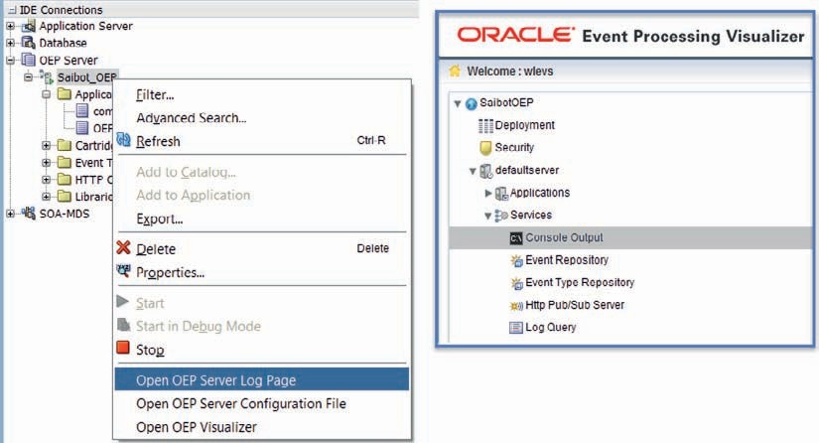

**FIGURE 16-2.** *Showing the OEP connection in JDeveloper (and the available actions) on the left*

*and the Event Processing Visualizer browser application on the right*

#### The Saibot Parking OEP Application

In JDeveloper, create a new application based on the template OEP Application. Call the application *SaibotParking*. Create an OEP project *CarParking_step1* inside the application—based on the Empty OEP project template. The application is created with an empty Spring context file called CarParking_step1.context.xml—which will contain definitions of beans, events, channels, and processors and a file called processor.xml that is used to store the CQL queries. The EPN diagram visualizes the Event Processing Network that is defined in the context file. The MANIFEST.MF file finally contains OSGi definitions—for the application itself and all its bundle dependencies.

##### Define Event CarMovementEvent

Events in OEP can be defined entirely declaratively or based on a Java bean (a POJO). We will adopt the latter approach. Create a Java Class *CarMovementEvent* which is a POJO with these properties:

 private String carparkIdentifier;

private Integer entryOrExit; // 1 for arrival, -1 for exit private String licencePlate;

private Long arrivalTime;

Generate getter and setter methods for these properties.

Open the EPN diagram. Click on the tab Event Types. Add a new event type to the CarParking_step1.context.xml. The new event is called *CarMovementEvent* and is based on the Java bean with that name.

Create a second Java Class, called *CarParkEvent* with these properties:

 private String carparkIdentifier;

private Integer carCount; // number of cars currently in the carpark private Float percentageFull; // % of capacity currently taken up private Long averageStayDuration; // in nanoseconds, OEPs unit of time

Again, generate getter and setter methods. And, as before, create an OEP event type—called

*CarParkEvent*—based on this Java bean.

##### Create Car Movement Simulator

OEP uses adapters to feed events into the EPN. Adapters can collect events from external sources—such as JMS, HTTP, RMI, and EDN. During development and for testing purposes, it can be very handy to create an adapter that generates events rather than retrieves them from an external source. Any Java Class can act as such an event generator, as long as it implements the *StreamSource* interface.

Create a Java Class called *CarMovementController* that implements this interface, as well as the *Runnable* interface to allow instances to schedule calls to themselves. A very simple implementation of a generator of *CarMovementEvents* looks like this:

 public class CarMovementController implements RunnableBean, StreamSource { private static final int SLEEP_MILLIS = 100; // time between events private boolean suspended;

private StreamSender eventSender;

private static Random rand = new Random();

public static int randInt(int min, int max) {

int randomNum = rand.nextInt((max - min) + 1) + min; return randomNum;

}

private String randChar() {

return new Character((char) randInt(65, 90)).toString();

}

public void run() { suspended = false;

while (!isSuspended()) { // Generate messages forever... generateCarMovementEvent();

try { synchronized (this) {

wait(SLEEP_MILLIS * randInt(1, 5) / 2);

}

} catch (InterruptedException e) { e.printStackTrace();

}

}

}

private void generateCarMovementEvent() { CarMovementEvent event = new CarMovementEvent(); event.setEntryOrExit(1); event.setCarparkIdentifier("1");

event.setLicencePlate(randChar() + randChar() + "-" + randInt(1, 999) + "-" + randChar() + randChar());

eventSender.sendInsertEvent(event);

}

public void setEventSender(StreamSender sender) { eventSender = sender;

}

public synchronized void suspend() { suspended = true;

}

private synchronized boolean isSuspended() { return suspended;

}

}

This class generates at a somewhat random rate car arrival events with randomly generated license plates. Later, more advanced incarnations of this class will derive car exit events as well and will generate events covering five different car parks.

###### NOTE

*It pays off to spend considerable effort on creating the event generator. It is a key element in the development and testing of the OEP application and ideally it should cover all use cases you want to be able to process.*

##### Create the Event Reporting Bean

The output from the OEP application can be reported through outbound adapters to external receivers, such as a JMS destination, an RMI client, a Socket endpoint, or the Event Delivery Network. During development and for testing purposes, it is frequently convenient to work with an internal event receiver. A simple Java Class that implements the *StreamSink* can be used to receive the outcomes from the event processor and, for example, write them to the console.

Create Java Class *CarParkReporter* that implements that interface and that write simple logging lines based on the events it receives:

 public class CarParkReporter implements StreamSink {

public void onInsertEvent(Object event) { if (event instanceof CarParkEvent) {

CarParkEvent cpe = (CarParkEvent)event; System.out.println("Current number of cars parked in Car Park "

+cpe.getCarparkIdentifier()+" : "+cpe.getCarCount()

+" percentage full "+(cpe.getPercentageFull())+"%"

+" The average stay of cars is "

+(0.1*Math.round(1E-08*cpe.getAverageStayDuration()))

+" seconds."

);

}

if (event instanceof CarMovementEvent) { CarMovementEvent cpe = (CarMovementEvent)event;

System.out.println("Car with licence plate "+cpe.getLicencePlate()

+" just "+ ( cpe.getEntryOrExit()==1?"arrived at":"left from")

+" car park "+cpe.getCarparkIdentifier()

);

}

}

}

##### Create the Event Processing Network

Open the EPN diagram. Drag an Adapter component to the diagram. Call the adapter *carMovementEventGenerator* and select the *CarMovementController* as the Java Class to implement the adapter.

Drag a Channel component to the diagram. Set the name of the channel to *carMovementInputChannel* and select the *CarMovementEvent* as the event type to flow through this channel. Connect the Adapter to the left hand side of the channel—to specify that the output from the adapter is the input for the channel.

Add a Processor component to the diagram. Set its name to *carMovementProcessor* and accept the default processor.xml file for the Configuration Location. Connect the *carMovementInputChannel* to the input (left-hand side) of the processor.

Add a second Channel component, called *carParEventChannel*. Set its event type to *CarParkEvent*.

Connect the output from the *carMovementProcessor* to the input side of this channel. Add a Bean component to the diagram. Call it *carParReporter* and select Java class

*CarParkReporter* as its implementation class.

Connect the output from the *carParEventChannel* to this bean. Also connect the output from the *carMovementInputChannel* to the *carParkReporter*.

The diagram should now look like Figure 16-3. This is the visualization of the configuration defined in CarParking_step1.context.xml.

The element still lacking from the application is the actual CQL query that processes and in this cases aggregates the *carMovement* events. Open file processor.xml. It contains the *carMovementProcessor* element with a query with id *ExampleQuery*. Replace the query element with this snippet:

 <query id="CarparkSummary"><![CDATA[

IStream(select sum(car.entryOrExit) as carCount, car.carparkIdentifier from carMovementInputChannel as car

group by carparkIdentifier) ]]>

</query>

##### Deploy and Test

The application can be deployed. Upon deployment, the *CarMovementController* will immediately start producing events and the processor will also immediately kick into action.

Right click on the project in the application navigator. From the context menu, select Deploy | oep_profile−1. The deployment wizard appears. Accept the default deployment action—*Deploy OSGi bundle to target platform*. Press Next. On the second page, check whether the *Saibot_OEP* server is the target server. If it is and the server is running, press Finish to perform deployment.

Check the log window—either in JDeveloper or in the Visualizer console. You will notice a steady flow of messages—one announcing a car that arrives and a second one that gives an update on the current number of cars in car park number one. CQL will publish a result in this case whenever the previous result is superseded by a new one—that is, with every new car that enters the parking lot.

Such an update of the car count is not really required for every car that enters. We may want to settle for a summary update every 5 seconds. This is easily accomplished by rewriting the from clause as:

 from carMovementInputChannel [range 1 DAY slide 5 second] as car

Here we have specified that the results from the query are to be calculated over 1 day worth of (input) events and should be produced once every 5 seconds. Make this change and redeploy the application. The summary messages will be less abundant than before.

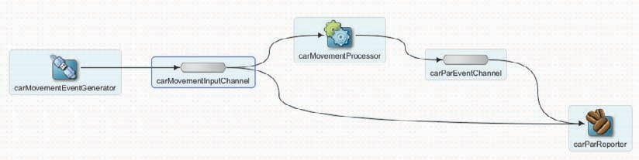

**FIGURE 16-3.** *The EPN diagram for processing carMovementEvents and sending all output to*

*the carParkReporter bean*

### More Event Intelligence

OEP can do much more than just count and aggregate. In this section, we will look at how we can correlate events, detect “missing” events and derive business intelligence from them.

Chaining OEP processors—within or across applications—is commonly done to derive varying conclusions from a certain base set of data signals at different levels of granularity; this can be done across applications or within. We will use several processors inside our application.

In this section, we determine for cars that leave how long have they stayed in the car park; we could use that to automatically calculate the parking fees. We next extend our summary with the average stay duration of cars. We look for cars that have out-stayed their welcome: our car parks are short stay only, intended for parking up to 36 hours. Cars that have been in the car park for more than 48 hours become candidate for towing.

Instead of going through every detailed little step and filling this chapter with a lot of long code fragments, the reader is kindly requested to download the book’s resources—and in particular the projects CarParking_step2 and _step3 under the Chapter 16 source folder. These projects contain all sources, the salient points of which are discussed below.

An important role is played by the *CarMovementController*—the event generator. This class has been extended to:

* Generate events for cars that leave a car park (when the initial event for the car arrival is generated, the randomly derive time for departure is recorded for the car in a *TreeSet*

sorted on departure time; whenever a car arrives at the car park, the *TreeSet* is inspected to see whether the top of the list should depart in which case car exit events are generated).

* Generate events for a set of (currently five) different car parks—each with a specific capacity; the generator respects the capacity, ensuring that not more cars are admitted to

the car park than the capacity allows.

It is common to want to enrich events at some point during the processing. For example, because events have to be placed in context, such as which car park did the car arrive at, what is that car park’s capacity or its location, and what name should be passed in the business event published to JMS or EDN.

Having to call out to, for example, a relational database each time an event has to be enriched can be quite expensive and is quite unnecessary for (fairly) static data. OEP supports the use of caches to store such data and allows joining to caches in CQL queries. OEP has its own internal (local) cache implementation system. Alternatively it supports use of Coherence (local and distributed) as well as third party caching solutions.

In the current example of the car parks, a cache is defined in the context file, using the internal caching mechanism. A Java class—*CarParkCacheLoader*—is created to provide the static data for the cache. A bean based on this class is configured as the cache-loader for the cache. The CQL query in the *carParkEvent* processor uses the cache to enrich the

*CarParkEvent* with the name of the car park. In the next section, the car park’s capacity is also retrieved from the cache and used to determine to what extent the car park is filled with cars.

In order to make use of caches, the MANIFEST.MF file has to be edited. The bundle com.bea.cache.jcache has to be added to the list of dependencies.

#### Car Stay Duration—Derived per Car and Promoted per Car Park

One thing OEP excels at is correlating events. It can find patterns across events that arrive at various points in time. In this example, we will have OEP associate the arrival and exit events for the same car. These events together constitute the “car stay” for which we could calculate the parking fee. By taking all these car stay events into consideration, we can have OEP calculate the average stay duration—per car park. Figure 16-4 shows the EPN for this approach.

##### CQL to Compose CarStayDone Events

The key CQL operator we leverage to correlate events into meaningful patterns is called MATCH_ RECOGNIZE. The query used in the carStayDoneProcessor uses the following clause:

 ... from carInputChannel match_recognize (

partition by carparkIdentifier, licencePlate measures A.licencePlate as licencePlate

, A.carparkIdentifier as carparkIdentifier

, A.arrivalTime as arrivalTime

, B.element_time - A.element_time as stayduration

**pattern (A B) define**

**A as entryOrExit= 1**

**, B AS entryOrExit = -1**

) as stayed

The crucial element in a MATCH_RECOGNIZE expression is the pattern that should be detected in the event stream. In this case, the pattern consists of events A and B that both apply to the same car park and car (through the license plate) as defined by the partition by clause. Additionally, for this one car, A is the arrival event (*entryOrExit* equals 1) and B the subsequent exit event.

Whenever these two events have been found—with no other events in between with different values for the *entryOrExit* attribute—the query will produce an event of type *CarStayDone*. The *stayduration* measure is calculated using the pseudo column *element_time*. Every event is time stamped by OEP in such a way that the difference between the *element_time* value for two events is equal to the time lapse (in nanoseconds) between the two events.

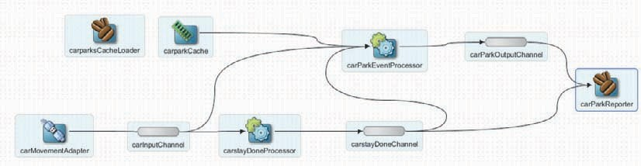

**FIGURE 16-4.** *The Event Processing Diagram for the CarPark events—deriving Car Stay*

*Complete events and Average Car Stay Duration insight with cache-based enrichment*

##### CQL to Calculate the Average Car Stay Duration

Using the *CarStayDone* events published to the *carstayDoneChannel*, it becomes quite simple to derive the *CarParkEvents* that report the average stay duration for each car park—with an update published whenever a car leaves a car park. The CQL snippet below takes care of this. Note that the average duration in this case is calculated over the last 100 cars that have left the car park.

 <query id="CarparkAvgStayQuery"><![CDATA[ IStream(select -1 as carCount

, carparkIdentifier as carparkIdentifier

, '' as description

, avg(carstayDuration as averageStayDuration from carstayDoneChannel [rows 100]

group by carparkIdentifier

)

]]></query>

When you inspect the contents of the processor.xml file, you will notice that for *carParkEventProcessor*, there are two query elements in the <rules> element. You can define multiple queries in a processor—and each of them is continuously executed. They all need to provide the same event type, obviously, to feed into the output channel. Note how the view *CarparkStatusView* contains the join between the *CarparkStatus* view and the *carparkCache*—which is used to enrich the *CarParkEvent* with the name of the car park that is retrieved from the cache.

#### Find Towing Candidates

As discussed before, frequently the absence of an expected event is what we should detect and what should result in a new business event to be published. In our case of airport parking, the missing event is the car that does not leave our short stay car park in time.

The event generator has been extended to also come up with cars that will not depart any time soon. Our OEP application should be able to detect such cars—that do not leave within 120 seconds (on the time scale of our sample application). See the sources in project CarParking_step3 for this step.

A new event was defined—*AbandonedCarEvent*—based on a POJO with that name. Java class *AbandonedCarsMonitor* implementing the *StreamSink* interface was created to receive these events and write a log message for them. The *abandonedCarsProcessor* was added to process the events from the *carInputChannel*, detect the abandoned cars and report on them to the *abandonedCarsOutputChannel*, as shown in Figure 16-5.

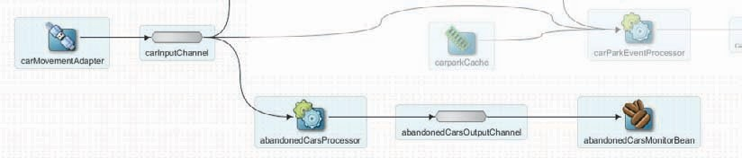

**FIGURE 16-5.** *The EPN flow for detecting and reporting on abandoned cars—using the missing*

*event detection pattern*

The next CQL snippet is at the heart of the processor.

 from carInputChannel match_recognize (

partition by carparkIdentifier, licencePlate measures A.licencePlate as licencePlate

, A.carparkIdentifier as carparkIdentifier

, A.arrivalTime as arrivalTime

**INCLUDE TIMER EVENTS**

**pattern (A NotExit*) duration 120 seconds define**

**A as entryOrExit= 1**

**, NotExit AS entryOrExit!= -1**

) as abandoned

Again, we inspect the *CarMovementEvents* on the *carInputChannel*. We are looking for the pattern A—entry of a certain car, followed by the *NotExit* event—which has been defined as an event for which the *entryOrExit* value is not equal to −1. A car that has entered the car park can do nothing than at some point leave that car park again generating an event with entryOrExit = −1 at that point. And if it does, it is not abandoned.

OEP allows us to mix in system-generated timer events with the regular event stream— using the INCLUDE TIMER EVENTS instruction, combined with the clause DURATION 120 SCONDS. These tell OEP that in every partition of the event stream—for every license plate and car park combination for which we have seen a first *CarMovementEvent*—a system event should be added every 2 minutes if and when there has not been a real event in that two minute timeframe. Subsequently, when such a timer event *is* added for a certain car—because for 120 seconds there has not been a real event, which should have been

the “car exit” event—the pattern will match for that car because the system-generated timer event does not have *entryOrExit* equals −1. In fact, timer events do not have attribute values at all.

### Publish Car Park Nearly Full events to JMS Destination

As part of car park management, it is important that Saibot staff has good insight into the fullness of each car park. When a car park crosses the 90 percent full marker—and it is not just a fluke peak but it has already been over 85 percent for some time—the car park is declared full. Another car park may be opened and the road signage is updated accordingly.

We will first extend the OEP application to calculate the state of all car parks—using the current car count that we already calculated and the capacity of the car park retrieved from the cache. The percentage filled is added to the summary that already reports the car count. Next, a message is published to a JMS destination to alert any listener about the car park situation.

See the sources in project *CarParking_step4* for this step.

#### Calculate the Percentage Full for Each Car Park

The *CarParkEvent* processor’s CQL statement that joins with the *carparkCache* is extended to calculate the percentage full for the car park. This number is added to

the *CarParkEvent* and reported in the *CarParkReporter* bean. The essential CQL snippet is shown here:

 <view id="CarparkStatusView"><![CDATA[

RStream( select carCount, car.carparkIdentifier as carparkIdentifier

, R.name as description

**, to_char(100*carCount/R.capacity) as percentageFull**

from CarparkStatus[now] as car

, carparkCache as R

where car.carparkIdentifier = R.identifier

)

]]></view>

#### Publish the CarParkNearlyFull Event

A new event is defined: *CarParkNearFullEvent* based on a Java class with that name. It is reported on by the extended *CarParkReporter*. A new processor is added (shown in Figure 16-6): the *carParkNearlyFullProcessor* that reads from the *carparkCache* and the *carInputChannel* with *CarMovementEvents* and publishes to the new *carParkNearlyFullChannel*.

This processor has to check the car park’s car count (the first view) and compare it to the capacity of the car park that it can pull from the cache (the second view). The third view produces the lowest car count in the last 30 seconds (comparable to perhaps 5 minutes in real life). Finally in the view itself, we produce a car park nearly full event when the current car park fullness percentage is >= 90 and the lowest percentage over the last 30 seconds is 85 or higher—so we do not start publishing a panicky event the first time we cross the 90 percent boundary for only a very brief moment. Note how multiple views can be defined in a processor, referring to each other, similar to inline views in an SQL statement.

 <processor>

<name>carParkNearlyFullProcessor</name>

<rules>

<view id="CarparkStatus"><![CDATA[

IStream(select sum(car.entryOrExit) as carCount

, car.carparkIdentifier

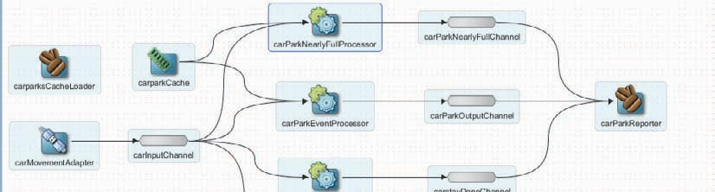

**FIGURE 16-6.** *The EPN diagram with the flows for spotting nearly full car parks*

</view>

from carInputChannel as car group by carparkIdentifier) ]]>

<view id="CarparkNearlyFullView"><![CDATA[ RStream( select car.carCount

, car.carparkIdentifier

, to_char(100*car.carCount/R.capacity) as percentageFull

, R.capacity as carParkCapacity from CarparkStatus [now] as car

, carparkCache as R

where car.carparkIdentifier = R.identifier

)

]]></view>

<view id="CarparkStatusView"><![CDATA[

RStream( select min(carCount) as recentLowCarCount

, carparkIdentifier

from CarparkStatus [range 30 second] as car group by carparkIdentifier

)

]]></view>

<query id="CarparkNearlyFullQuery"><![CDATA[ IStream( select carCount

, c1.carparkIdentifier as carparkIdentifier

, percentageFull

from CarparkNearlyFullView[now] as c1

, CarparkStatusView[now] as c2

where c1.carparkIdentifier = c2.carparkIdentifier and percentageFull >= 90

and (100*c2.recentLowCarCount/c1.carParkCapacity) >= 85

)

]]></query>

#### Publish from OEP to JMS

The *CarParkNearFull* event has to be pushed outside the OEP application, so the world—or at least carpark management staff at Saibot Airport—learns about it. OEP can publish events to various outbound channels. In this case, we will use JMS. We have to configure the JMS Destination, add an outbound JMS adapter in the OEP application and extend its manifest file, and create a bean that converts the OEP event to the JMS message.

##### Configure JMS Destination on WebLogic

Add a JMS Queue (or Topic) to your desire, for example, in the *SaibotJMSModule* (see Chapter 6) in the WebLogic Server that runs SOA Suite, and, for example, called jms/facilities/ CarParkNearlyFullQueue.

##### Add an Outbound JMS Adapter

Open the EPN diagram and drag an outbound JMS adapter on to it. The JMS Adapter wizard appears—though not the same one as used in SOA composites and Service Bus services. In OEP

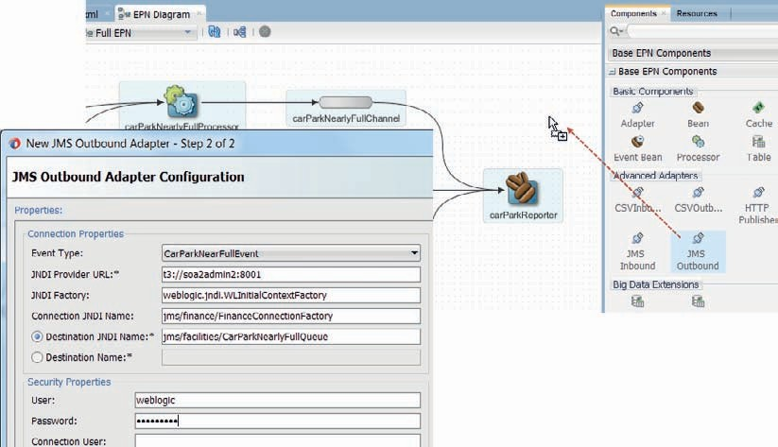

**FIGURE 16-7.** *Configuring the outbound JMS adapter—connected to the CarParkNearlyFullQueue*

we do not use the same JCA adapters. Set the name to carpark-nearly-full-jms-outbound-adapter. Press Next. Configure the adapter as shown in Figure 16-7.

Connect the *carParkNearFullChannel* to the freshly added JMS adapter.

##### Add Dependencies to Project and OSGi Manifest

The OEP project properties have to be edited. Add a dependency on the Java EE library (to cover the standard JMS API dependencies). A dependency has to be added on the JAR com.bea.wlevs. adapters.jms_12.1.3.0_0.jar. This file is located in the oep\modules directory under the OEP Home directory.

Similarly, in order to successfully deploy the OEP application, its MANIFEST.MF file needs to be extended with two new bundle dependencies introduced because of use of JMS.

Add these two lines:

 com.bea.wlevs.adapters.jms.api;version="12.1.3", javax.jms,

##### Create Message Converter

The JMS adapter can process the events produced by the EPN in an OEP application into JMS MapMessages with entries named after the event properties. For this to happen, an instance- property with name *eventType* and value *CarParkNearFullEvent* has to be configured on the JMS adapter in the Spring context file.

This automatic conversion does not work for complex event properties—such as List—and may not always produce the desired result. It is easy and common to create

and configure a message converter on a JMS adapter that will process the event into the desired *MapMessage*.

In this case, create Java class *CarParkNearlyFullEventConverter* that implements interface *OutboundMessageConverter*. Provide code in the *convert* method—that takes a JMS session and your own OEP Event object as input and returns a List<Message>. A simple code snippet is shown here:

 public List<Message> convert(Session session, Object inputEvent) throws MessageConverterException, JMSException {

CarParkNearFullEvent event = (CarParkNearFullEvent) inputEvent; MapMessage message = session.createMapMessage(); message.setString("carparkIdentifier", event.getCarparkIdentifier()); message.setFloat("percentageFull", event.getPercentageFull()); List<Message> messages = new ArrayList<Message>(); messages.add(message);

return messages;

}

Then define a bean in the Spring context file and configure the bean as the converter for the JMS adapter, using the following configuration:

 <bean id="carParkNearlyFullEventConverter" class="saibot.airport.facilities.parking.jms.CarParkNearlyFullEventConverter"/>

<wlevs:adapter id="carpark-nearly-full-jms-outbound-adapter" provider="jms- outbound">

<wlevs:instance-property name="converterBean" ref="carParkNearlyFullEventCon verter"/>

</wlevs:adapter>

#### Deploy and Run—and Listen

With the application completed, you can now deploy it to the OEP server. The output from the reporter bean will immediately be visible in the log window. From this moment on, messages can also be published to the JMS Queue—whenever a car park is seen to be almost full. You can check on the contents of the JMS Queue in several ways—in the WebLogic console, using the QBrowser, through an SOA composite or Service Bus service with inbound JMS adapter or transport, or through a custom JMS client. The latter is included in the online sources—in the project *CarParkNearlyFullQueueListener*. Note that you probably have to change the connection properties in the source.

Figure 16-8 shows a fragment of the logging output produced by the OEP application.

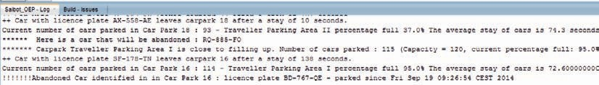

**FIGURE 16-8.** *Some of the logging produced by the OEP application for various car park–*

*related events*

### Publish Car Park Nearly Full Events to Event Delivery Network

The messages published to the JMS destination can of course be read by inbound JMS adapters in SOA composite applications and then turned into business events on the Event Delivery Network (EDN). However, OEP can publish events directly onto the EDN—as we will see next. Note that OEP also has an inbound EDN adapter that allows it to read and process the business events published on the Eevent Delivery Network.

The EDN event is defined—as introduced in Chapter 15—using an EDL file with an associated XSD definition of the payload. These files are imported into the OEP application and referenced from an outbound EDN adapter. A smatter of SQL/XML is added to the CQL query to produce the EDN event’s payload in the right format. An SOA composite application subscribed to the EDN event will be triggered whenever OEP produces the *CarParkNearFullEvent*.

The sources for this next step are found in project *CarParking-step5*.

#### SOA Composite Application for Responding to a Nearly Full Car Park

Create a new SOA application called *SaibotParkingStaff* with a project with that same name based on the *empty* template. In his application, we will first define the EDN event and then create a Mediator that subscribes to the event and writes a line to a log file through a File Adapter.

##### Define EDN Event

Create an XSD file called FacilitiesEvents.xsd in the Schemas folder, with target namespace *saibot. airport/facilities*. Define an element *CarParkAlmostFullEvent* and associated type *carParkAlmostFullEventType* with children to hold the key attributes of the event. These describe the payload for the EDN event. Check in the online resources for an example.

Right click on the Events folder and select New | Event Definition from the menu. Enter *FacilitiesEvents* as the name for the EDL file and use the same namespace as in the XSD document. Create a new event called *CarParkAlmostFullEvent* based on the XSD element with that same name.

##### Mediator to Consume Event

Add a Mediator to the composite, called *CarParkAlmostFullHandler*. Select the template *Subscribe to Events*. Select the *CarParkAlmostFull* event as the one to subscribe to.

Create a File Adapter binding—*writeCarParkAlmostFullEntryInAlertLog*—that appends a line to a file called *CarParkAlertLog.txt*. Each line contains details taken from the EDN event, describing a car park that is nearly full. Connect the Mediator to the File Adapter binding. Create the XSL Map to transform from the EDN event to the input to the File Adapter binding and add it to the routing rule.

##### Deploy and Test

Deploy the SOA composite to the run time. Go to the Business Event page in the EM FMW Control. Publish a test instance of the event. Then check if a new instance of the composite is created—and if the contents of your test event is written correctly to the log file. If that is successful, you can proceed to the next section.

#### Extend OEP Application with EDN Integration

In order to connect the OEP application with the SOA Suite Event Delivery Network, we have to configure the EDN Outbound Adapter and add a processor to transform the OEP message into the XML format required for the EDN event.

##### Add and Configure EDN Outbound Adapter

Add an EDN Outbound Adapter to the EPN. Set the name to *CarparkAlmostFull-edn-outbound- adapter*. Click next. Configure the EDN adapter with the JNDI provider URL set to t3://host:port (e.g., localhost:7101 for the Integrated WLS). Browse for the FacilitiesEvents.edl file that you have created in the previous section in the SOA composite application *SaibotParkingStaff*. Select the *CarParkAlmostFullEvent* as the event to publish from OEP to EDN. Check the checkbox *Raw XML Content*. This tells the EDN adapter, that the event passed into it, already has the proper XML payload.

Click Finish to complete the creation of the EDN Outbound Adapter. You will receive a message to the effect that JDeveloper has imported the EDL file and the associated XSD document into the OEP application.

##### Create Processor to Prepare EDN Events with Proper Payload

Add a new processor to the EPN, called *carParkNearlyFullEventToEDNProcessor*. This processor will prepare the *CarParkAlmostFullEvent* for the EDN adapter, with the proper XML payload.

Connect the *carParkNearlyFullChannel* to the input of this processor. Create a new channel *CarParkAlmostFullEventChannel* that reads from this processor and publishes to the outbound EDN adapter.

Now we need to prepare the CQL statement for the processor to create the EDN events’ payload. Since we have configured the EDN adapter to process raw XML, we will have to provide the exact payload for the EDN event. The code snippet below shows how we can use SQL/XML instructions to compose the XML in the right namespace.

 <query id="CarParkAlmostFullEventEDNEventQuery"><![CDATA[ select XMLELEMENT(

NAME "CarParkAlmostFullEvent",XMLATTRIBUTES('saibot.airport/ facilities' as "xmlns"),

XMLELEMENT(NAME "CarParkIdentifier"

, ''||carparkIdentifier), XMLELEMENT(NAME "CarParkName"

, description),

XMLELEMENT(NAME "PercentageFull" ,to_char(percentageFull)), XMLELEMENT(NAME "Capacity" ,to_char(capacity)),

XMLELEMENT(NAME "CurrentCarCount" ,to_char(lowestRecentCount)), XMLELEMENT(NAME "LowestRecentCarCount" ,to_char(percentageFull))

) as xmlContent

from carParkNearlyFullChannel [now] ]]></query>

This query will make our processor create OEP events with an XML content that is exactly according to the EDN event’s payload schema. The EDN adapter will take these events and turn them into regular events on the EDN.

#### Deploy and Test/Run

Before our OEP server can successfully talk to the SOA Suite 12*c* Event Delivery Network, we have to properly set its expectations regarding the EDN set up. In the default case, EDN is based on WebLogic JMS and we have to add JVM startup parameters to let EDN know that.

Open the file startwlevs.sh (or .cmd depending on your OS). Almost at the end of the file is the call to run the wlevs.jar. In this line you need to add the following string, just prior to the “–jar”:

 -Dedn.jms.topic="jms/fabric/EDNTopic" -Dedn.jms.connection-factory="jms/ fabric/EDNConnectionFactory"

After making this change (re)start the OEP Server.

You can now deploy the OEP application. The log console should display a message indicating that OEP has created an *EdnJmsConnectionFactory* object—through which it will communicate with EDN.

Sit back and relax—watch for the event report in the log console. Then check the EM FMW Control for a new instance of the SOA composite, triggered by the EDN event—published by the OEP application, as is shown in Figure 16-9. That last part is not visible as such in the flow trace in EM FMW: the origin of the EDN event is unclear.

### Credit Card Theft Detection

Another interesting use case for OEP is described in detail in the online resources—along with all code samples. It concerns the shopping area at Saibot Airport, where a series of credit card thefts have taken place. Upon investigation, it became clear that on each occasion, the perpetrator stole the credit card in the crowded main terminal area, made his way toward the

exit and in between, within 15 minutes, made three or more purchases with the credit card in the

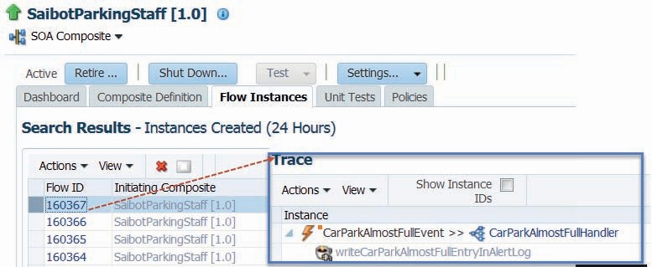

**FIGURE 16-9.** *Instances of the SaibotParkingStaff SOA composite triggered by the*

*CarParkAlmostFull EDN event published by the OEP application CarParking*

range of $200 to $500. He sometimes back traced a little, entering a shop a little further from the main exit than the previous one.

OEP is set up to process a stream of credit card purchase events, which contain the amount, the credit card number and the shop identifier. With OEP, the pattern described above and shown in Figure 16-10 is to be detected. When it is found, it is to be reported in the form of an EDN event to be taken care of by an SOA composite. Online you will also find sources for an ADF web application that visualizes the suspicious transactions, much in the same way as Figure 16-10 does.

Some salient aspects of this *CreditCard* processing application:

* + Use of the listAgg operator to aggregate multiple events into a Java Collection
  + Use of custom Java Classes from within CQL queries
  + Use of XMLParse to add XML content inside XML Element with child elements, based on a string [prepared in a custom Java class from a List of shop identifiers and purchase

amounts] to produce richer, more complex EDN event payloads

* + Use of keywords *within* and *subset* in the CQL query to respectively find a pattern only if it occurs within a certain period of time (15 minutes) and to allow aggregation over all or

some of the events that constitute the pattern

**FIGURE 16-10.** *The credit card transactions pattern OEP is set up to detect: a series of mid amount*

*range purchases, in a short time window, roughly along the route from main terminal to the exit*

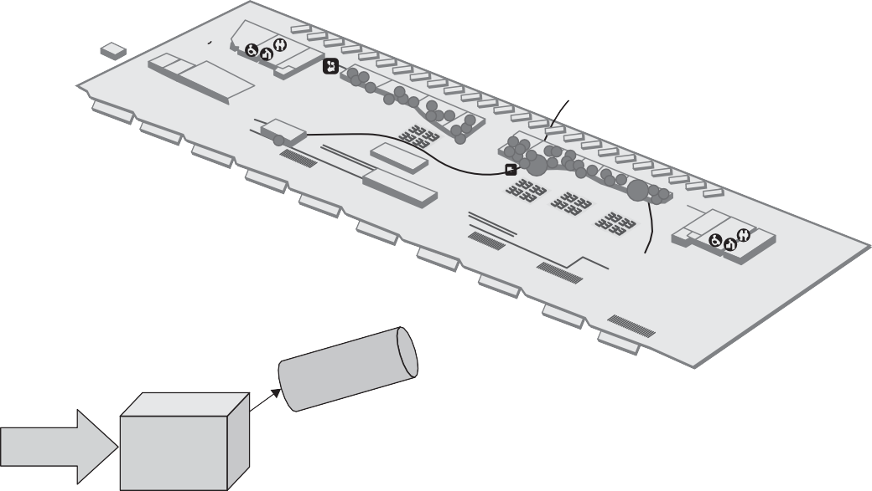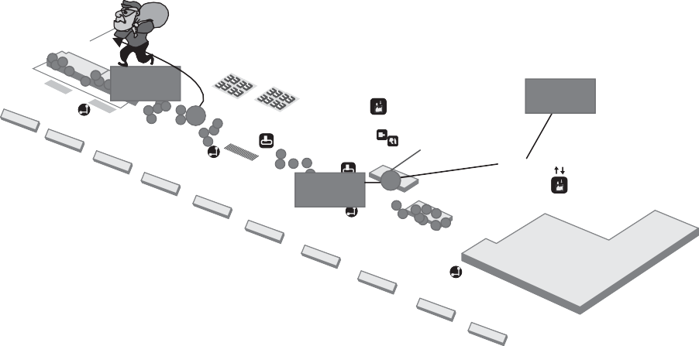

EDN

Medi- ator

EXIT

SPAD

JPJ L1-1

TAXI BAY

$250

$300

$380

L1-13-17

BUS BAY

SOA Suite 12c

Main Terminal

Fast Data

OEP

EDN

TransactionLog.txt

$440

This next snippet shows some crucial aspects of the CQL query that finds fishy transactions:

 select its.creditCardNumber as creditCardNumber,totalSum as sumAmounts

, delta as shoppingDuration, shops as shops, purchaseAmounts as purchaseAmounts

from creditCardMidRangePurchaseChannel MATCH_RECOGNIZE (

PARTITION BY creditCardNumber

MEASURES C.creditCardNumber as creditCardNumber

, sum(allPurchases.amount) as totalSum

, C.element_time - A.element_time as delta

, listAgg(allPurchases.shopIdentifier) as shops

, listAgg(allPurchases.amount) as purchaseAmounts PATTERN ( A+ B? A+ C) within 30000 milliseconds SUBSET allPurchases = (A,B,C)

DEFINE

A as A.shopIdentifier >= A.shopIdentifier

, B as B.shopIdentifier < A.shopIdentifier and A.shopIdentifier - B.shopIdentifier < 7

,C as A.shopIdentifier - C.shopIdentifier < 7

) as its

### Stream Explorer

Stream Explorer was released by Oracle as an extension on top of OEP 12*c*. Stream Explorer is a browser based user interface targeted at business users. Through the attractive user interface, see Figure 16-11, with focus on functional details, users can quickly create explorations on top of streams and define ways to visualize these. In doing so, they are creating OEP applications—that if necessary can be further refined by developers in JDeveloper. Stream Explorer can be accessed from the browser when the OEP Server is running, using the URL http://host:port/sx, for example http://127.0.0.1:9002/sx.

The business user defines Streams for the input. Such a Stream can be a (CSV) file, an HTTP Subscriber, EDN event, a JMS destination, a Database Table, or a REST service. These streams carry shape instances. A shape is a record (event) definition that consists of the properties and their types. The Streams can perhaps be preconfigured for the LoB user by the tech savvy IT colleague. The business user can then define Explorations on the Streams, which are based on predefined templates. The business user can make use of many predefined templates that are categorized by industry. These templates represent specific ways of processing events.

The business user has to provide values for template parameters such as the aggregation interval, the aggregation function or the event property to group by. Multiple explorations can be chained; this means that the outcome of one exploration can provide the input for a next.

Downstream destination to which the outcome of an exploration can be sent include

a CSV file, an HTTP Publisher, EDN, a JMS destination, a REST service, or BAM—the Business Activity Monitor.

Stream Explorer is a web application that is installed in the Jetty Server that also runs the OEP engine and the OEP Visualizer Admin Console. OEP applications configured using Stream Explorer can be exported to be imported and refined |extended | augmented in JDeveloper by

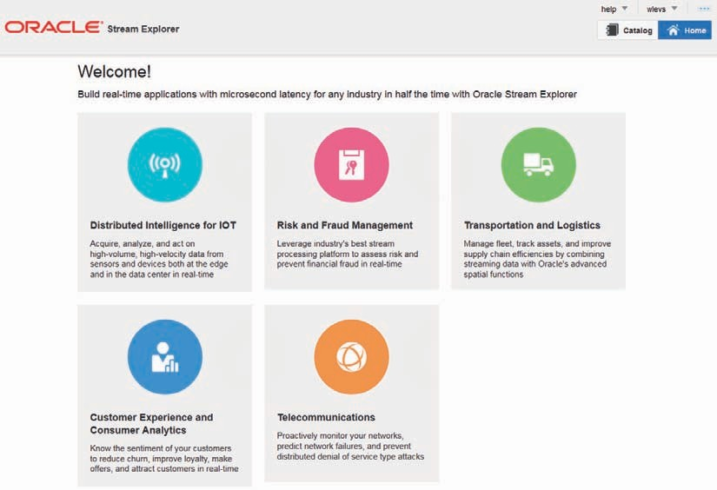

**FIGURE 16-11.** *The user friendly home page of the Stream Explorer*

the IT specialists. The Stream Explorer applications contain an Event Processing Network and CQL-based event processors that were constructed using templates.

The near future of Stream Explorer holds interaction with NoSQL sources and destinations, BAM visualizations, support for machine learning algorithms, data redaction on sensitive data, Coherence cache integration, and location-based features.

### Summary

Real-time findings—insight, alert, action, based on vast and possibly fast data from a variety of sources—published to various types of channels for onward processing is in a nutshell what Oracle Event Processor can do for us. By constantly scanning streams of events arriving at unpredictable moments, OEP is able to look out for abnormal conditions, meaningful patterns, relevant aggregates, and even important event absences.

Event processing applications use CQL—the Continuous Query Language, that is similar in syntax to SQL and can join event channels, caches, and relational data sources to produce coarser grained, higher value output events. OEP connects on both inbound and outbound edges with SOA Suite and Java applications through JMS, Coherence, and the Event Delivery Network.

By focusing on the core competencies of OEP—light weight, multichannel interaction, cross insta nces|sessions|transactions|conversations—it is easy to see how, for example, OEP can play an important role for monitoring of and across business processes. Note that the core of the OEP engine has been embedded inside Oracle BAM to help with precisely that.

The support for integration from OEP with the Event Delivery Network in the SOA Suite provides great potential to implement EDA (Event-Driven Architecture) with SOA Suite or at least make the service architecture more event-enabled. Finally, the Stream Explorer product lowers the threshold for starting to leverage event processing from a business point of view.